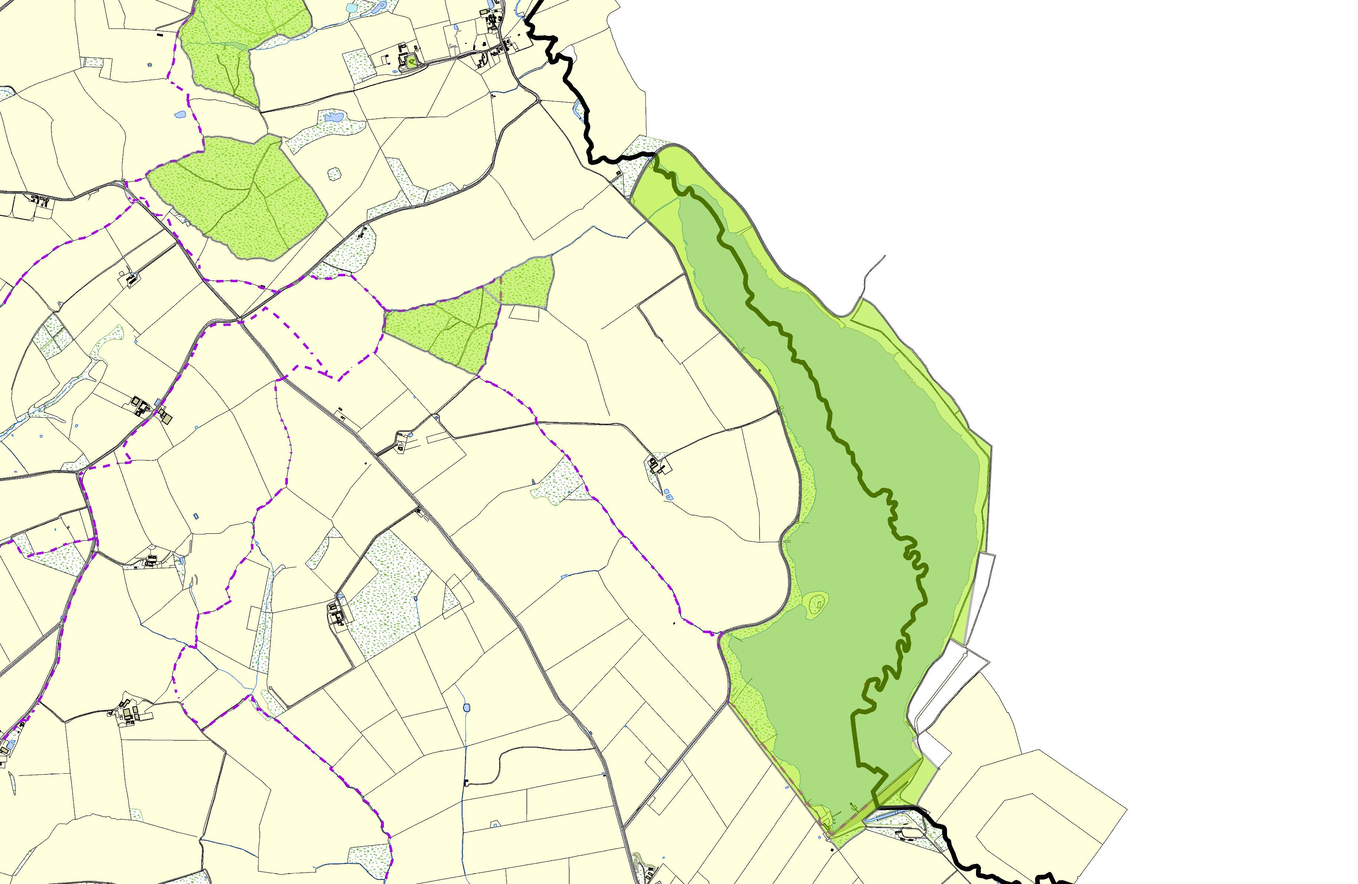Stockerston OSSR sites, LGS sites and Wildlife Sites Note the LGS sites are proposals only at Sept 2015

 | Mature Ash Tree 9, King's Hill Lodge Eyebrook Valley Woods 1  Stockeston Churchyard  Eyebrook Valley Woods 2  Great Merrible Wood  Great Merrible Wood | Eyebrook Reservoir | Legend  Not recommended for LGS Designation Recommended for LGS designation Wildlife Sites  Open Space, Sport and Recreation Sites  OS MM Boundary  DESCTERM  !!!!!!!!!!!!!!!!!!!! County  District Electoral Parish
 | ©Crown Copyright. All rights reserved. Harborough District Council 100023843 2014

