Stonton Wyville OSSR sites, LGS sites and Wildlife Sites Note the LGS sites are proposals only at Sept 2015

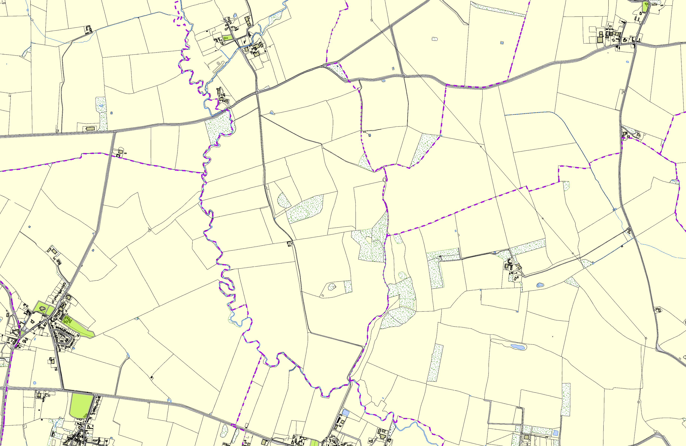

|  |  |  |  |  |  |
| --- | --- | --- | --- | --- | --- |
| St Peters Church - East Langton Allotments in East Langton  Hanbury Playing Field - East Langton Village Green Church Langton - East Langton  East Langton Cricket Club  Coronation Gardens - East Langton | | Stonton Wyville Churchyard | Allotment Gardens on Main Street - Thorpe Langton | | St Michael & All Angels Churchyard, Cranoe  **Legend**  Not recommended for LGS Designation Recommended for LGS designation Wildlife Sites  Open Space, Sport and Recreation Sites  **OS MM Boundary**  **DESCTERM**  !!!!!!!!!!!!!!!!!!!! County  District Electoral Parish |
|  | **©Crown Copyright. All rights reserved. Harborough District Council 100023843 2014** | | |  | |