Stoughton OSSR sites, LGS sites and Wildlife Sites Note the LGS sites are proposals only at Sept 2015

Legend

Not recommended for LGS Designation Recommended for LGS designation Wildlife Sites
Open Space, Sport and Recreation Sites
OS MM Boundary
DESCTERM
!!!!!!!!!!!!!!!!!!!! County

District Electoral Parish

LGS/STO/2 - Natural recreation area Stoughton

LGS/STO/3 - Small Paddocks 1 Stoughton

Woodlands - Stoughton Lane - Stoughton
LGS/STO/4 - Small Paddocks 2 Stoughton

LGS/STO/5 - Larger paddock entrance to Charity Farm Stoughton

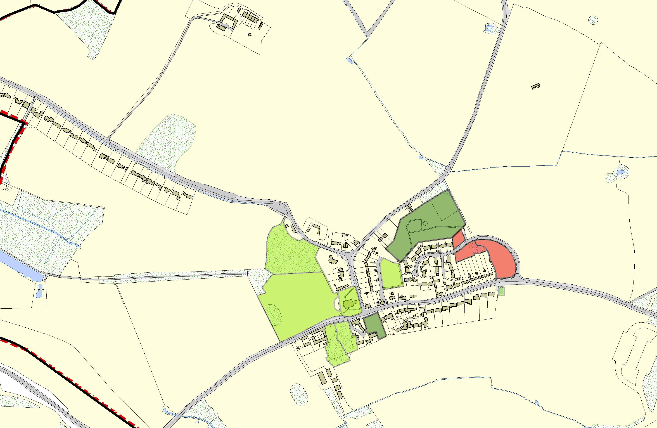
Village Play Area, Gaulby Way - Stoughton

Pond/Gaulby Lane - Stoughton

Blank RecordSt Marys Church Gaulby Lane/Church Lane -Stoughton

LGS/STO/1 - Paddock opp Church Land Stoughton

Byways Garden Gaulby Lane - Stoughton

Byways Garden Gauby Lane 2 - Stoughton

©Crown Copyright. All rights reserved. Harborough District Council 100023843 2014

