Stoughton OSSR sites, LGS sites and Wildlife Sites Note the LGS sites are proposals only at Sept 2015

LGS/STO/2 - Natural recreation area Stoughton
LGS/STO/3 - Small Paddocks 1 Stoughton

Woodlands - Stoughton Lane - Stoughton
LGS/STO/4 - Small Paddocks 2 Stoughton
LGS/STO/5 - Larger paddock entrance to Charity Farm Stoughton

Village Play Area, Gaulby Way - Stoughton
Pond/Gaulby Lane - Stoughton Blank RecordSt Marys Church Gaulby Lane/Church Lane -Stoughton

LGS/STO/1 - Paddock opp Church Land Stoughton Byways Garden Gauby Lane 2 - Stoughton

Stretton Circuit - Stoughton

Legend

Not recommended for LGS Designation Recommended for LGS designation Wildlife Sites
Open Space, Sport and Recreation Sites
OS MM Boundary
DESCTERM

!!!!!!!!!!!!!!!!!!!! County
Little Stretton Church/Cemetery

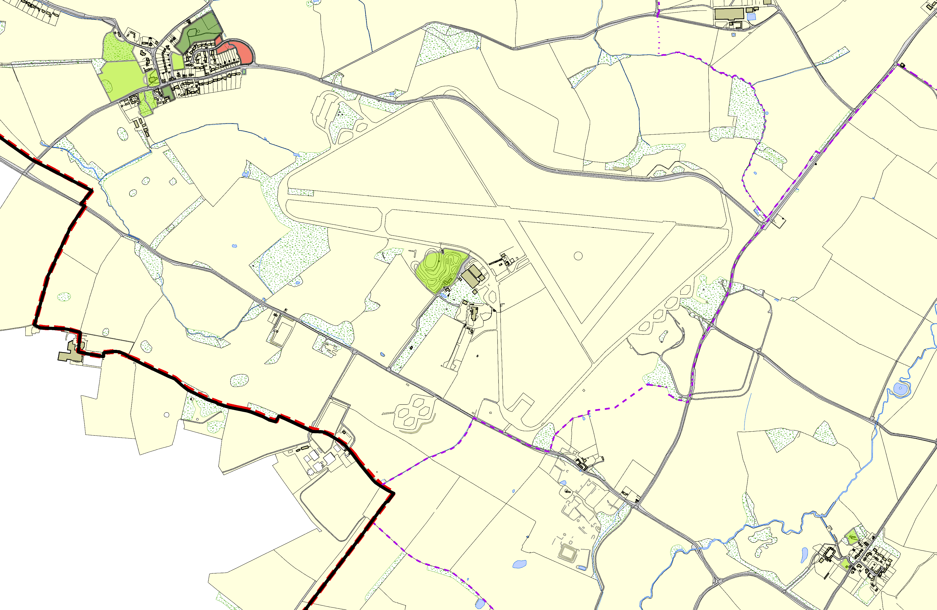

©Crown Copyright. All rights reserved. Harborough District Council 100023843 2014
District Village Hall and Small Play Area - Little Stretton

Electoral Parish

