Stoughton OSSR sites, LGS sites and Wildlife Sites Note the LGS sites are proposals only at Sept 2015

Legend

Bushby Spinney

Not recommended for LGS Designation Recommended for LGS designation Wildlife Sites
Open Space, Sport and Recreation Sites
OS MM Boundary
DESCTERM
!!!!!!!!!!!!!!!!!!!! County

District Electoral Parish
LGS/STO/2 - Natural recreation area Stoughton
LGS/STO/3 - Small Paddocks 1 Stoughton

Woodlands - Stoughton Lane - Stoughton
LGS/STO/4 - Small Paddocks 2 Stoughton
LGS/STO/5 - Larger paddock entrance to Charity Farm Stoughton

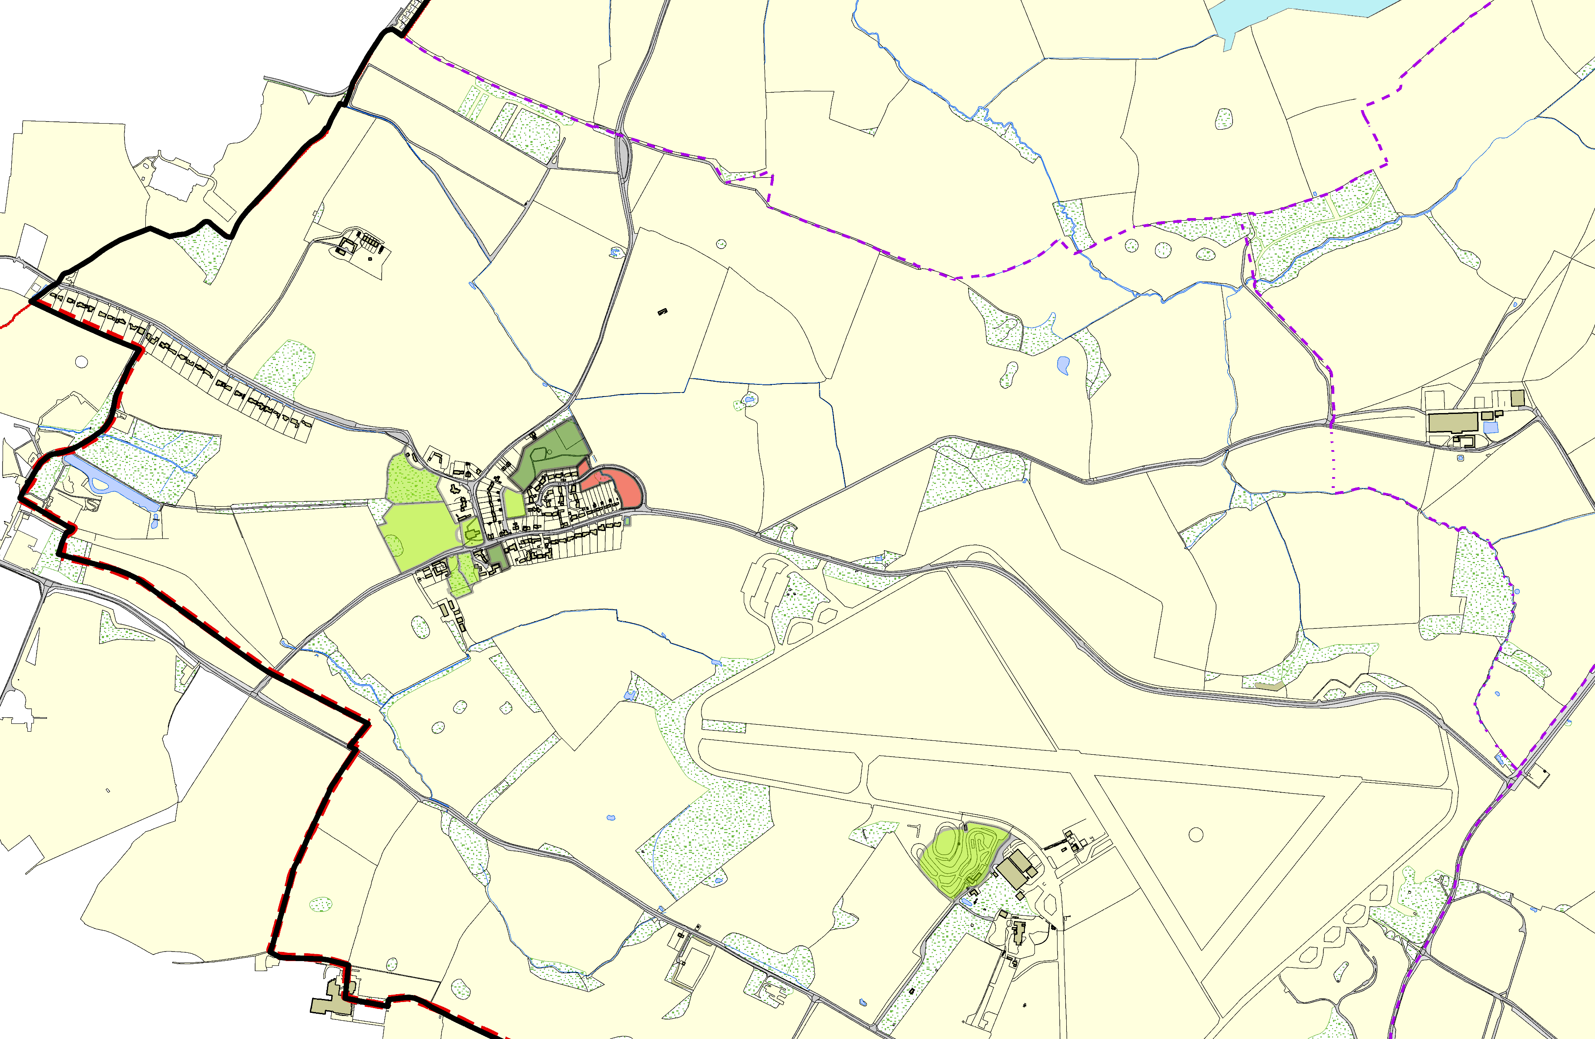Village Play Area, Gaulby Way - Stoughton
Pond/Gaulby Lane - Stoughton Blank RecordSt Marys Church Gaulby Lane/Church Lane -Stoughton

LGS/STO/1 - Paddock opp Church Land Stoughton Byways Garden Gauby Lane 2 - Stoughton

Stretton Circuit - Stoughton

©Crown Copyright. All rights reserved. Harborough District Council 100023843 2014

