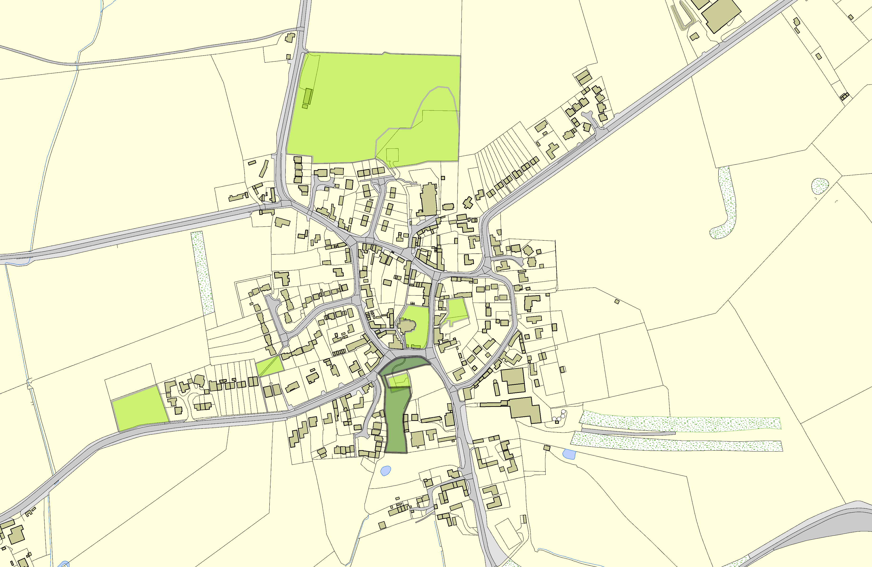Swinford OSSR sites, LGS sites and Wildlife Sites Note the LGS sites are proposals only at Sept 2015

 | Cemetery in Swinford | Cricket and Hockey Playing Field and Pavillion - S  School Playing Field in Swinford  Public House Garden and Play Area - Swinford Churchyard in Swinford  Chapel Fields, Swinford  Play Area - Swinford  LGS/SWIN/1 - Glebe Land behind Play Area Swinford |  | Legend  Not recommended for LGS Designation Recommended for LGS designation Wildlife Sites  Open Space, Sport and Recreation Sites  OS MM Boundary  DESCTERM  !!!!!!!!!!!!!!!!!!!! County  District Electoral Parish
 | ©Crown Copyright. All rights reserved. Harborough District Council 100023843 2014

