Swinford OSSR sites, LGS sites and Wildlife Sites Note the LGS sites are proposals only at Sept 2015

Legend

Cricket and Hockey Playing Field and Pavillion - S
School Playing Field in Swinford

Public House Garden and Play Area - Swinford Churchyard in Swinford

Chapel Fields, Swinford
Play Area - Swinford
Cemetery in SwinfordLGS/SWIN/1 - Glebe Land behind Play Area Swinford

Not recommended for LGS Designation Recommended for LGS designation Wildlife Sites
Open Space, Sport and Recreation Sites
OS MM Boundary
DESCTERM
!!!!!!!!!!!!!!!!!!!! County

District Electoral Parish

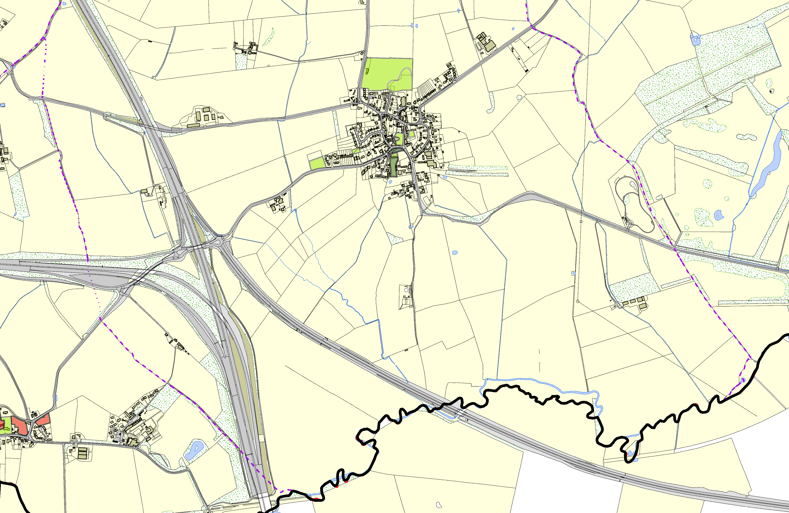

LGS/CAT/2 - Catthorpe Allotment LGS/CATL1GS- C/CaAttTh/o3rp- eCCaththuorcrpheyaOrdrchard

©Crown Copyright. All rights reserved. Harborough District Council 100023843 2014

