Theddingworth OSSR sites, LGS sites and Wildlife Sites Note the LGS sites are proposals only at Sept 2015

LGS/THEDD/1 - Play Area Theddingworth (shoudl be OSSR site)

Theddingworth Cemetery Theddingworth Churchyard

Legend

Woodland Roadside Belt, Theddingworth Road - Husband

Woodland Roadside Belt, Theddingworth Road 2 - Husba

LGS/THEDD/3 - Jubilee Area Theddginworth

Not recommended for LGS Designation Recommended for LGS designation Wildlife Sites
Open Space, Sport and Recreation Sites
OS MM Boundary
DESCTERM
!!!!!!!!!!!!!!!!!!!! County

District Electoral Parish

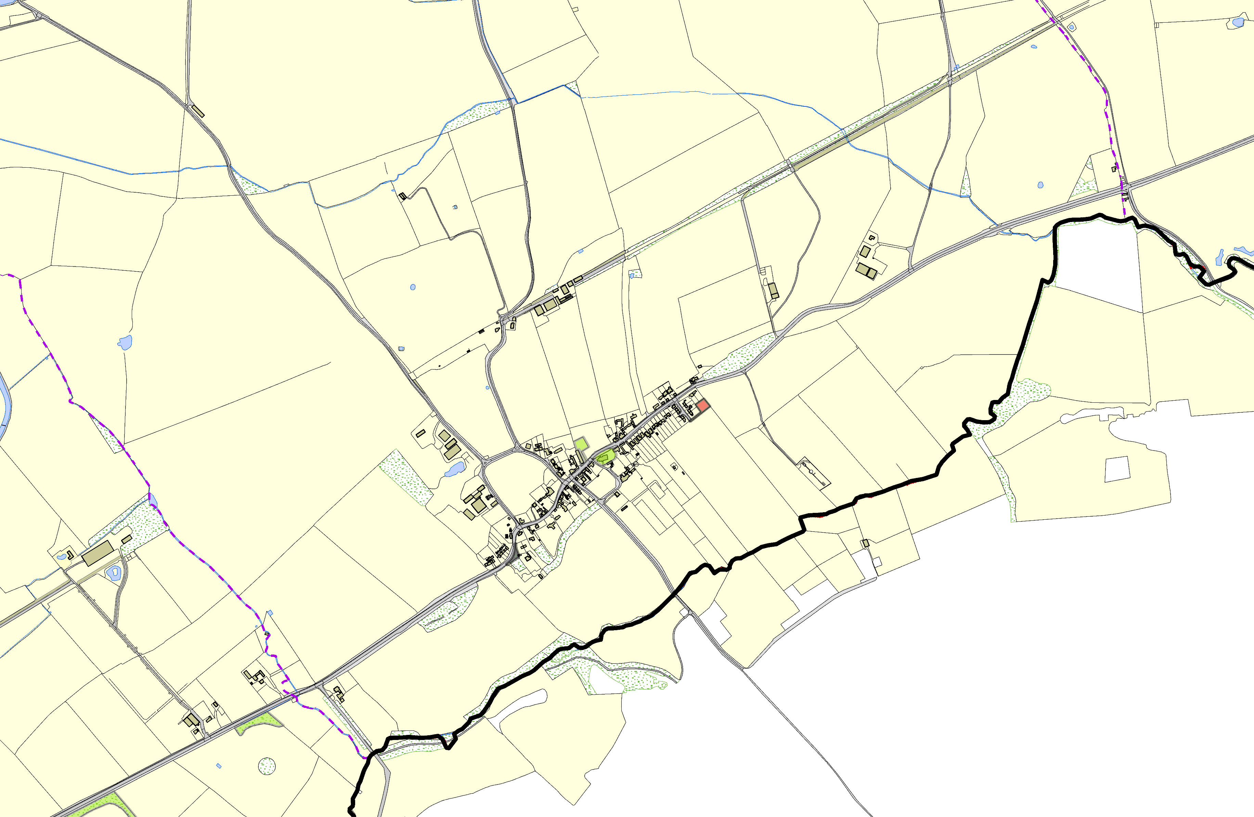©Crown Copyright. All rights reserved. Harborough District Council 100023843 2014

