Legend

Theddingworth OSSR sites, LGS sites and Wildlife Sites Note the LGS sites are proposals only at Sept 2015
Sloping grassland, Laughton Model Aero Club

Not recommended for LGS Designation Recommended for LGS designation Wildlife Sites
Open Space, Sport and Recreation Sites
OS MM Boundary
DESCTERM
!!!!!!!!!!!!!!!!!!!! County

District Electoral Parish

Kicklewell Spinney

Laughton Hills Wood

Owell Spinney's Ash

Paddle Wood

Sweet Chestnut Coppice

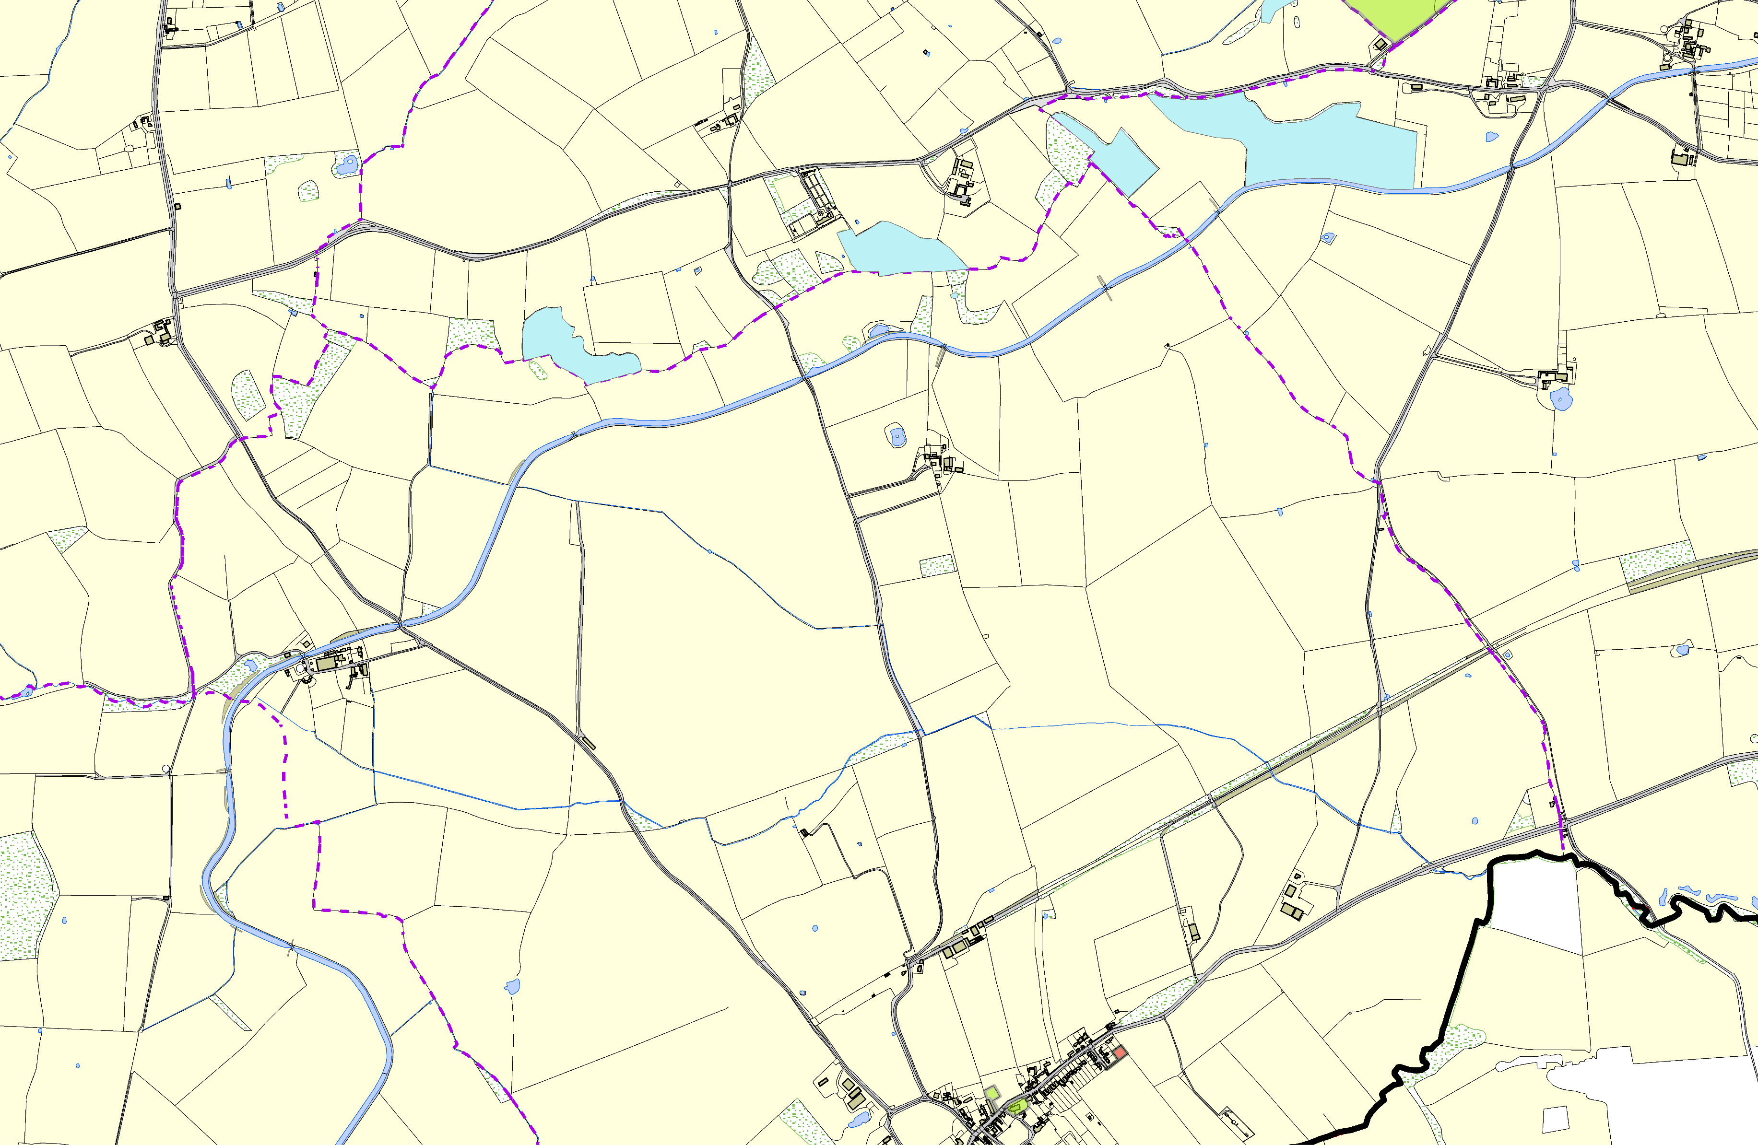

LGS/THEDD/1 - Play Area Theddingworth (shoudl be OSSR site)

Theddingworth Cemetery Theddingworth Churchyard

©Crown Copyright. All rights reserved. Harborough District Council 100023843 2014

