**Legend**

# Thorpe Langton OSSR sites, LGS sites and Wildlife Sites Note the LGS sites are proposals only at Sept 2015

Not recommended for LGS Designation Recommended for LGS designation Wildlife Sites

Open Space, Sport and Recreation Sites

# OS MM Boundary

**DESCTERM**

!!!!!!!!!!!!!!!!!!!! County

District Electoral Parish

Allotment Gardens on Main Street - Thorpe Langton

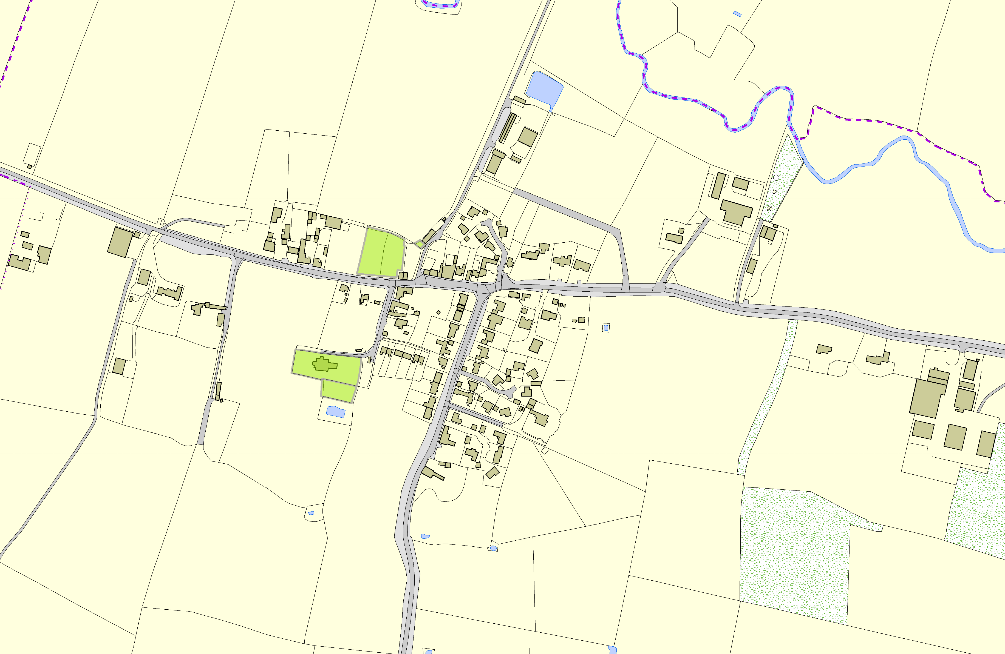

St Leonards Church - Thorpe Langton

Back of Church - Thorpe Langton

**©Crown Copyright. All rights reserved. Harborough District Council 100023843 2014**