**Legend**

# Thorpe Langton OSSR sites, LGS sites and Wildlife Sites Note the LGS sites are proposals only at Sept 2015

St Leonards Church - Thorpe Langton Back of Church - Thorpe Langton

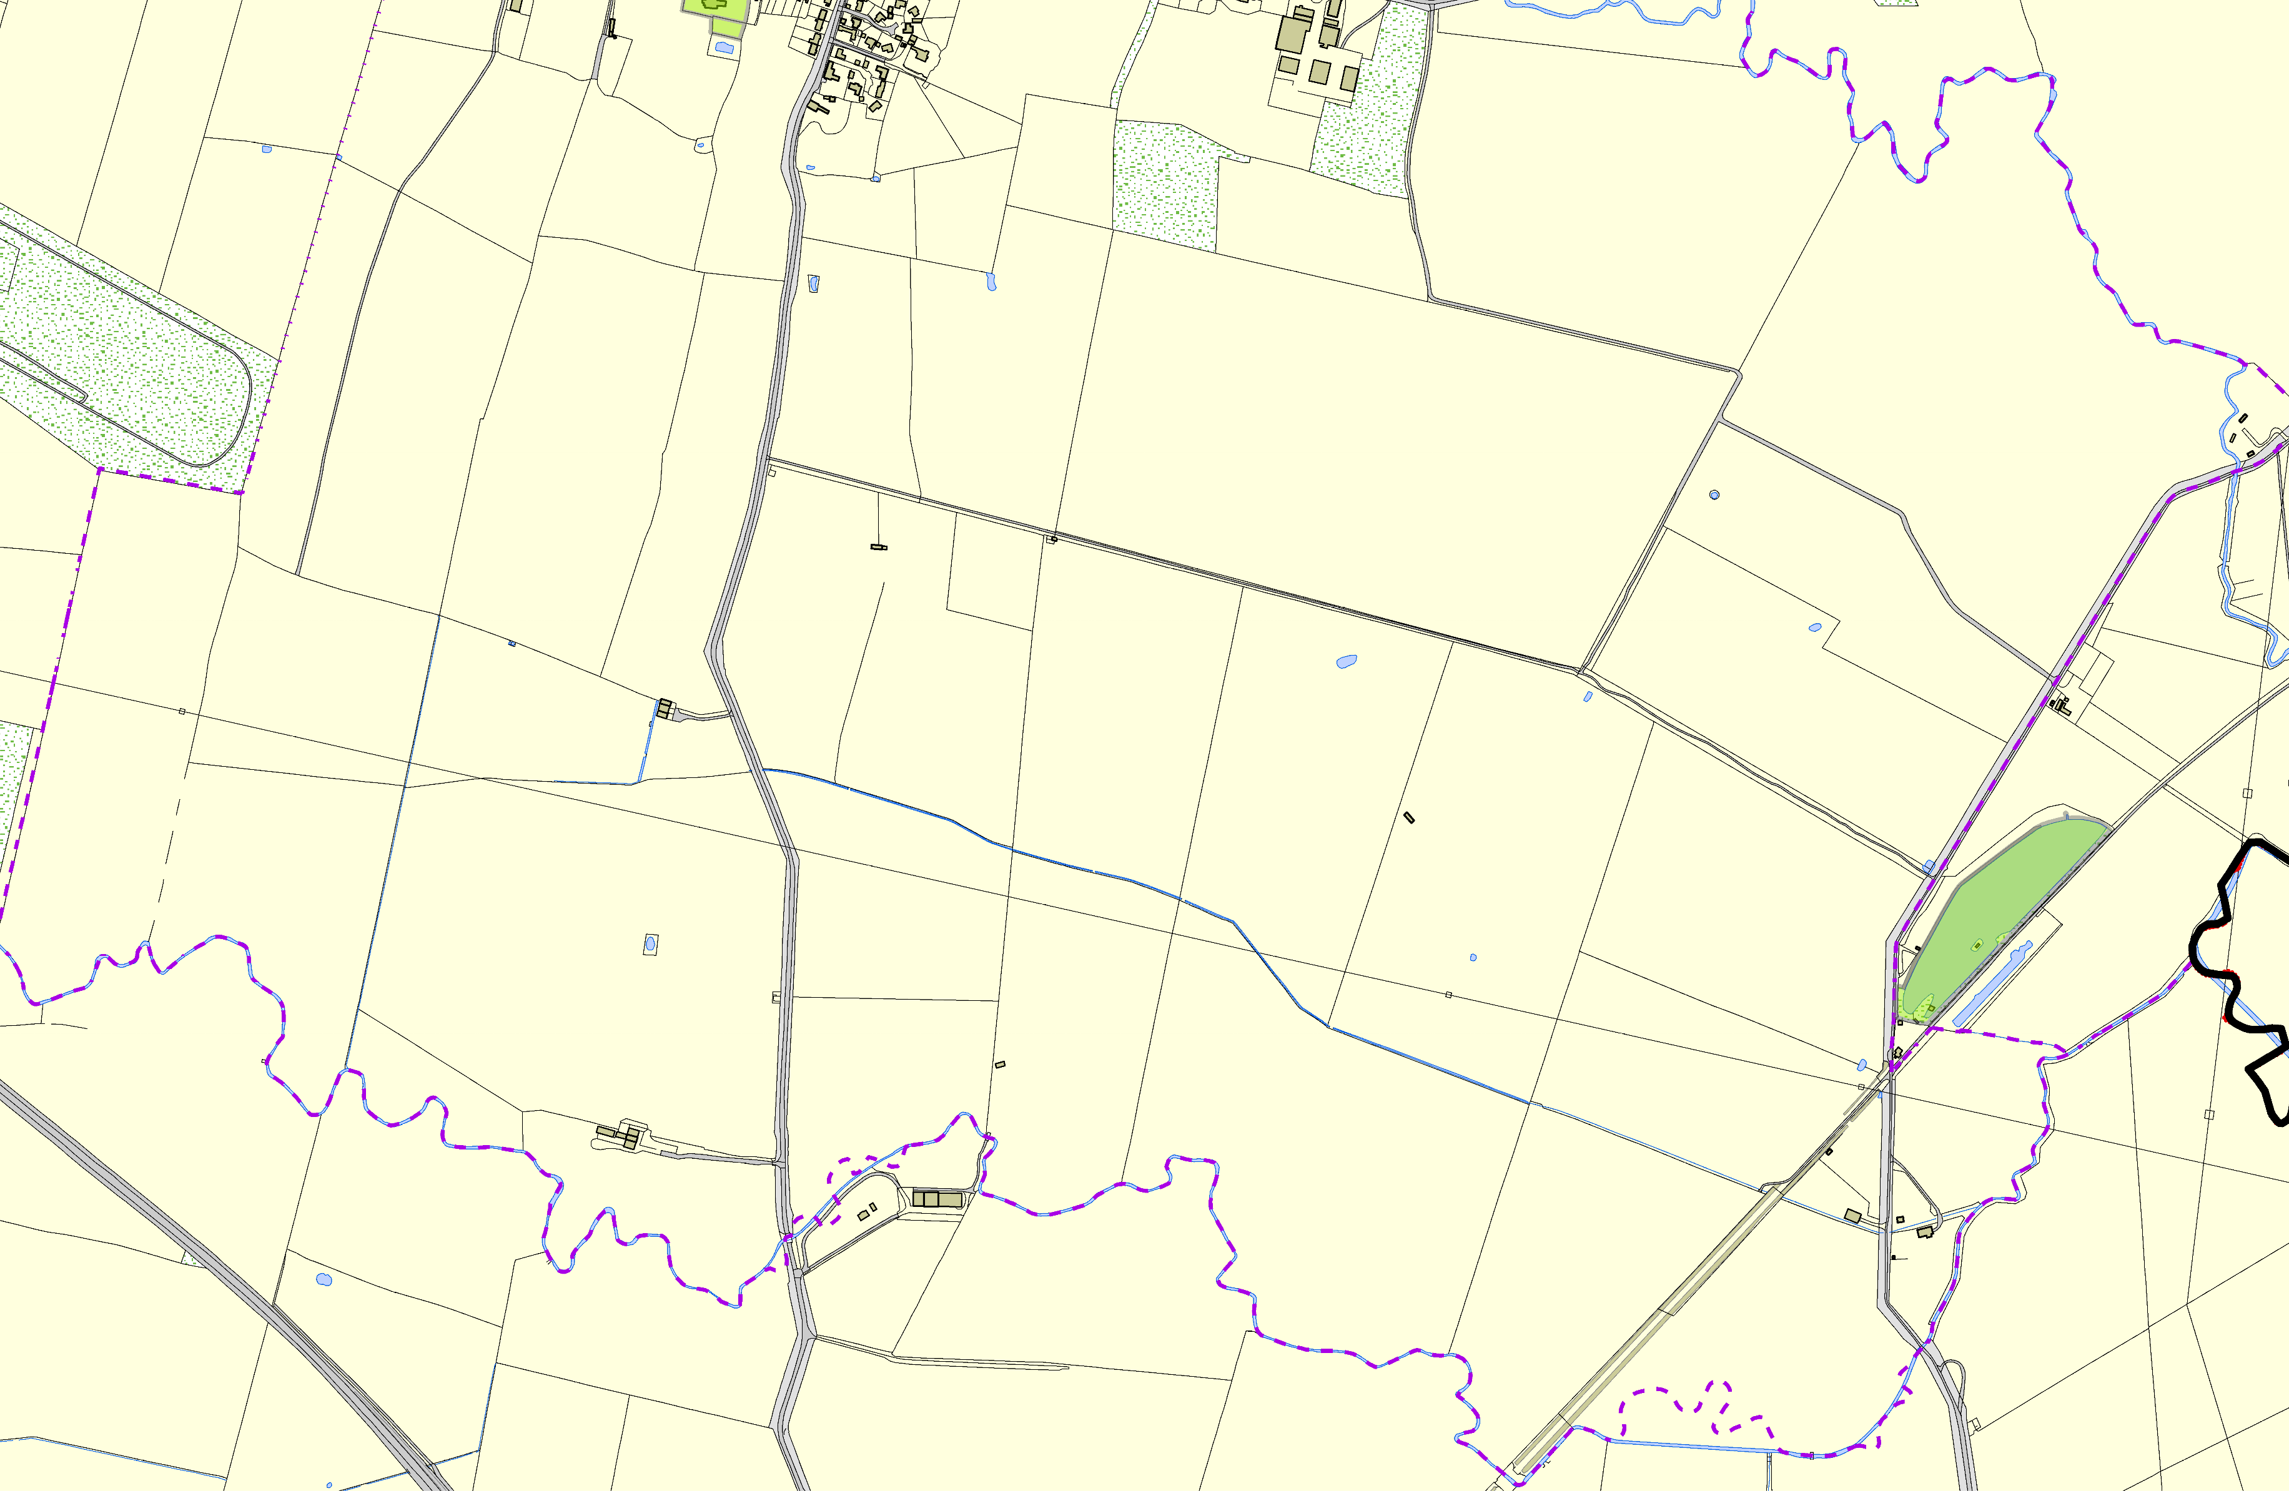

Not recommended for LGS Designation Recommended for LGS designation Wildlife Sites

Open Space, Sport and Recreation Sites

# OS MM Boundary

**DESCTERM**

!!!!!!!!!!!!!!!!!!!! County

District Electoral Parish

Ballast Hole, Fishing Lake, Bowden Lane - Welham

**©Crown Copyright. All rights reserved. Harborough District Council 100023843 2014**