Thurnby and Bushby OSSR sites, LGS sites and Wildlife Sites Note the LGS sites are proposals only at Sept 2015

Wadkins- Thurnby and Bushby

LGS/THUR/3 - Green on Hollies Way Thurby (should be OSSR site)

Bushby Spinney

LGS/THUR/1 - Green in front of Rose and Crown 1

Legend

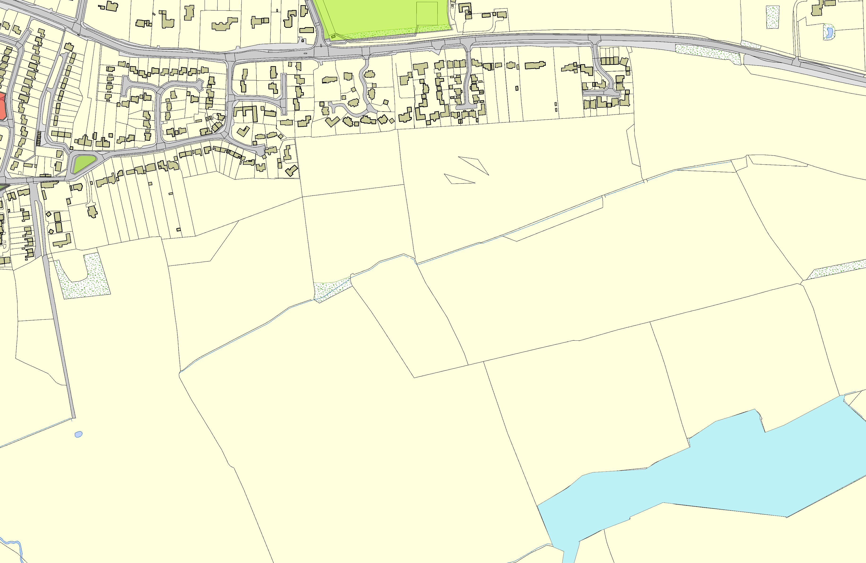Not recommended for LGS Designation Recommended for LGS designation Wildlife Sites
Open Space, Sport and Recreation Sites
OS MM Boundary
DESCTERM
!!!!!!!!!!!!!!!!!!!! County

District Electoral Parish
©Crown Copyright. All rights reserved. Harborough District Council 100023843 2014

Bushby Spinney

