Thurnby and Bushby OSSR sites, LGS sites and Wildlife Sites Note the LGS sites are proposals only at Sept 2015
Somerby Road Open Space - Thurnby and Bushby

LGS/THUR/4 - Embankments on Station Road 2
LGSLLG/GTSHS//UTTHRHU/U5RR-//5G4 r--eGEermnesbeTanenslkfTomerldefonWrtdsaoWynTaShytuTarthnioubnrynR1byo(sa2hdo(1uslhdobueldObSeSORSsSiRte)site)
LGS/THUR/8 - Dismtantled Railway Line Thurnby
LGS/THUR/8 - Dismantled Railway line - unsuitable area for LGS Wadkins Badger Area, Thurnby

LGS/THUR/6 - Anthony Drive and Fiona Drive Green space (should be OSSR site)
Field near Uppingham Road - Thurnby and Bushby

Manor Field Park Playing Area - Thurnby and Bushby
Wooded Area Uppingham Road - Thurnby and BushbyLGS/THUR/7 - Greens Bradgate Close Thurnby
Manor Field - Thurnby and Bushby
Manor Field Park - Thurnby and Bushby
LGS/THUR/2 - Greens in front of 694 to 702 UppinghWamadRlkionasdP1lay Area -Thurnby and Bushby LGS/THUR/2 - Greens in front of 694 to 702 Uppingham Road 2
Wadkins- Thurnby and Bushby

Manor Field South - Thurnby and Bushby
St Lukes School - Thurnby and Bushby
LGS/THUR/3 - Green on Hollies Way Thurby (should be OSSR site)
St Lukes Churchyard

The Green - Thurnby and Bushby
Bushby Spinney
LGS/THUR/1- Green in front of Rose and Crown 2 LGS/THUR/1 - Green in front of Rose and Crown 1

Lakeside Court - Thurnby and Bushby
Scout and Guide HQ - Playing Fields, Thurnnby

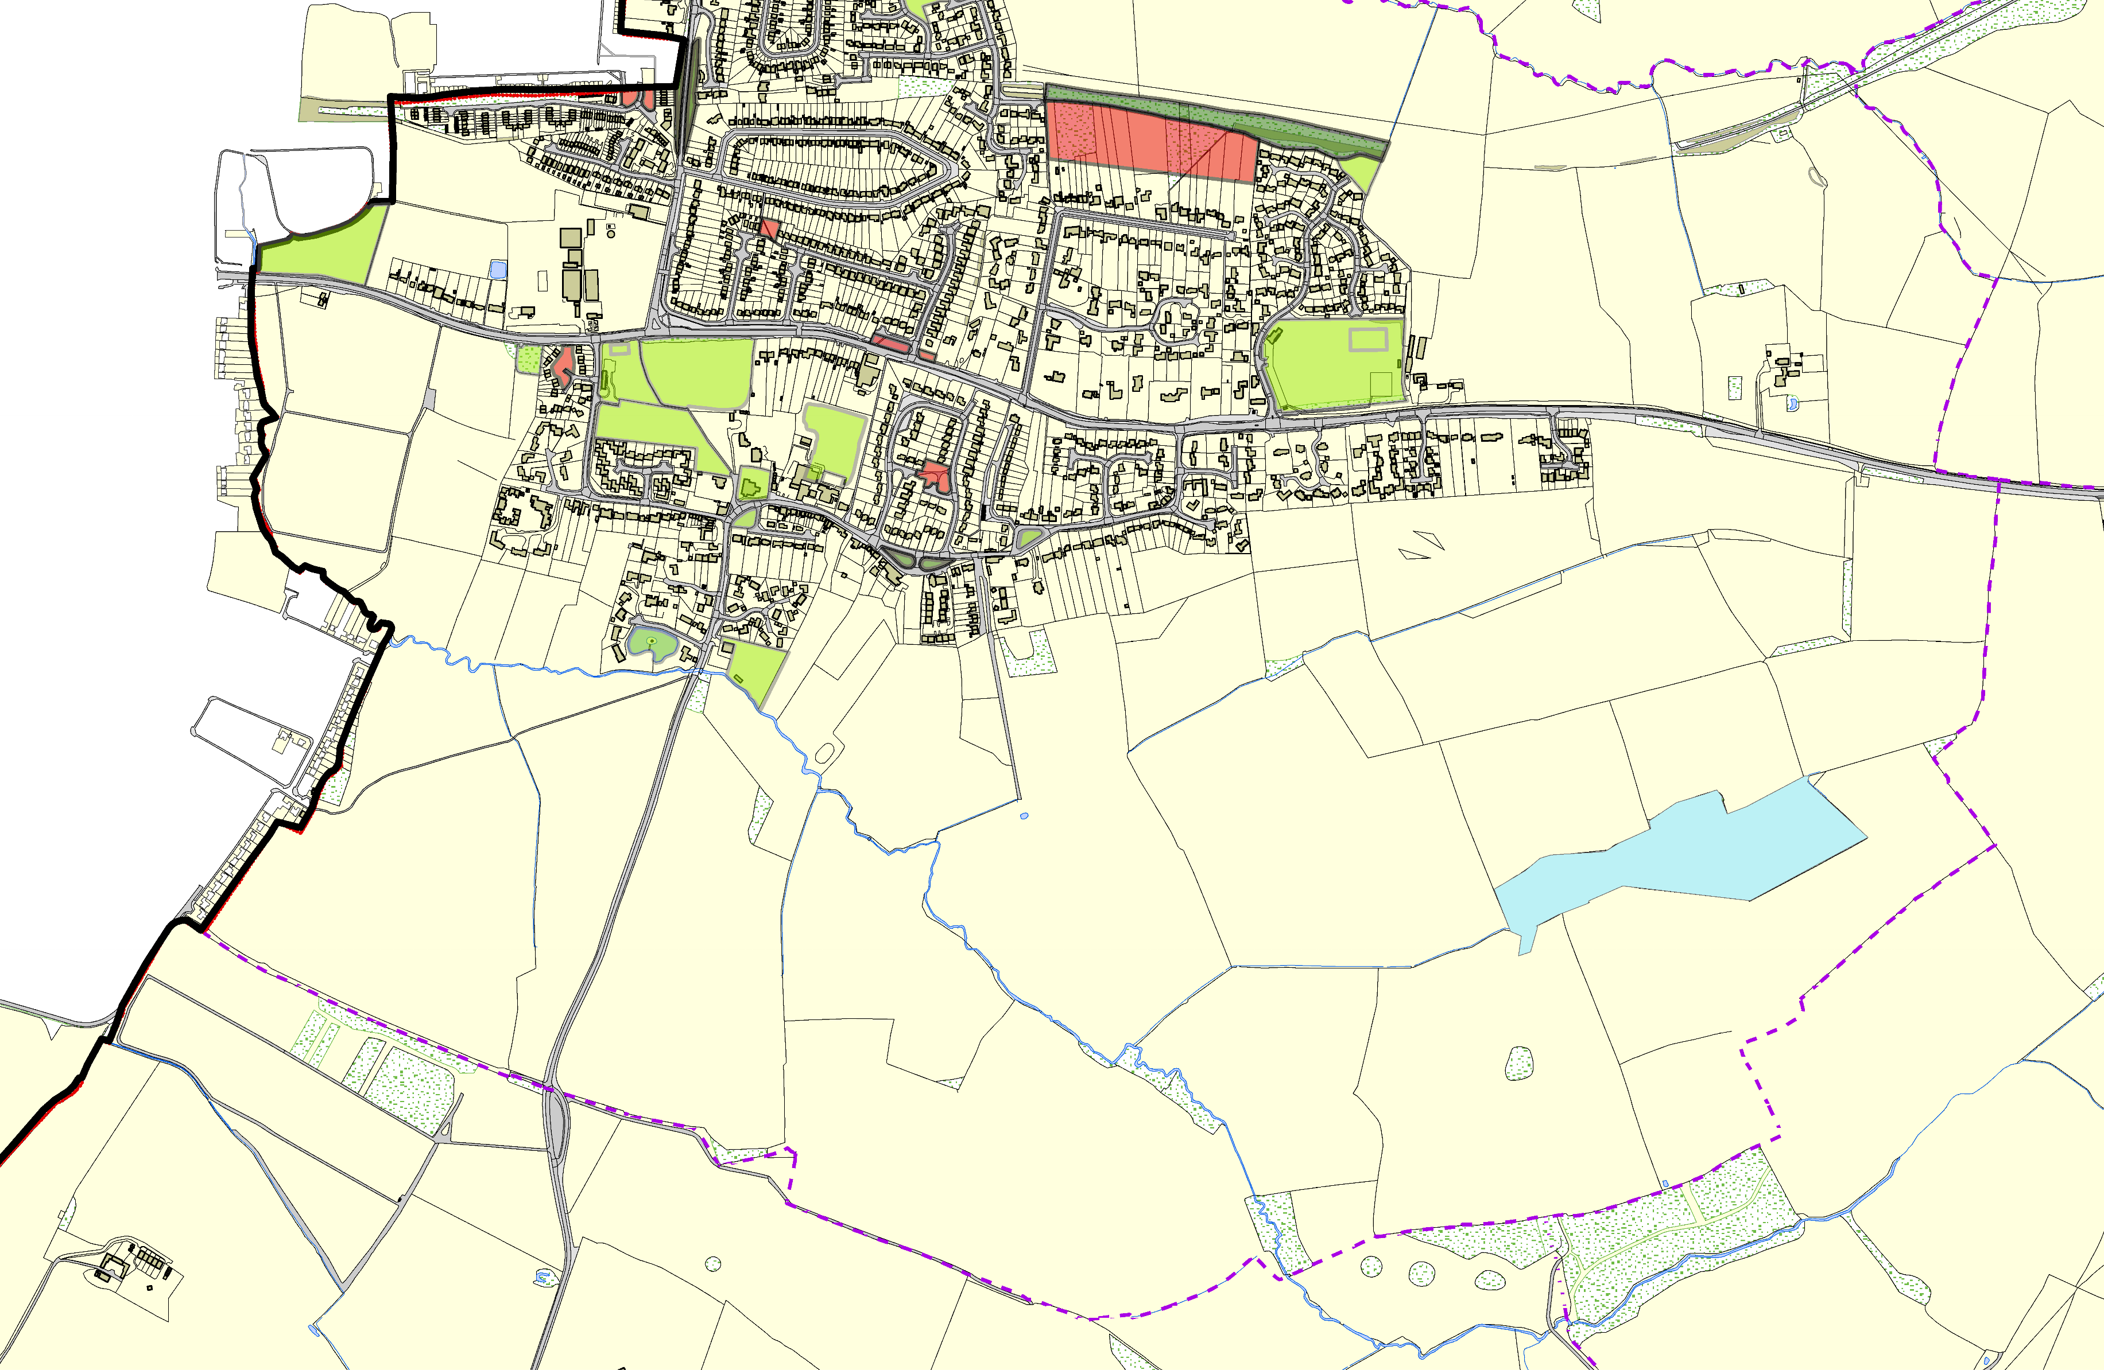Legend

Not recommended for LGS Designation Recommended for LGS designation Wil life Sites
Open Space, Sport and Recreation Sites
OS MM Boundary
DESCTERM
!!!!!!!!!!!!!!!!!!!! County

District Electoral Parish
©Crown Copyright. All rights reserved. Harborough District Council 100023843 2014

Bushby Spinney

