Legend

Thurnby and Bushby OSSR sites, LGS sites and Wildlife Sites Note the LGS sites are proposals only at Sept 2015

Not recommended for LGS Designation
Somerby Road Open Space - Thurnby and Bushby

Recommended for LGS designation Wildlife Sites
Open Space, Sport and Recreation Sites
OS MM Boundary
DESCTERM
!!!!!!!!!!!!!!!!!!!! County

District Electoral Parish

LGS/THUR/2 - Greens in front of 694 to 702 Uppingham Road 1 LGS/THUR/2 - Greens in front of 694 to 702 Uppingham Road 2

LGS/THUR/8 - Dismtantled Railway Line Thurnby LGS/THUR/8 - Dismantled Railway line - unsuitable area for LGS

Wadkins Badger Area, Thurnby

Wadlkins Play Area -Thurnby and Bushby

Wadkins- Thurnby and Bushby

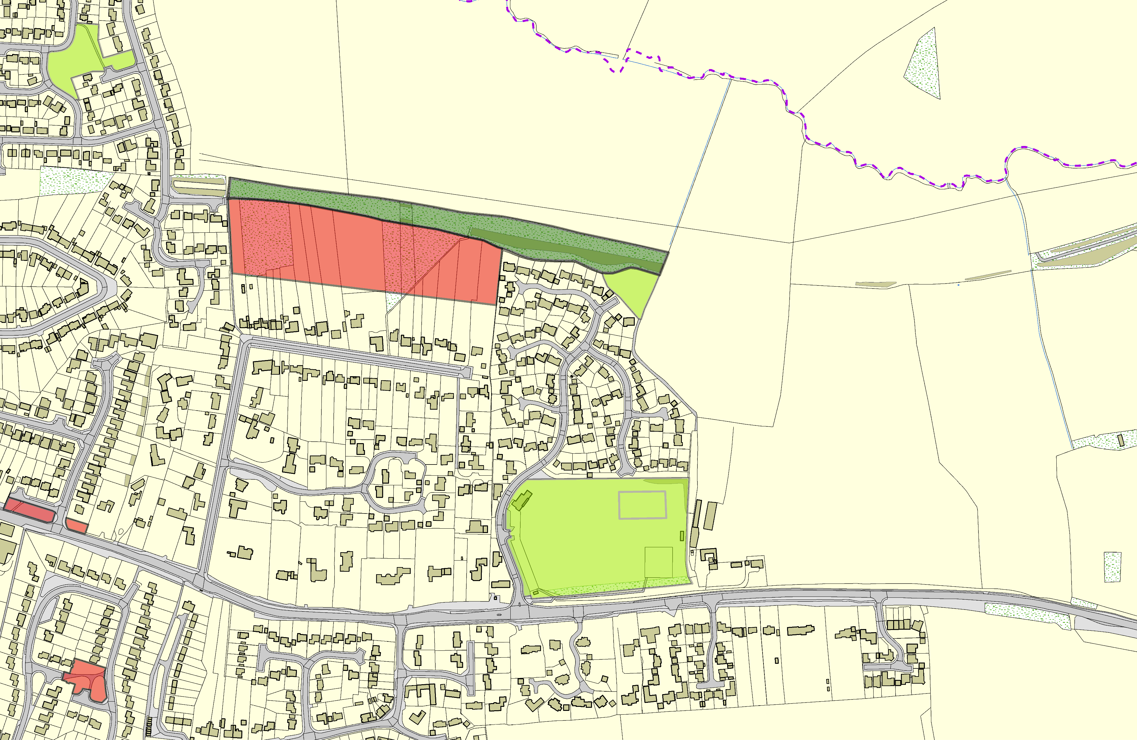

LGS/THUR/3 - Green on Hollies Way Thurby (should be OSSR site)

©Crown Copyright. All rights reserved. Harborough District Council 100023843 2014

