Legend

Thurnby and Bushby OSSR sites, LGS sites and Wildlife Sites Note the LGS sites are proposals only at Sept 2015
LGS/SCRAP/3 - Glebe Land Scraptoft

Not recommended for LGS Designation Recommended for LGS designation Wildlife Sites
Open Space, Sport and Recreation Sites
OS MM Boundary
DESCTERM
!!!!!!!!!!!!!!!!!!!! County

Pulford Drive, Scaptoft

District Electoral Parish

Fernvale School - Thurnby and Bushby

Somerby Road Open Space - Thurnby and Bushby

LGS/THUR/4 - Embankments on Station Road 1 LGS/THUR/4 - Embankments on Station Road 2
LGS/THLUGRS/5/T-HGUrRe/e5n-s GTerelfeonrds WTealfyorTdhWuranybyT1hu(rsnhboyul2d b(sehOouSldSRbesiOteS)SR site)

LGS/THUR/8 - Dismtantled Railway Line Thurnby

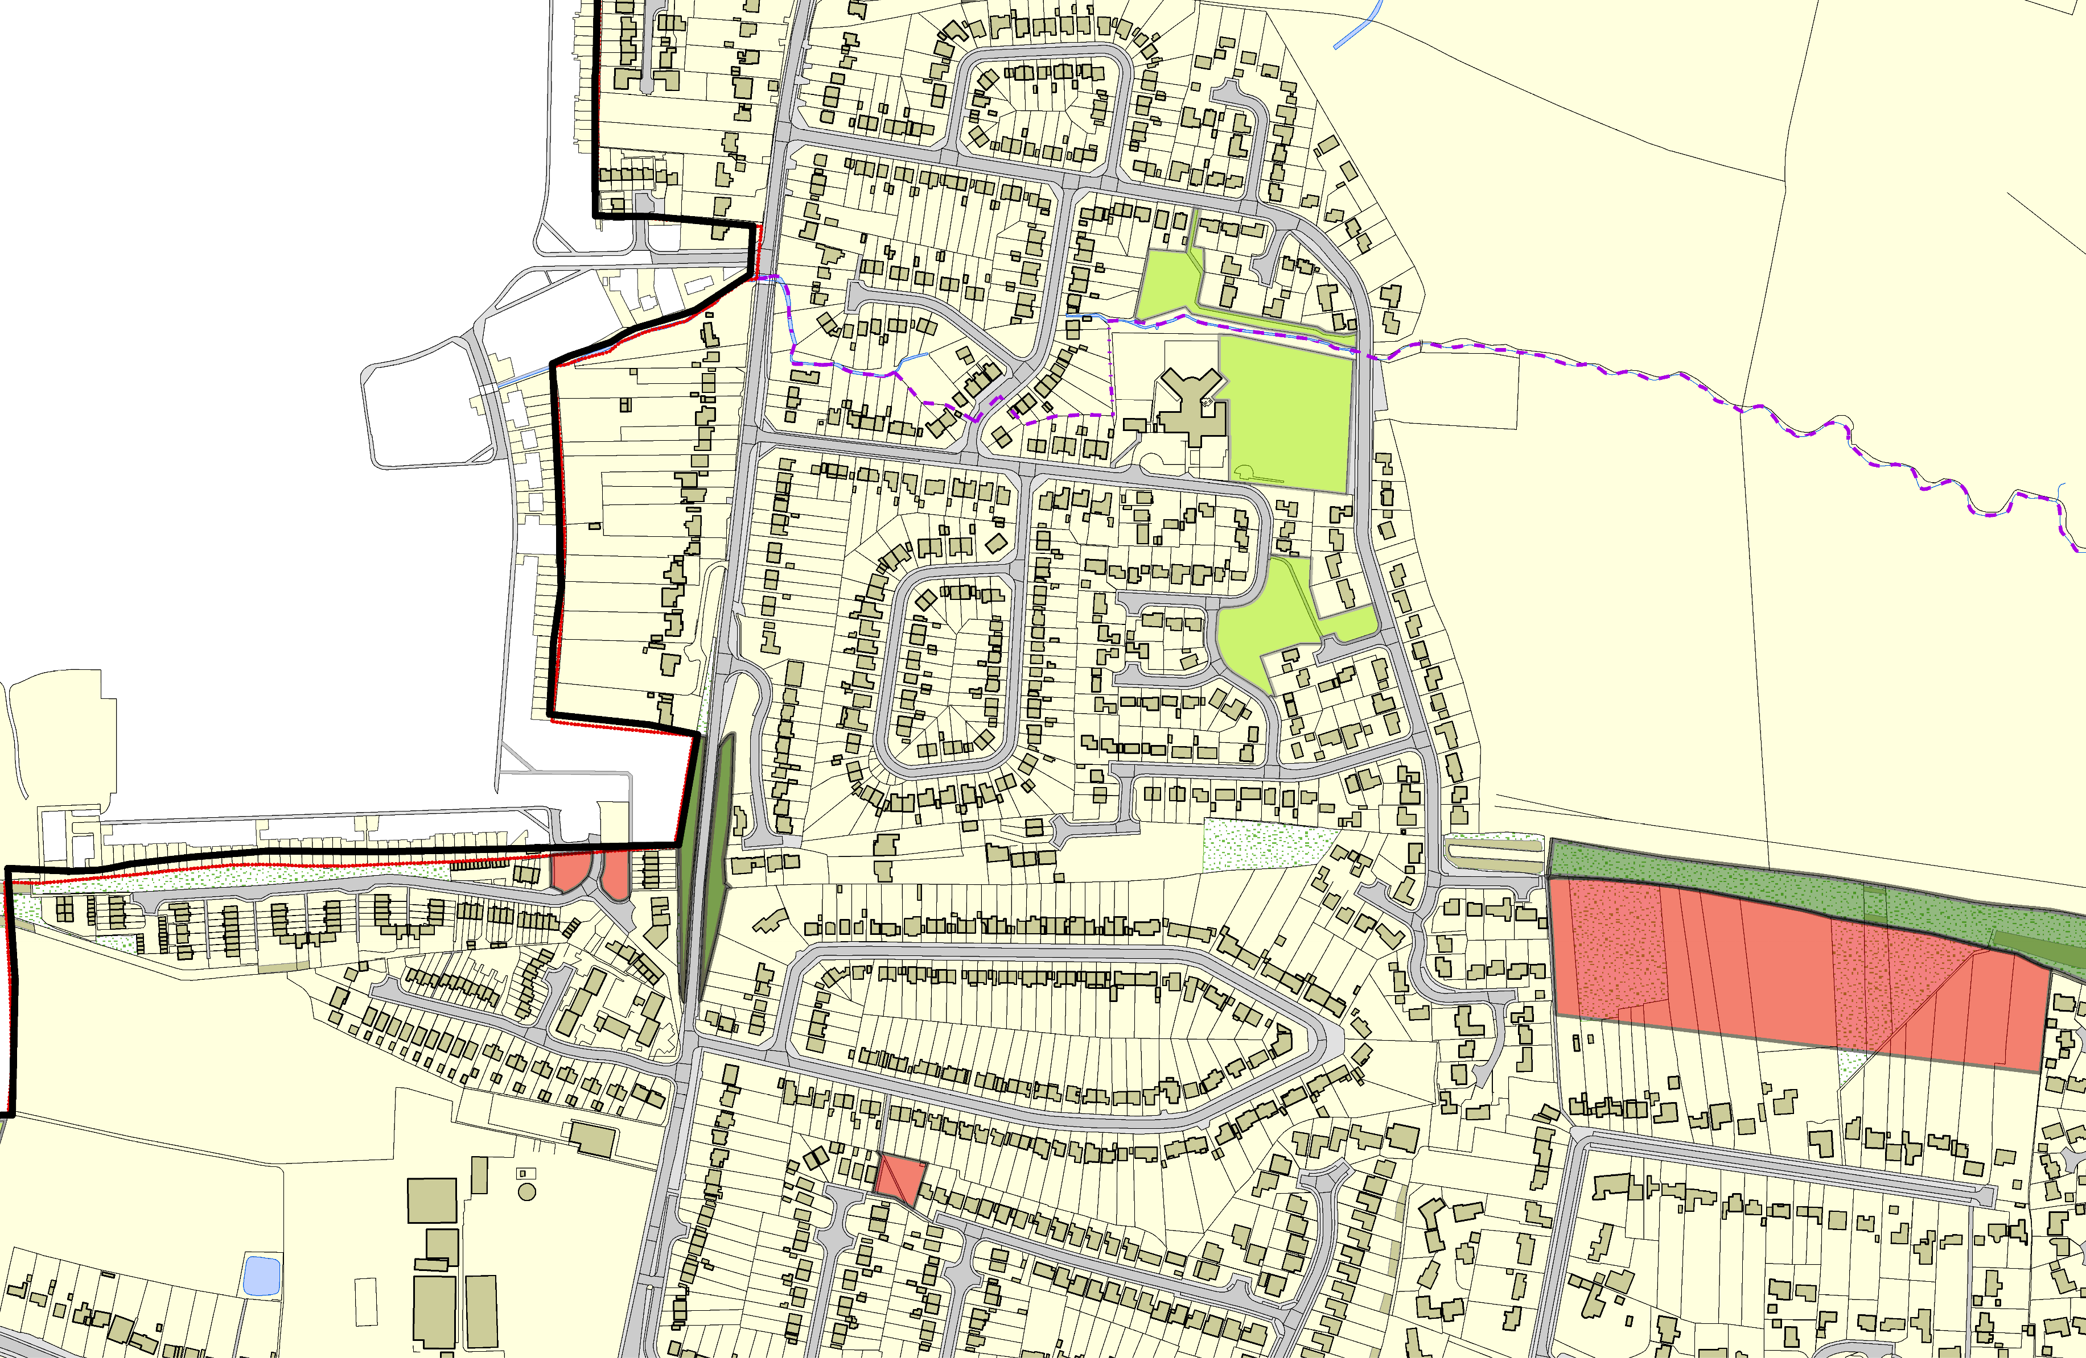

LGS/THUR/8 - Dismantled Railway line - uns

Field near Uppingham Road - Thurnby and Bushby

LGS/THUR/6 - Anthony Drive and Fiona Drive Green space (should be OSSR site)

©Crown Copyright. All rights reserved. Harborough District Council 100023843 2014

