Thurnby and Bushby OSSR sites, LGS sites and Wildlife Sites Note the LGS sites are proposals only at Sept 2015

LGS/THUR/6 - Anthony Drive and Fiona Drive Green space (should be OSSR site)

Field near Uppingham Road - Thurnby and Bushby

Manor Field Park Playing Area - Thurnby and Bushby Wooded Area Uppingham Road - Thurnby and BushbyLGS/THUR/7 - Greens Bradgate Close Thurnby
Manor Field Park - Thurnby and BushbyManor Field - Thurnby and Bushby

LGS/THUR/2 - Greens in front of 694 to 702
LGS/THUR/2 - Greens in front

Manor Field South - Thurnby and Bushby
St Lukes School - Thurnby and Bushby

LGS/THUR/3 - Green on H
St Lukes Churchyard

Legend

The Green - Thurnby and Bushby

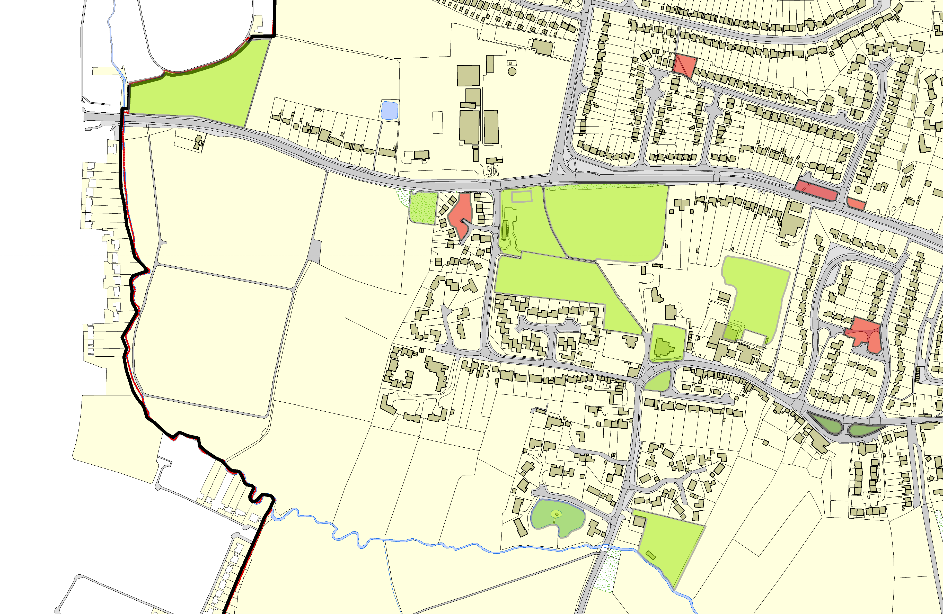Not recommended for LGS Designation Recommended for LGS designation Wildlife Sites
Open Space, Sport and Recreation Sites
OS MM Boundary
DESCTERM
!!!!!!!!!!!!!!!!!!!! County

District Electoral Parish
©Crown Copyright. All rights reserved. Harborough District Council 100023843 2014

Lakeside Court - Thurnby and Bushby

Scout and Guide HQ - Playing Fields, Thurnnby

LGS/THUR/1- Green in front of Rose and Crown 2 LGS/THUR/1 - Green in front of Rose and Crown 1

