Legend

Tilton on the Hill OSSR sites, LGS sites and Wildlife Sites Note the LGS sites are proposals only at Sept 2015

Not recommended for LGS Designation Recommended for LGS designation Wildlife Sites
Open Space, Sport and Recreation Sites
OS MM Boundary
DESCTERM
!!!!!!!!!!!!!!!!!!!! County

District Electoral Parish

Tilton Grassland, Tilton on the Hill; Area 1 Tilton Grassland, Tilton on the Hill; Area 2

Hammer's Lodge Farm, Cold Newton

Tilton Old School The Mound, Digby Close, Tilton

The Hills Meadow, Cold Newton
Tilton Play Area
Tilton St Peters Church Tilton Tennis Courts

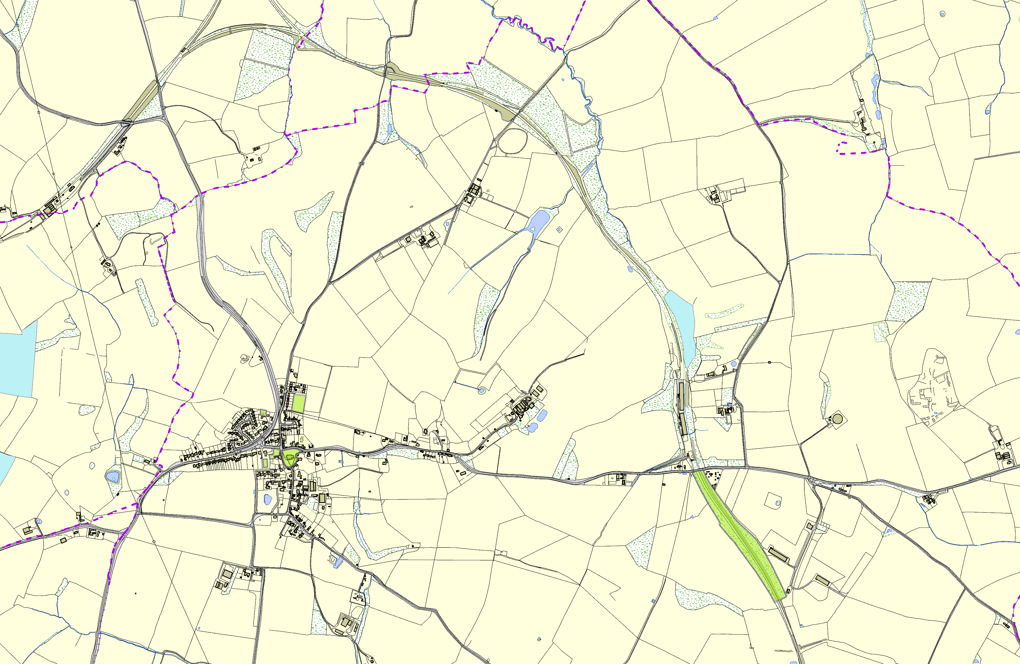

Tilton Railway Cutting

©Crown Copyright. All rights reserved. Harborough District Council 100023843 2014

