The Mound, Digby Close, Tilton

Tilton on the Hill OSSR sites, LGS sites and Wildlife Sites Note the LGS sites are proposals only at Sept 2015

Tilton Play Area
Tilton St Peters Church Tilton Tennis Courts

Tilton Railway Cutting

Brook Farm Meadow

Rectangle Wood, Tilton on the Hill

Ancient Woodland, Tilton on the Hill

Ancient Woodland, Tilton on the Hill

Legend

Not recommended for LGS Designation Rec mmended for LGS designation Wildlife Sites
Open Space, Sport and Recreation Sites
OS MM Boundary
DESCTERM
!!!!!!!!!!!!!!!!!!!! County
Skeffington Gravel Pit

Leighfield Forest

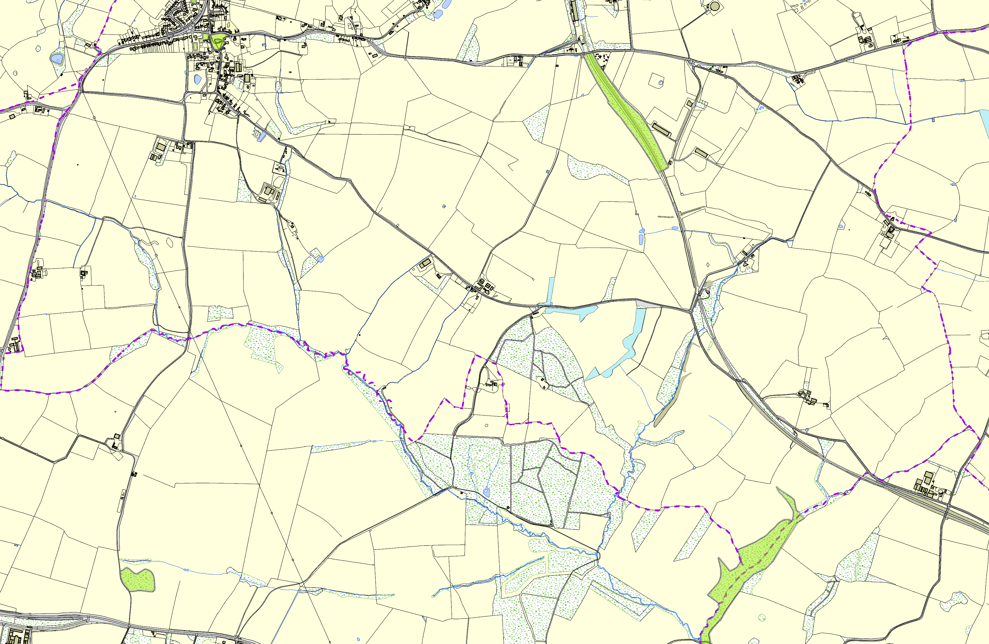District
Electoral Parish
©Crown Copyright. All rights reserved. Harborough District Council 100023843 2014

