Legend

Tugby and Keythorpe OSSR sites, LGS sites and Wildlife Sites Note the LGS sites are proposals only at Sept 2015

Not recommended for LGS Designation Recommended for LGS designation Wildlife Sites
Open Space, Sport and Recreation Sites
OS MM Boundary
DESCTERM
!!!!!!!!!!!!!!!!!!!! County

District Electoral Parish

Leighfield Forest

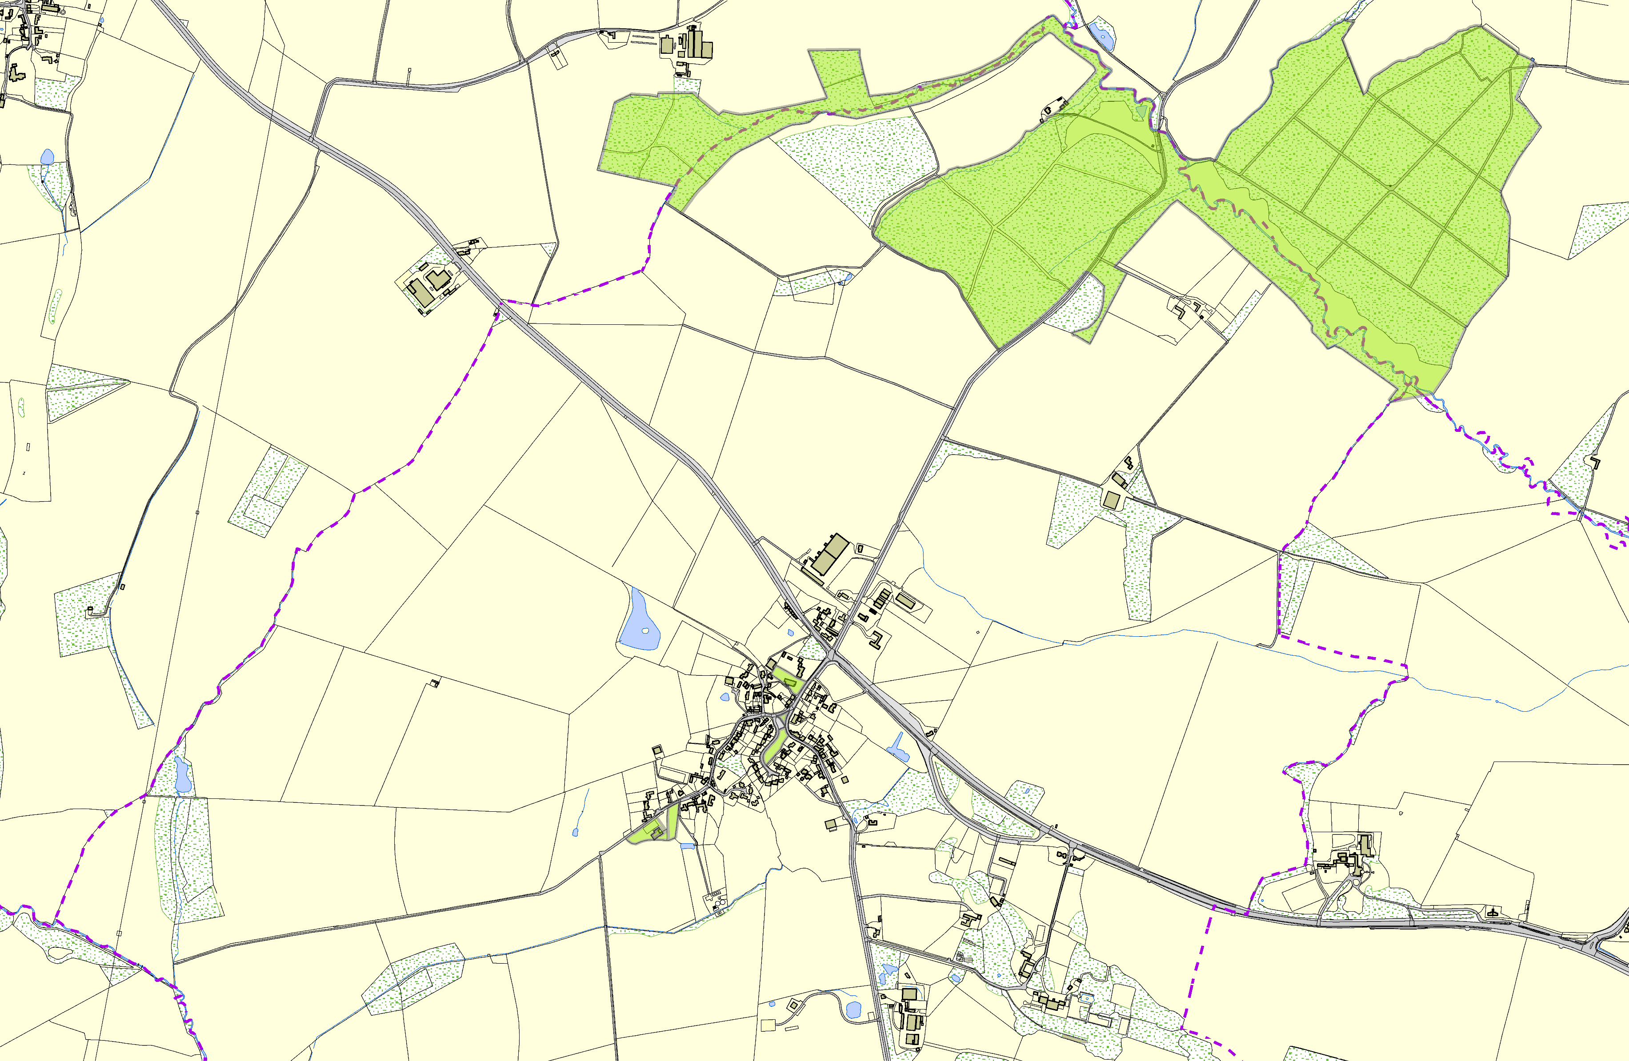

Thomas Beckett Church - Tugby & Keythorpe

Tugby & Keythorpe Village Green

Wellfield Green - Tugby & Keythorpe

Tugby & Keythorpe Allotments The Tugby Centre - Main Street

©Crown Copyright. All rights reserved. Harborough District Council 100023843 2014

