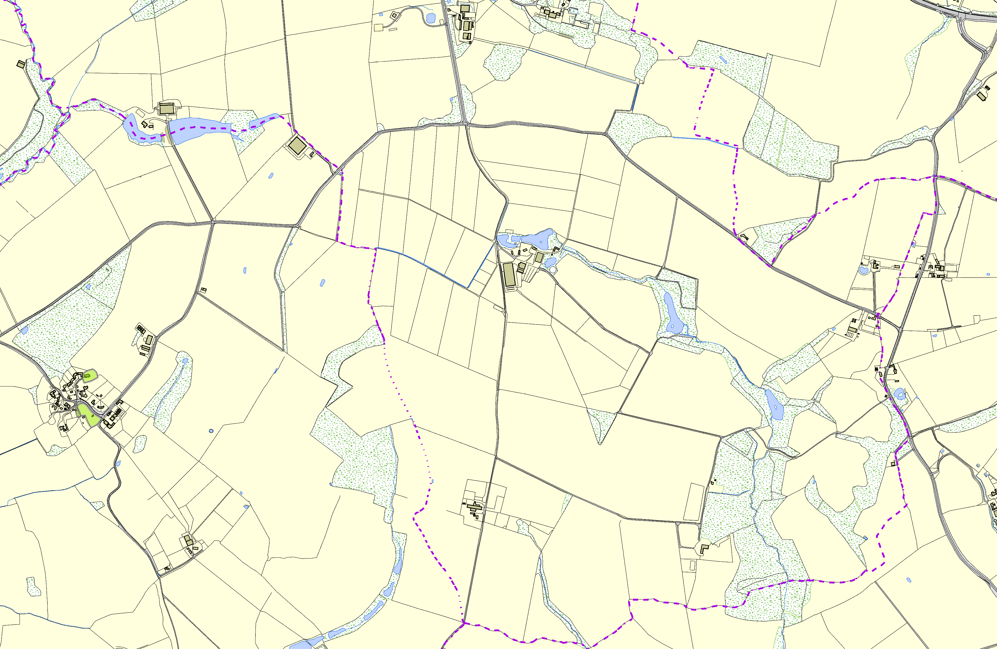Tugby and Keythorpe OSSR sites, LGS sites and Wildlife Sites Note the LGS sites are proposals only at Sept 2015

St John the Baptist C of E - Goadby
Legend
Village Green - Goadby
NotPraeddcoockm- Gmoadebny ded for LGS Designation Recommended for LGS designation Wildlife Sites
Open Space, Sport and Recreation Sites

OS MM Boundary
DESCTERM
!!!!!!!!!!!!!!!!!!!! County
District Electoral Parish
©Crown Copyright. All rights reserved. Harborough District Council 100023843 2014

