Legend

Tur Langton OSSR sites, LGS sites and Wildlife Sites Note the LGS sites are proposals only at Sept 2015

Not recommended for LGS Designation Recommended for LGS designation Wildlife Sites
Open Space, Sport and Recreation Sites
OS MM Boundary
DESCTERM
!!!!!!!!!!!!!!!!!!!! County

District Electoral Parish

Land Adjacent the Brambles - Tur Langton Land Opposite Rose Cottage

Stonton Wyville Churchyard

Land Adjacent Crox Barn Land Adjacent the Yews - Tur langton

Land infront of Village Hall - Tur LangtonLand adjacent the Crown - Tur Langtom
LGS/TURL/1 - Bulls Head Field Tur Langton

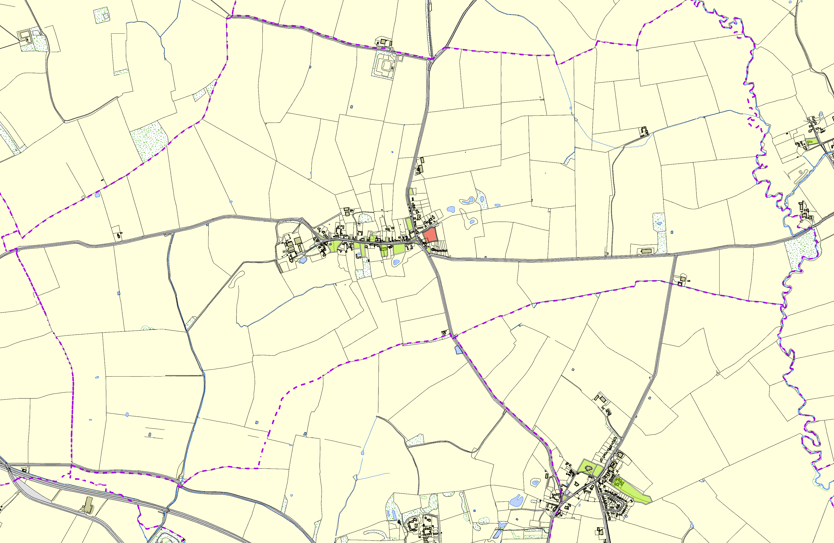Land Adjacent Greystones Land Adjacent the ElmsLand Adjacent Wadlands Cottage - Tur Langton Remains of Medieval ChurchSt Andrews Cemetery/Churchyard - Tur Langton

St Peters Church - East Langton Allotments in East Langton

Hanbury Playing Field - East Langton Village Green Church Langton - East Langton

©Crown Copyright. All rights reserved. Harborough District Council 100023843 2014

