Ullesthorpe OSSR sites, LGS sites and Wildlife Sites Note the LGS sites are proposals only at Sept 2015

Cemetery - Claybrooke Parva
Ullesthorpe Playing Field

Ullesthorpe Amenity Green Space 1Ullesthorpe -School Field
Ullesthorpe Allotments Ullesthorpe Amenity Green Space 2

Baldwins Spinney - Ullesthorpe

Old Manor Reedbed, Ullesthorpe

Legend

Not recommended for LGS Designation Recommended for LGS designation Wildlife Sites
Open Space, Sport and Recreation Sites
OS MM Boundary
DESCTERM
!!!!!!!!!!!!!!!!!!!! County

District Electoral Parish

LGS/BIT/1 - The Lake Bittesby

LGS/LUT

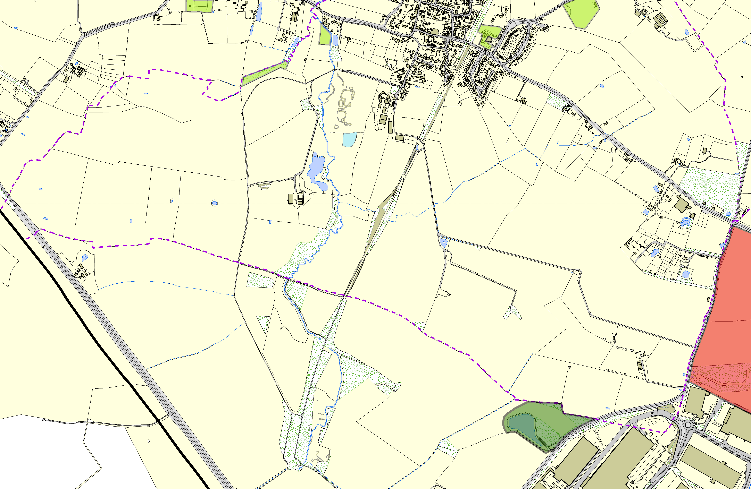
©Crown Copyright. All rights reserved. Harborough District Council 100023843 2014

