Ullesthorpe OSSR sites, LGS sites and Wildlife Sites Note the LGS sites are proposals only at Sept 2015

Ullesthorpe Golf Course

Ullesthorpe Golf Course
Ullesthorpe Golf Course

Ullesthorpe Playing Field

Ullesthorpe -School Field

Ullesthorpe Allotments
Ullesthorpe Amenity Green Space 1 Ullesthorpe Amenity Green Space 2

Legend

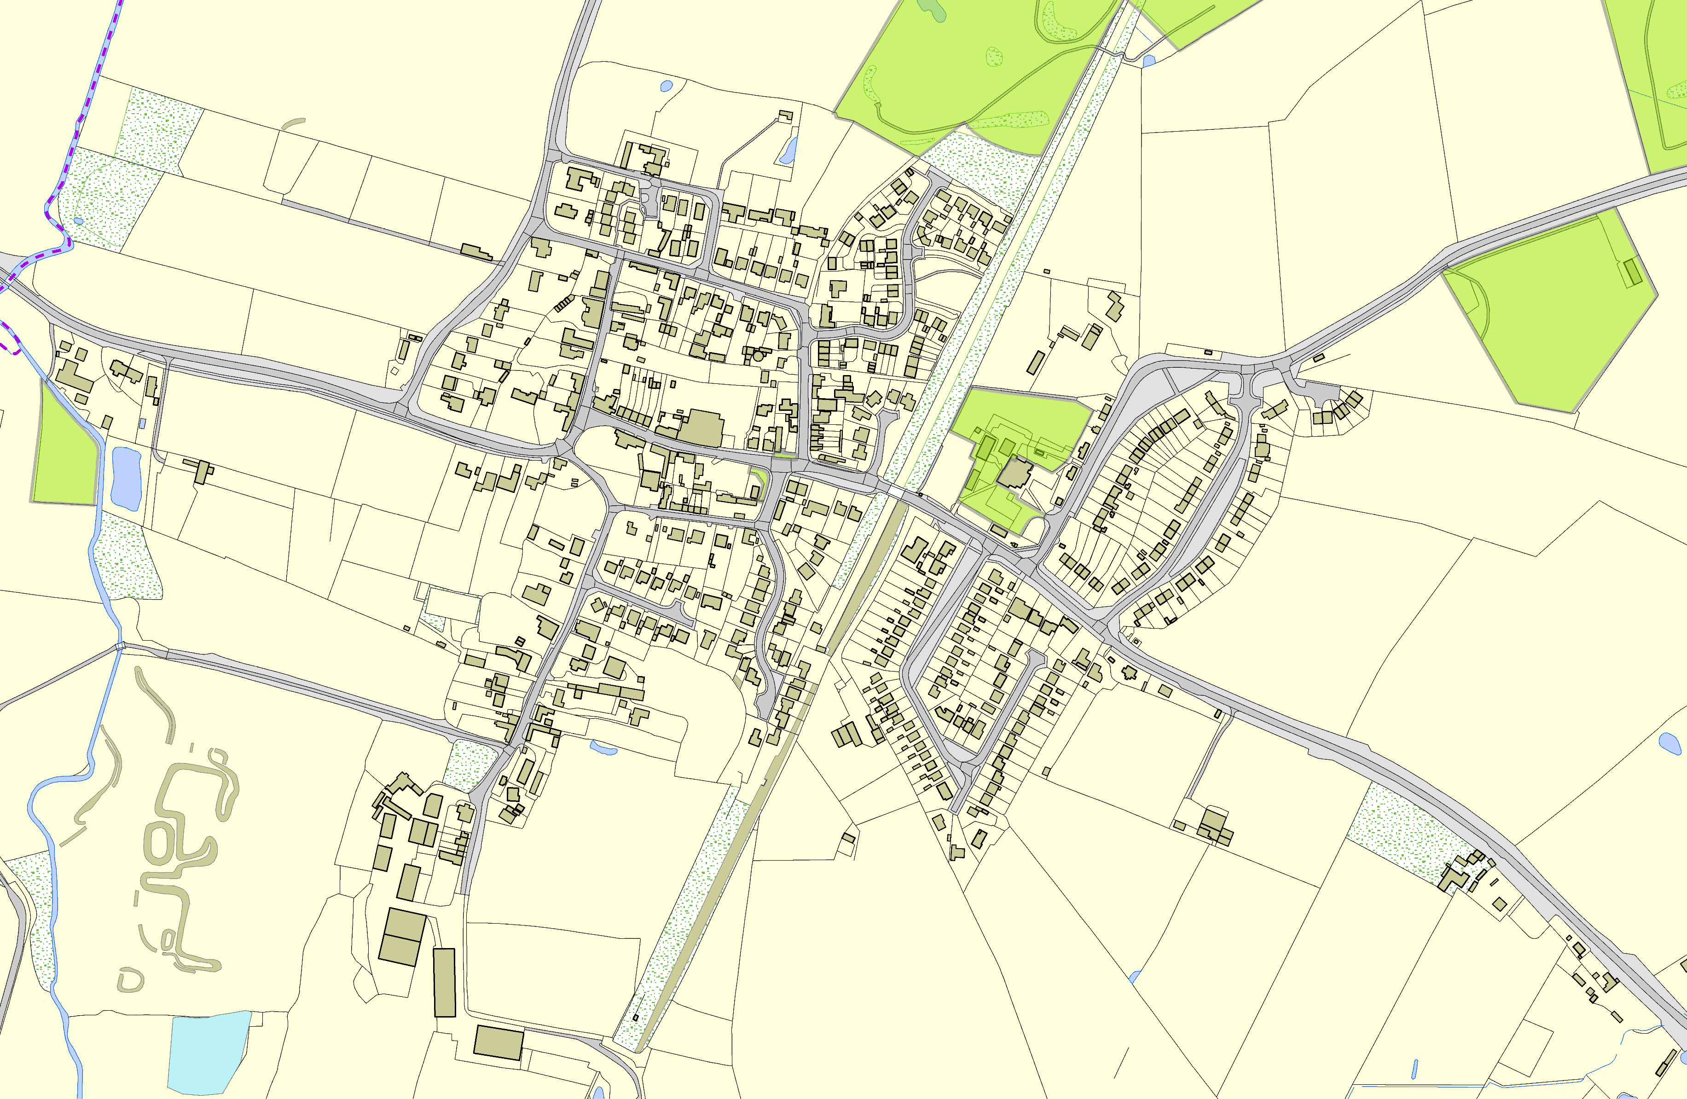

Old Manor Reedbed, Ullesthorpe

©Crown Copyright. All rights reserved. Harborough District Council 100023843 2014

Not recommended for LGS Designation Recommended for LGS designation Wildlife Sites
Open Space, Sport and Recreation Sites
OS MM Boundary
DESCTERM
!!!!!!!!!!!!!!!!!!!! County

District Electoral Parish

