Ullesthorpe OSSR sites, LGS sites and Wildlife Sites Note the LGS sites are proposals only at Sept 2015

Ullesthorpe Marsh, Ullesthorpe; Area 2 Ullesthorpe Marsh, Ullesthorpe; Area 3

Frolesworth Road Hedgerows - Pond

Ullesthorpe Railway

Ullesthorpe Marsh, Ullesthorpe; Area 1 Ullesthorpe Marsh, Ullesthorpe; Area 4

LGS/CLAPA/2 - Park Field Ullesthorpe Road

Claybrooke Parva Village Green
LGS/CLAPA/3 - Church Field Claybrooke Parva LCGhSu/rCchLyAaPrAd /-4C-lAaynbgrloooSkaexPoanrvMaanor Claybrooke Parva

Cemetery - Claybrooke Parva

Ullesthorpe Allotments

Ullesthorpe Amenity Green Space 1

Ullesthorpe -School Field
Ullesthorpe Golf Course

Ullesthorpe Playing Field

Legend

Not recommended for LGS Designation Recommended for LGS designation Wildlife Sites
Open Space, Sport and Recreation Sites
OS MM Boundary
DESCTERM
!!!!!!!!!!!!!!!!!!!! County

Baldwins Spinney - Ullesthorpe
Ullesthorpe Amenity Green Space 2

District
Electoral Parish

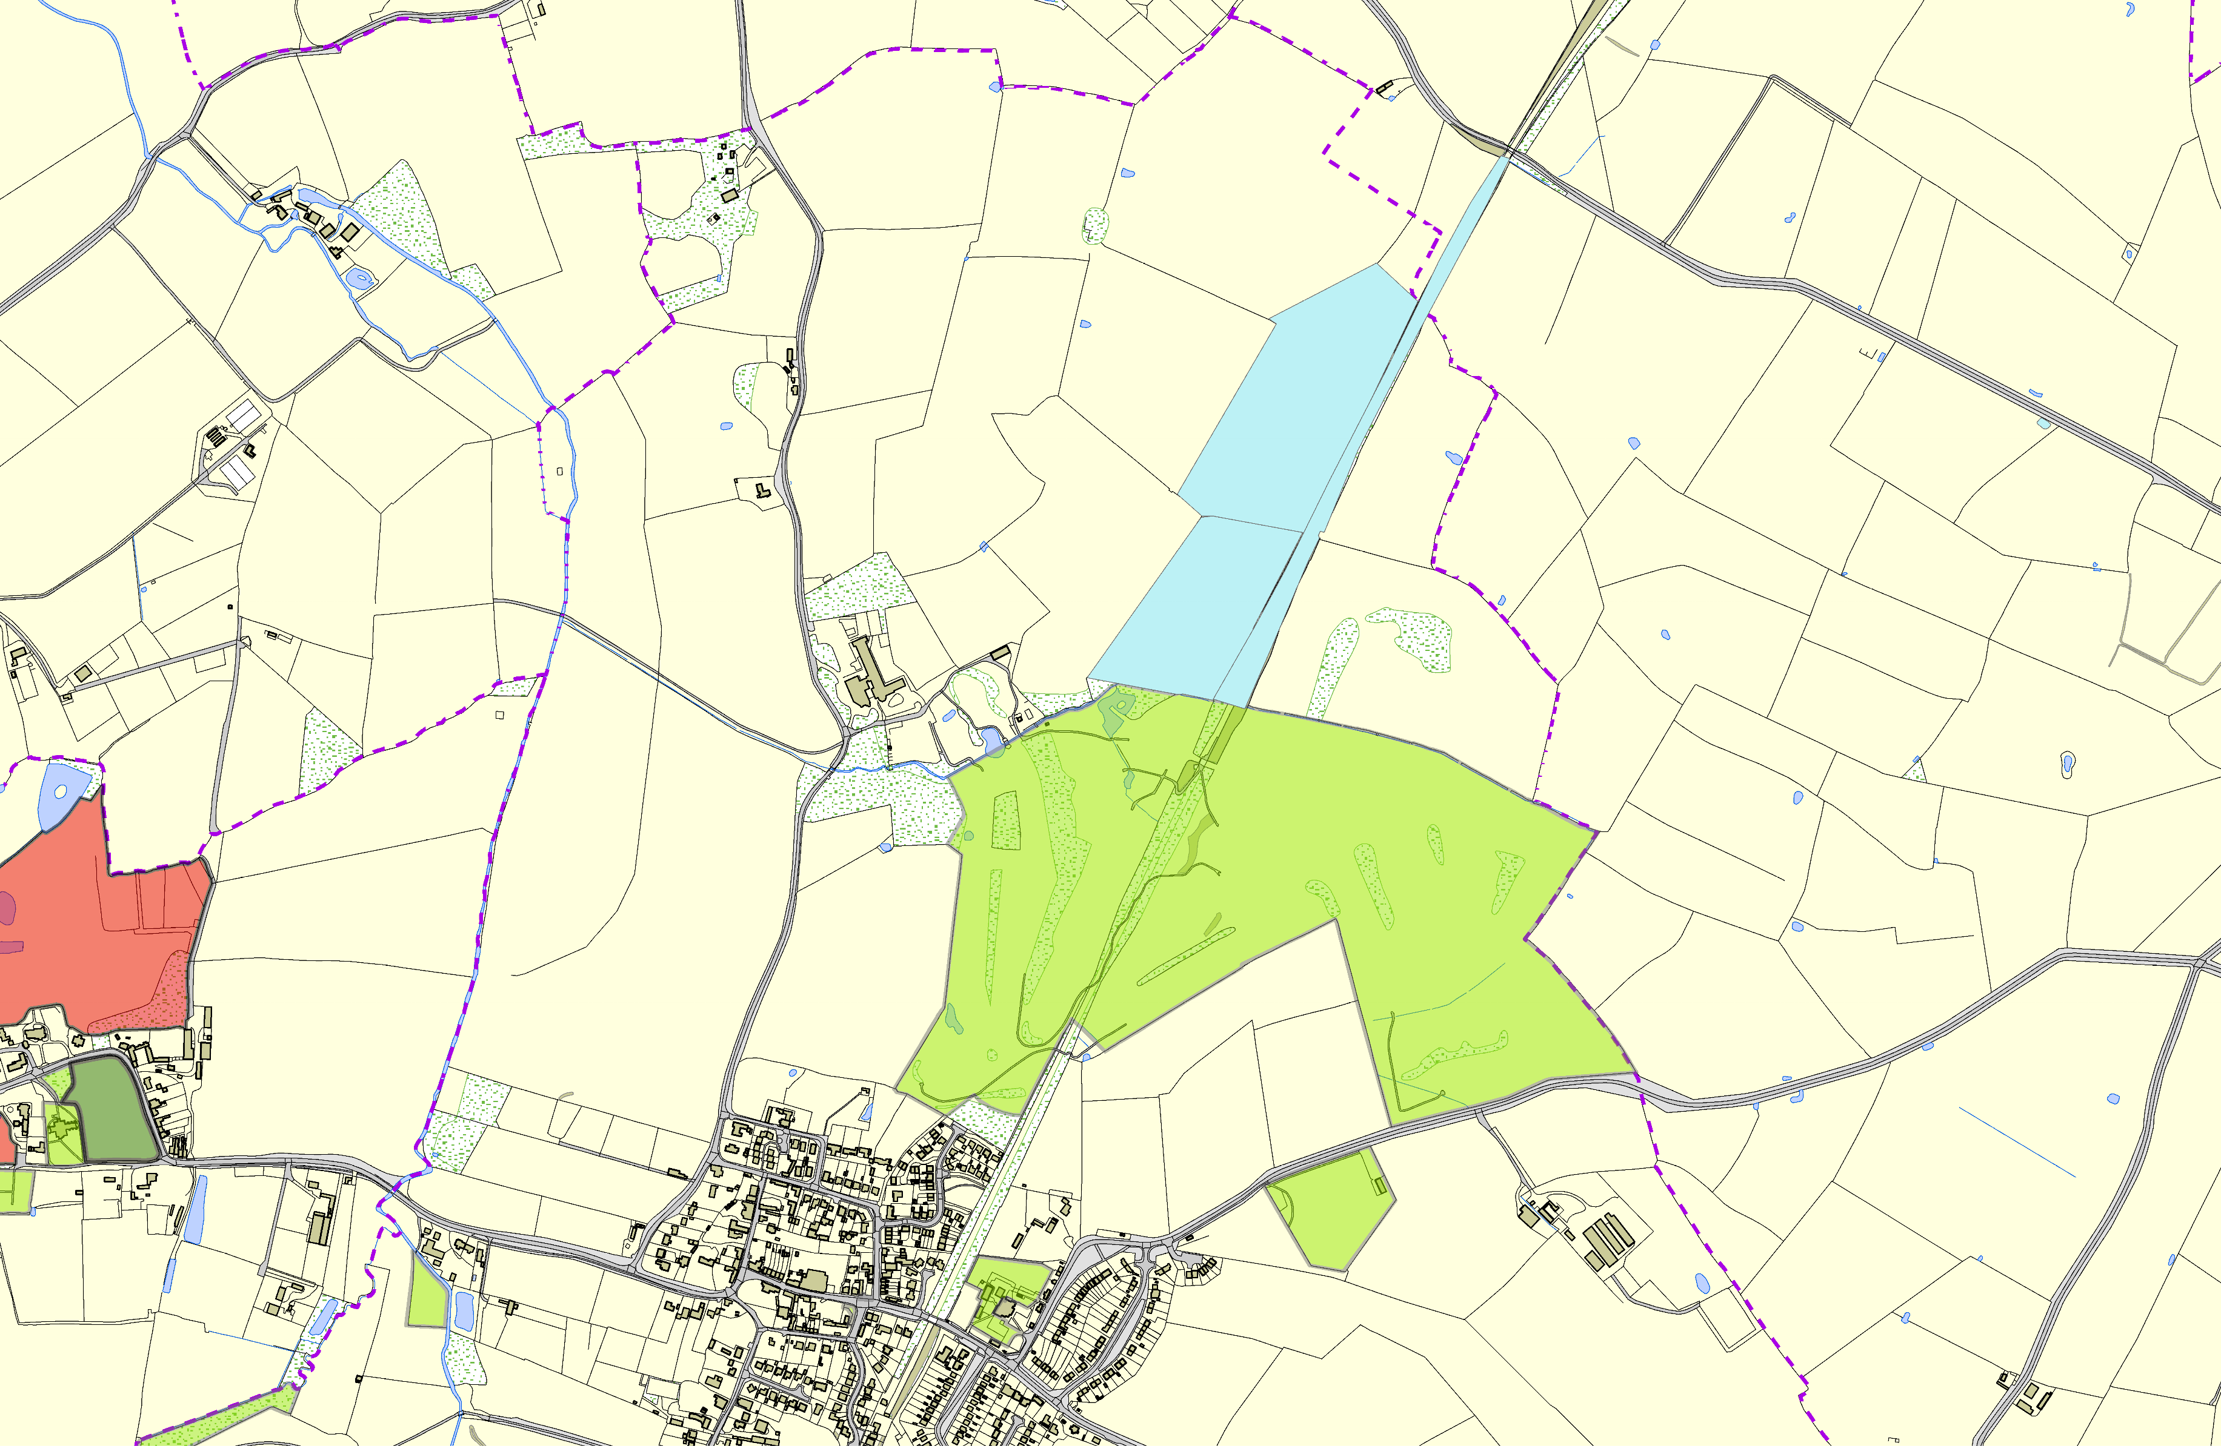©Crown Copyright. All rights reserved. Harborough District Council 100023843 2014

