Welham OSSR sites, LGS sites and Wildlife Sites Note the LGS sites are proposals only at Sept 2015

Legend

Not recommended for LGS Designation
Recommended for LGS designation
Main Street Village Green - Slawston
Wildlife Sites
Open Space, Sport and Recreation Sites

OS MM Boundary
DESCTERM
!!!!!!!!!!!!!!!!!!!! County
District Electoral Parish

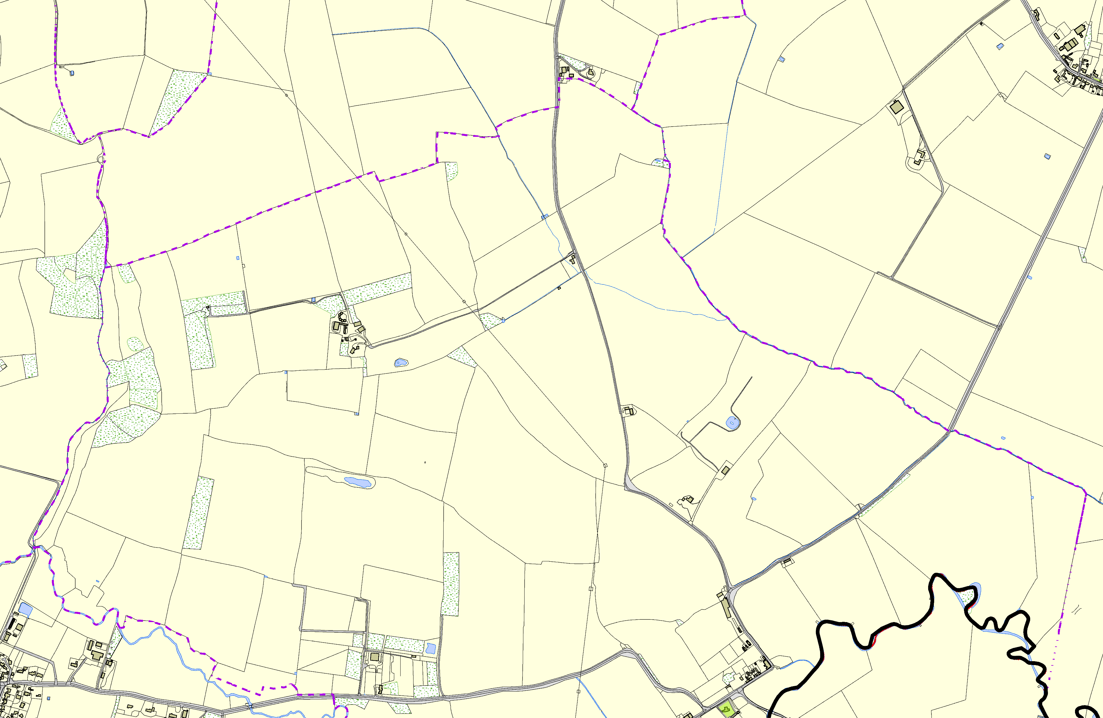
©Crown Copyright. All rights reserved. Harborough District Council 100023843 2014
St Andrew Church - Welham

