Welham OSSR sites, LGS sites and Wildlife Sites Note the LGS sites are proposals only at Sept 2015

St Andrew Church - Welham

Legend

Ballast Hole, Fishing Lake, Bowden Lane - Welham
Not recommended for LGS Designation Recommended for LGS designation Wildlife Sites
Open Space, Sport and Recreation Sites

OS MM Boundary
DESCTERM
!!!!!!!!!!!!!!!!!!!! County
District Electoral Parish

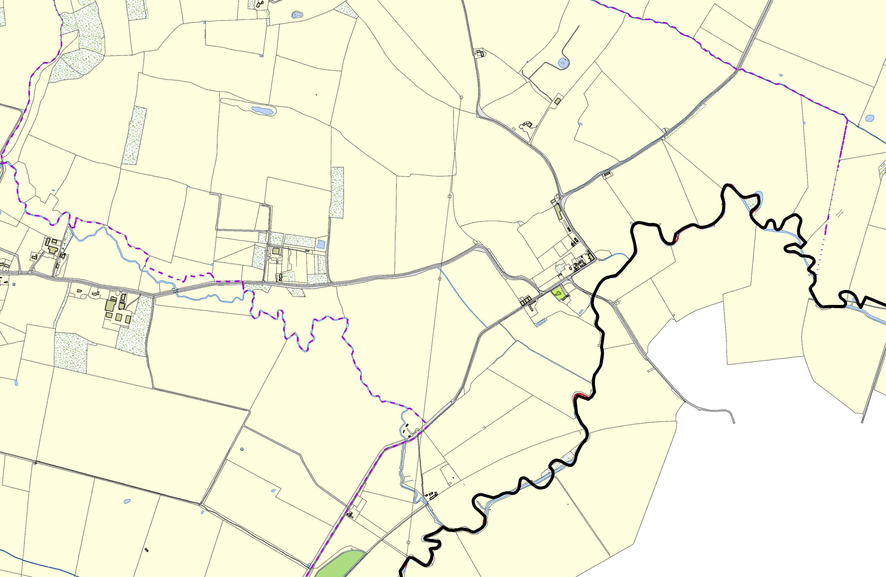©Crown Copyright. All rights reserved. Harborough District Council 100023843 2014

