Legend

Wistow OSSR sites, LGS sites and Wildlife Sites Note the LGS sites are proposals only at Sept 2015

Not recommended for LGS Designation Recommended for LGS designation Wildlife Sites
Open Space, Sport and Recreation Sites

OS MM Boundary
DESCTERM
!!!!!!!!!!!!!!!!!!!! County
District Electoral Parish

LGS/GR

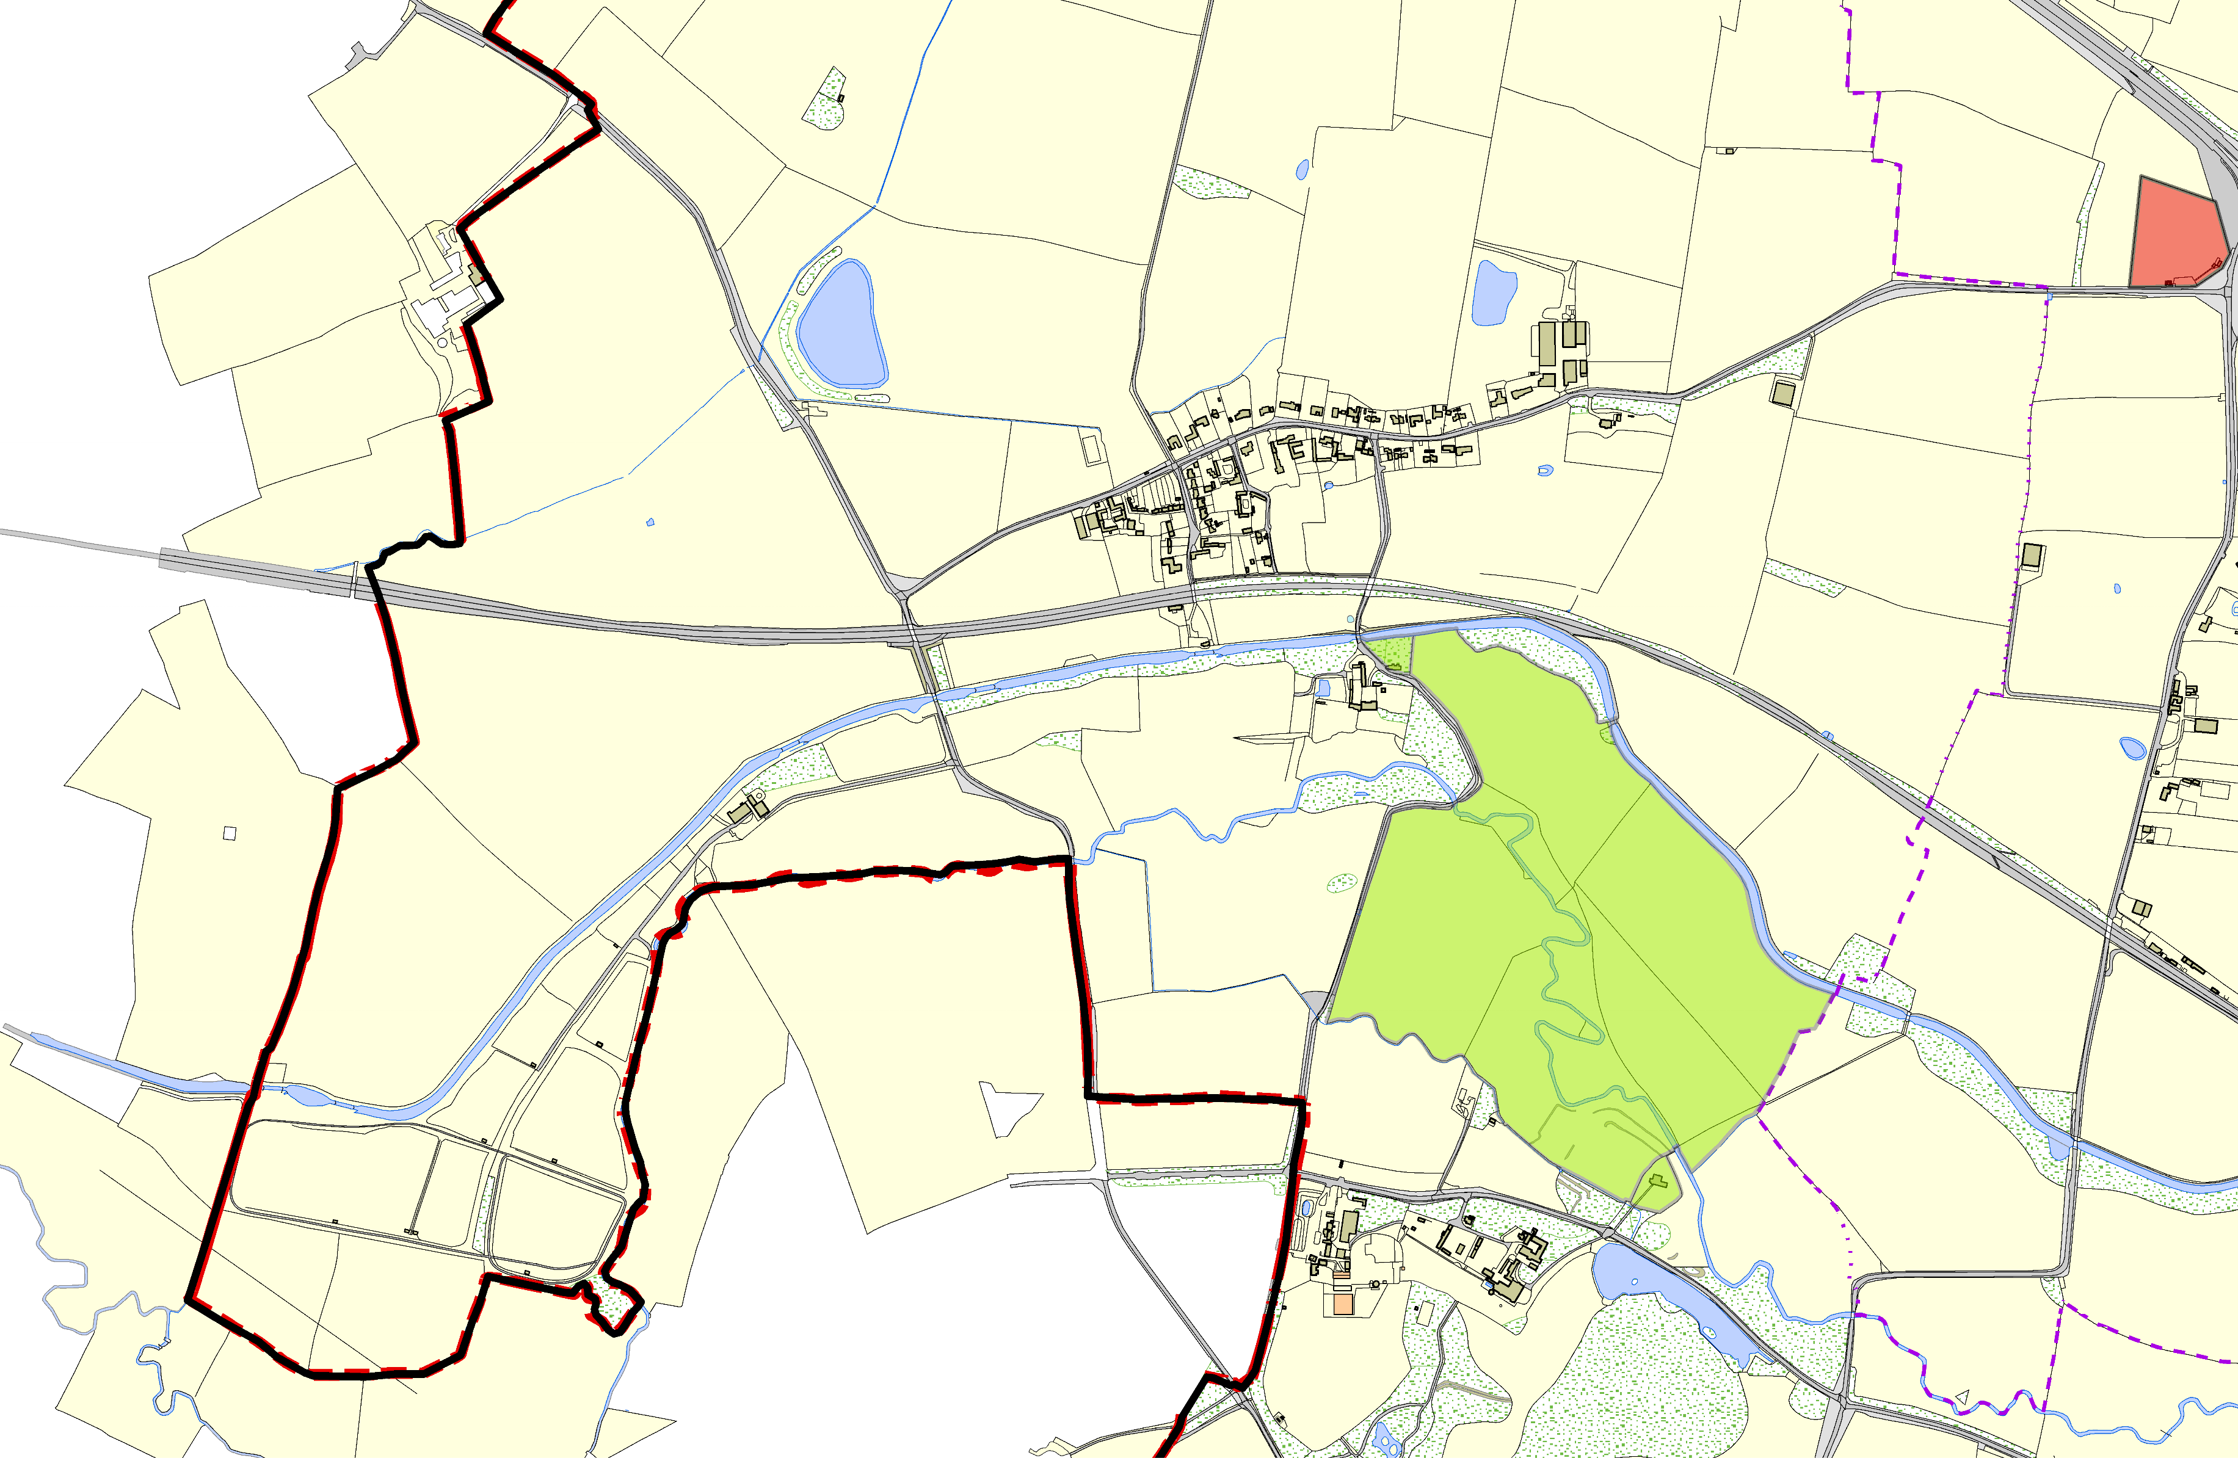Mature Oak, Newton Harcourt canal

Newton Harcourt Church St Lukes - Wistow

Wistow Estate Countryside Stewardship

Wistow Church - St Wistans

©Crown Copyright. All rights reserved. Harborough District Council 100023843 2014

