Laughton OSSR sites, LGS sites and Wildlife Sites Note the LGS sites are proposals only at Sept 2015
St Luke Church - Laughton

LGS/LAUGH/1 - Village Hall Green/ Paddock Laughton Village Green
Laughton Village Green

Spring Grassland, Gumley
Laughton and Mowsley Cricket Club Ground

Marshy Meadow, Gumley

Pond in sloping grassland, Laughton Sloping grassland, Laughton
Model Aero Club

Sweet Chestnut Coppice
Paddle Wood

Legend

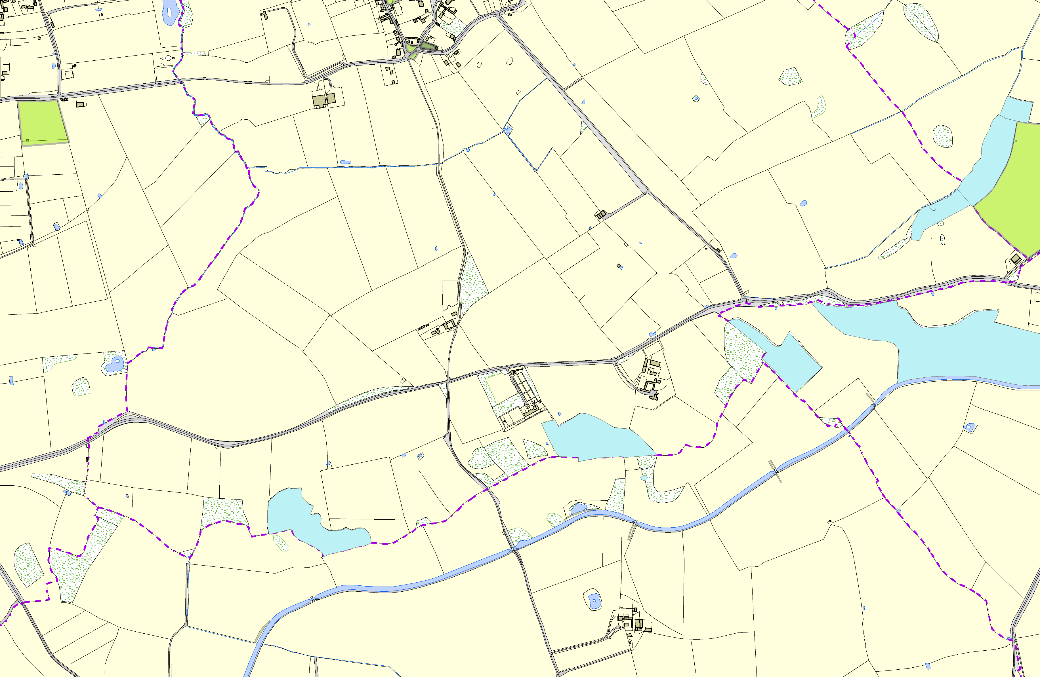

Kicklewell Spinney

©Crown Copyright. All rights reserved. Harborough District Council 100023843 2014

Laughton Hills Wood

Owell Spinney's Ash

Not recommended for LGS Designation Recommended for LGS designation Wildlife Sites
Open Space, Sport and Recreation Sites
OS MM Boundary
DESCTERM
!!!!!!!!!!!!!!!!!!!! County

District Electoral Parish

