Laughton OSSR sites, LGS sites and Wildlife Sites Note the LGS sites are proposals only at Sept 2015

Saddington Reservoir

Cricket Pitch in Gumley

Legend

Not recommended for LGS Designation Recommended for LGS designation
Wildlife Sites

y Field Play Area - Mowsley
Foll

Open Space, Sport and Recreation Sites
OStSNichMolasMPrimaBry SochuoolnPladyinag Frieylds - Mowsley
DESCTERM
!!!!!!!!!!!!!!!!!!!! County
Saint Nicholas Churchyard - (closed) - Mowsley
sl arisDh BisurtiarliGcrtound
Mow
ey P

Electoral Parish
Laughton and Mowsley Cricket Club Ground

St Luke Church - Laughton

LGS/LAUGH/1 - Village Hall Green/ Paddock Laughton Village Green
Laughton Village Green

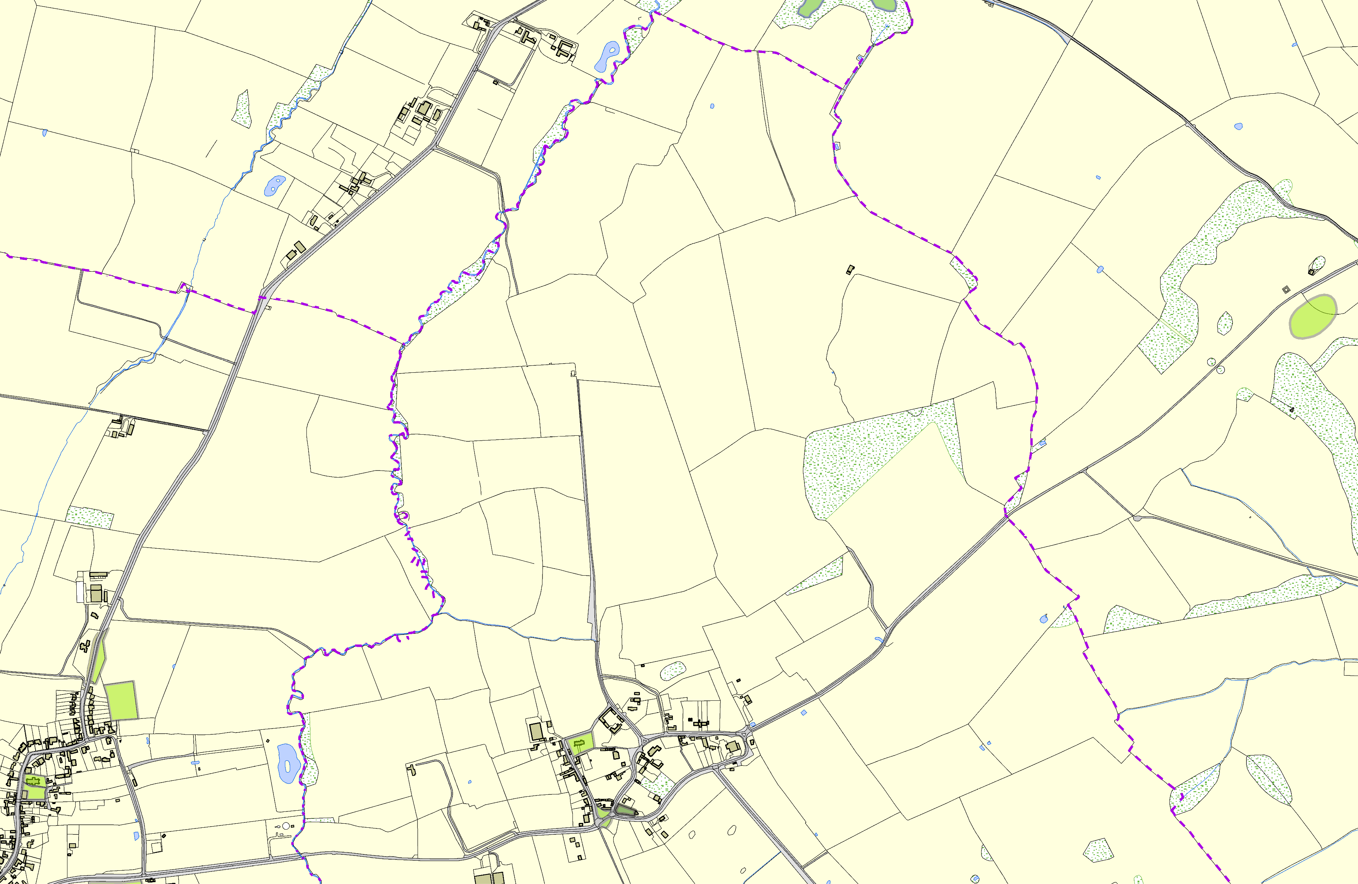©Crown Copyright. All rights reserved. Harborough District Council 100023843 2014

