Laughton OSSR sites, LGS sites and Wildlife Sites Note the LGS sites are proposals only at Sept 2015

St Luke Church - Laughton

Legend

Not recommended for LGS Designation Recommended for LGS designation Wildlife Sites
Open Space, Sport and Recreation Sites

OS MM Boundary
DESCTERM
!!!!!!!!!!!!!!!!!!!! County
District Electoral Parish
LGS/LAUGH/1 - Village Hall Green/ Paddock Laughton Village Green

Laughton Village Green

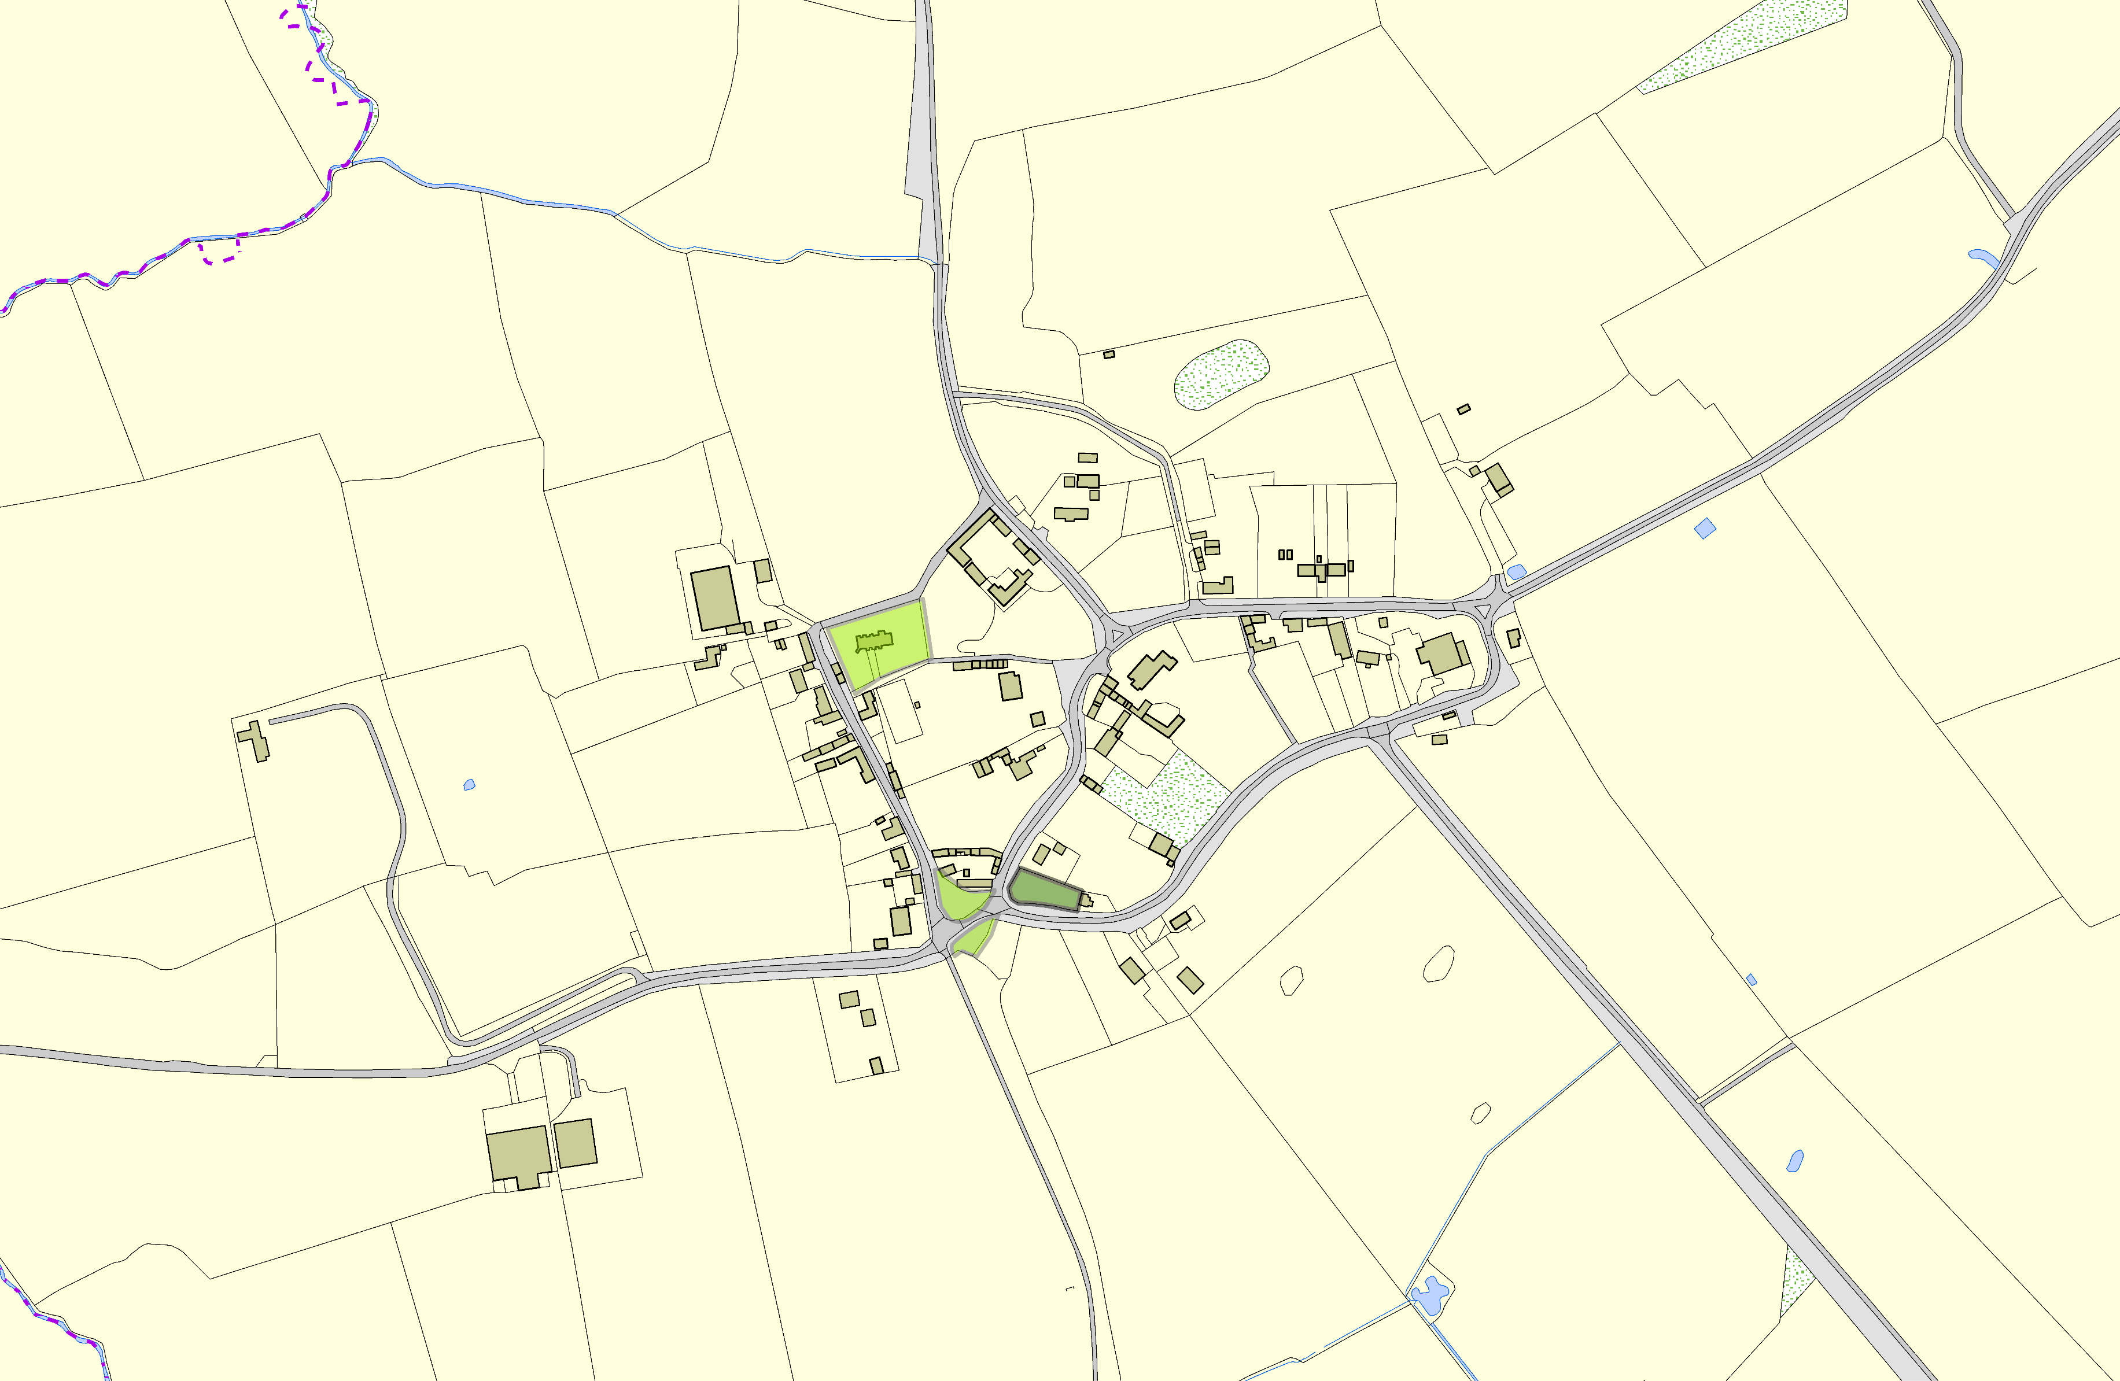©Crown Copyright. All rights reserved. Harborough District Council 100023843 2014

