DECLARATION OF RESULT OF POLL FOR THE FOXTON NEIGHBOURHOOD PLAN AREA REFERENDUM

I, Richard Ellis, being the Counting Officer for Harborough District Council at the Referendum held on 27th January 2017 under the Neighbourhood Planning (Referendums) Regulations 2012, do hereby give notice that the result of votes cast is as follows:

Description |  | Votes
Total number of votes cast |  | 122
Number cast in favour of a "YES" |  | 98
Number cast in favour of a "NO" |  | 24
The number of Ballot Papers rejected was as follows | (a) Want of Official Mark
The number of Ballot Papers rejected was as follows | (b) Voting more times than the voter was entitled to
The number of Ballot Papers rejected was as follows | (c) Writing or mark by which the voter could be identified
The number of Ballot Papers rejected was as follows | (d) Being unmarked or wholly void for uncertainty
The number of Ballot Papers rejected was as follows | (e) Rejected in part
The number of Ballot Papers rejected was as follows | Total number of Spoilt Votes
Turnout– 35% - Electorate 348
I do hereby declare that more than half of those voting have voted in favour of the Foxton Neighbourhood Plan.

Signed

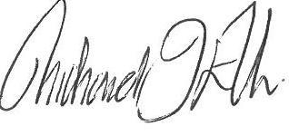

Richard Ellis
Counting Officer
The Symington Building, Adam & Eve Street
Market Harborough

