
Harborough District Community Safety Partnership

Three Year Partnership Plan 2017-2020

Introduction

This document outlines the high level priorities that the Harborough District Community Safety Partnership (CSP) will tackle for the 2017/20 period.

The Plan explains what the CSP is and why partnership working is essential in making Harborough District a safe place for everyone. The document explains progress so far in tackling crime and disorder and how we have involved the community in our work and in setting the new priorities.

These priorities will be reviewed on a yearly basis.

What is the Community Safety Partnership?
The CSP was set up under Sections 5-7 of the Crime & Disorder Act 1998 and is made up of statutory services who need to work together to protect our local communities from crime and to help people feel safer. Harborough Community Safety Partnership is made up of representatives from five partner agencies.
- Harborough District Council
- Leicestershire Constabulary
- Leicestershire County Council – includes Leicestershire Youth Offending Service
- Leicestershire Fire & Rescue Service
- Turning Point – Substance misuse recovery service
They work out how to deal with local issues like antisocial behavior, protecting victims and reducing reoffending. They annually assess local crime priorities and consult partners and the local community about how to deal with them.

Partnership Strategic Assessment

The Partnership Strategic assessment is a statutory document produced annually to inform Community Safety Partnerships about crime, disorder and community safety issues in their area.

The aim of the Strategic assessment is to provide Harborough Community Safety Partnership with a comprehensive analysis of crime, disorder and community safety issues to enable the partnership to review, modify or change their priorities.

Key Findings of Strategic Assessment

- Overall crime figures are up with main increases in Harborough Town and Harborough North beats, however numbers are relatively low and this only relates to approximately 1 extra crime a day across the district.

- Largest increases are in acquisitive crime with Burglary up, Theft from motors up and Shop theft up. However theft of vehicles is down.

- There appears to have been a significant increase in violence against the person and domestic violence in 2016/17. Clarity is being sought on exact figures as there are conflicting figures from different agencies. We will therefore continue to focus on raising awareness of referral services and support for victims of abuse.

- Anti-social behaviour figures dropped by a significant 12% between 2014/15 and 2015/16. Figures are predicting a 20% increase this year, however if you take into account the change in recording systems and a now more accurate count, it is likely that the percentage rise would have been less had last years figures been more accurate.

- There are very low levels of deliberate fires in the Harborough district and it has been agreed to recommend this is removed as a priority for HCSP.

- Drug offences have reduced year on year and there is predicted a reduction of 26% by end of this year.
During 2016 Turning Point took over from Swanswell as our treatment providers for Leicestershire and at this time we do not have comparison figures on drugs and alcohol use.

- At end September 2016 Hate incidents and Crimes were up 56% year on year, although numbers are still relatively low.

- There has been a reduction in youth offending year on year and this is also reflected in anti-social behaviour cases which are now predominately adult perpetrators.

- Local Parish survey rated Road Safety, Acquisitive Crime and ASB as their top three priorities.

3 year comparison figures
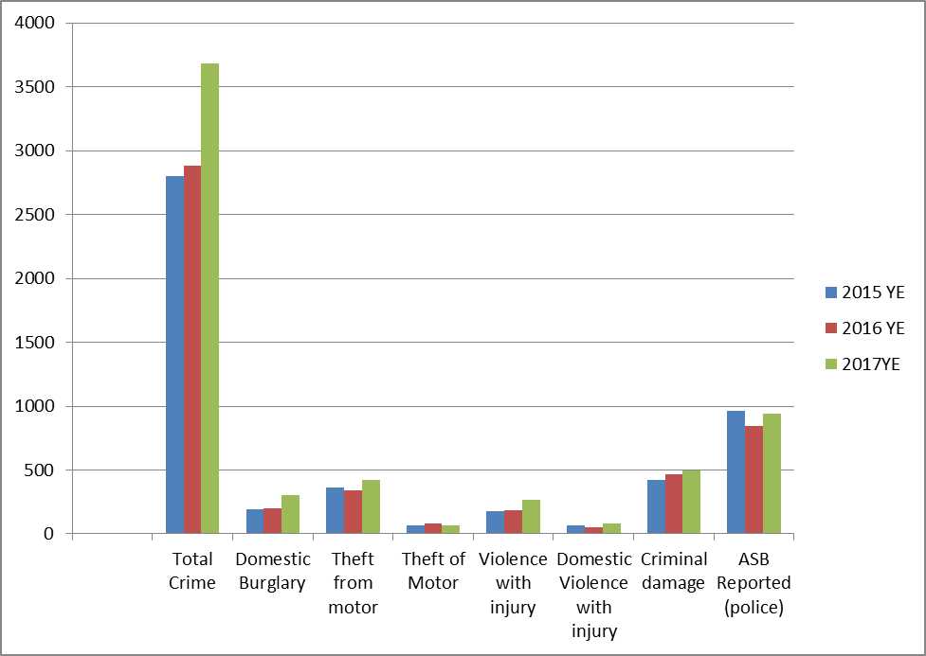

Community Consultation

Parish Council Survey

A questionnaire was sent to all Parish Councils asking for their top three priorities for Community Safety for the next year and asking what their specific issues were at this time. The same question was asked of all Councillors.

13 responses were received, 12 Parishes and 1 Councillor.
All had Road Safety in their top 3 with Speeding through villages, mobile phone use and dangerous parking. 7 felt this was their top priority.

Acquisitive crime was the next most popular priority with 4 parishes marking it as their top issue, in particular burglary dwelling and rural thefts from farms.

ASB was top concern for one parish and 7 others also had it in their top 3. This included general ASB on a housing estate, young people congregating causing noise, underage drinking and damage, hare coursing and fly-tipping was also mentioned.

Finally one parish chose Identifying and supporting vulnerable individuals and families.

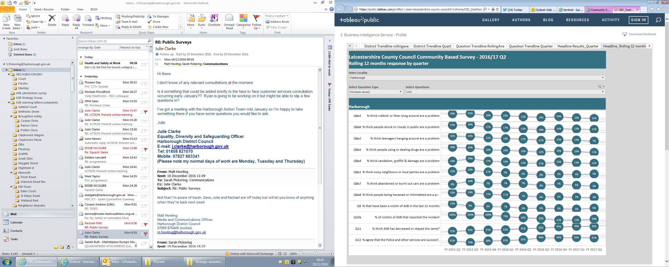
Leicestershire County Council Community Based Survey

100% of those questioned in Harborough felt safe in their local area during the day and 94% felt safe in the area after dark.

From the LCC Community based survey the areas of most concern to the community appear to be rubbish/litter, although the percentage concerned has decreased considerably since Qtr 3 2015 from 41% to 15%.

Of equal concern (around 11/12%) was drunk/ rowdy behaviour, using or dealing drugs and criminal damage.

Partner Consultation

The Police and Crime Commissioner is now responsible for the majority of Government and local spending on Community Safety in Leicestershire. Like other public services this funding is being reduced and it is likely that there will be significantly less funding available for CSPs.

To ensure resources are targeted the PCC has developed a Police and Crime Plan where work with district CSPs will be focussed on the following areas:

Visibility:
Through ease of access to Community Safety services and of reporting crime and ASB.

Victims:
Victims of crime and ASB to have access to appropriate support services

Vulnerability:
Focussing on Sexual Violence, Domestic Abuse (including coercion), Hate Crime, Child abuse (including CSE), Mental Health and Learning Disabilities, Human Trafficking, Modern Day Slavery and Missing from Home individuals (including those at risk of self-harm).

Priorities for 2017-2020;

Aims and Objectives 17-18
The following priorities build on previous work, link to trends set out in the Strategic Assessment and address current community concerns. The priorities also link to the Police and Crime Plan ensuring as joined up an approach to tackling crime and disorder as possible.

- To reduce acquisitive crime
  - Work to reduce domestic burglary within the district
  - Work to reduce theft from motor vehicles
  - Work to reduce retail crime
  - Continue to support ‘Rural Communities’ working to reduce ‘Rural Crime’

- To tackle anti-social behaviour
- Continue to raise awareness and understanding of ASB
- Work to reduce incidents of ASB

- Raise awareness of, and enforcement of the FATAL Four
Work to reduce incidents of:
- Speeding,
- Mobile phone use,
- No Seatbelt
- Drink and drug driving

- To identify and support vulnerable individuals and families
  - Promote the referral services and support available for domestic abuse victims
  - Increase the reporting of Hate Incidents
  - Raise awareness of Child Sexual exploitation
  - Increase awareness of PREVENT
  - Raise awareness of Financial Fraud

- Raise awareness of Cybercrime
- Online Fraud
- Online Child Sexual exploitation
- Cyber bullying
- Online radicalisation

Cross cutting priorities
- To prevent and raise awareness of the effects of substance misuse
- To reduce reoffending

How will we achieve these priorities?

We have developed an Action Plan for 2017/18 which sets out how we will deliver on our priorities and linked to our current resources. This will be reviewed annually to take account of resources and any emerging threats during the three year plan period.

Progress and development will be monitored through Community Safety Partnership Strategy Group meetings chaired by the lead Harborough District Councillor for Community Safety.

Some examples of work contained in the action plan are;
- Funding for admission to Warning Zone for 10/11 year olds to encourage safety and responsibility in children.
- Diversionary Activities targeted at young people in asb hotspot areas such as Street games.
- Use of re-deployable CCTV camera to deter and detect crime and asb in hotspot areas.
- Funding local target hardening to identify and support vulnerable victims and those at risk of burglary.
- To deliver Fatal 4 clinics at key locations targeting Drinking and Driving, Speeding, Non use of Seatbelts and Mobile Phones.
- Funding a new KIDVA service for Harborough District to support children of victims of Domestic Abuse.
- Continued use of police speed gun in village locations

How did we do last year?

For more information contact:
Community Safety Team
Harborough District Council
E: communitysafety@harborough.gov.uk

