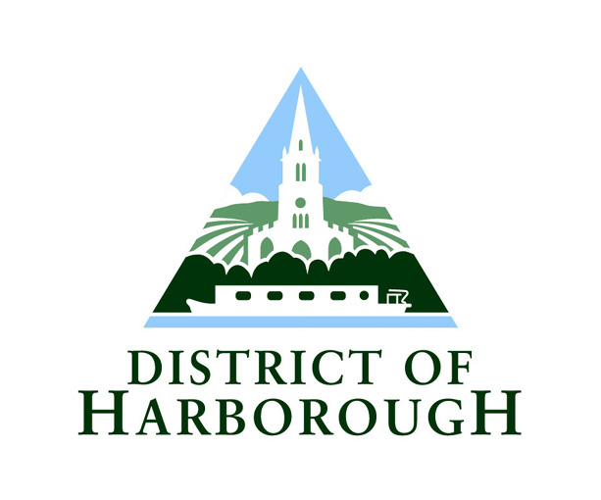

REVISION NOTES:
DUAL DRIVER & PRIVATE HIRE
DRIVER KNOWLEDGE TEST

INTRODUCTION

As you have recently applied for a Dual driver or Private Hire driver’s licence you will be required to sit a knowledge test.

This leaflet is a revision guide for new applicants and each part of the test is described in full. It is advisable that you take time to read the information so you know exactly what to expect.

The test consists of 3 parts and will take 1 hour and 20 minutes, but to allow for administration tasks you should allow 1¾ to 2 hours for the whole test. The fee for the initial knowledge test is included in the application fee.

Should you fail the test then arrangements can be made to retake the parts failed for which there is a charge of £22 per part. You can sit the test up to 3 times in a 12 month period.

If you require any assistance with the test you can contact the Licensing Team in confidence and arrangements can be made to cater for any individual needs.

We usually hold test sessions monthly, normally in the first week of the month. Resits are arranged as required. If you have any questions, or would like to book yourself onto a test session, please contact the Licensing Team on 01858 828282 or by email to licensing@harborough.gov.uk.

PART 1

Part 1 is based on the Conditions and Byelaws booklets which have been enclosed as part of your application pack.

This knowledge is being tested as it is important that, as a licensed driver in the Harborough District, you are aware of the legislation that affects you. The conditions lay out what you can, can’t, must and mustn’t do as a Dual driver or Private Hire driver.

It is advisable that you read all sections of the booklets thoroughly.

In this part there are 10 questions for Dual drivers and 7 questions for Private Hire drivers, which are based on all sections of the booklets and a previous table of fares. A copy of the fare sheet (only applicable to Dual driver applicants) is included in the test so you do not need to memorise this.

Please be aware that the questions require a mixture of multiple choice, yes/no, true/false and written answers.

You will have 20 minutes to complete this part of the test and the pass mark for this part is 75% i.e. 8/10 for Dual drivers and 6/7 for Private Hire drivers.

PART 2

This part is aimed to test your sense of direction inside and outside of the District. Being licensed as a Dual driver and Private Hire driver means that you need to have a good knowledge of the area as you will not always have the opportunity to plan your route or use sat nav.

Please be aware that there are no prescribed routes/set answers for Part 2. If the route chosen is appropriate then the answer will be marked as correct. Please note that your directions must take us to the final destination; there are no marks for getting partway there. You can use the road names, road numbers, landmarks etc to direct us.

You will have 40 minutes to complete this part of the test and the pass mark for this section is 75% i.e. 8/10.

Below is a list of areas you should revise:

Market Harborough based drivers Lutterworth/Broughton Astley
based drivers

Market Harborough Lutterworth
Hallaton Bitteswell
Saddington Ullesthorpe
Foxton Gilmorton
Lutterworth Broughton Astley
Corby Catthorpe
Kettering Hinckley
Northampton Rugby
Leicester Leicester
Airports in the Midlands Airports in the Midlands

It is important to familiarise yourself with these areas in depth not just how to get to them. You should look at places such as medical centres/hospitals, supermarkets, schools, hotels, pubs, shopping centres, tourist attractions, sports clubs/grounds/centres, cinemas, theatres and nearest motorway junctions/train stations.

Questions 1 to 3

For this section of the test you will need to describe the route you would take a fare from a main road in Market Harborough/Lutterworth to a destination with Market Harborough/Lutterworth.

Questions 4 to 6

For these questions you will need to describe the route you would take a fare from the taxi rank in Market Harborough/Lutterworth to 3 different destinations within Harborough district.

Questions 7 to 10

For these questions you will need to describe the route you would take a fare from the taxi rank in Market Harborough/Lutterworth to 3 different destinations outside Harborough district.

PART 3

This part of the test is based on the Highway Code and the legal requirements of all road users.

For this part of the test it is advisable that you read the Highway Code and/or any theory test revision books.

All drivers have a responsibility to follow the Highway Code and due to the long hours licensed drivers may work it is felt necessary that, as such, drivers should have a good knowledge of the code.

There are 20 multiple choice questions in total. Please note that some questions require more than one answer which is clearly indicated on the paper.

You will have 20 minutes to complete this part of the test and the pass mark is 75% i.e.15/20.

