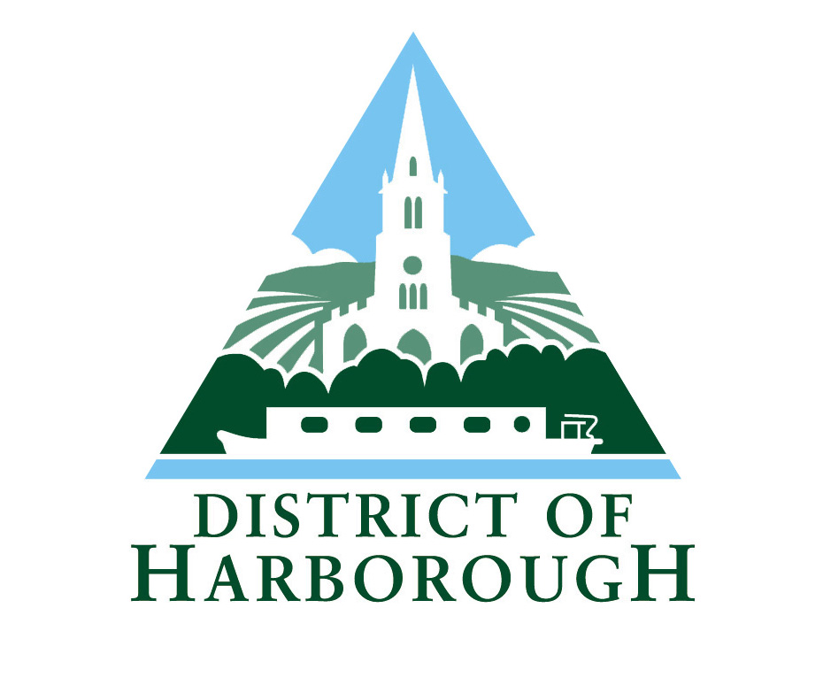

Vehicle Licence Surrender/Transfer Form

The Council is collecting your information in order to assist the delivery and provision of services to you. The information you have supplied will be used for processing your Surrender/Transfer form and updating our database. Your information may be shared with other Council departments or partners. Your information will be held in accordance with the Council’s Document Retention and Disposal Policy and we will only ask you for as much information as is required to respond to your enquiry or service need.

For further information on how your information is used, how we maintain the security of your information , and your rights to access information we hold about you, please contact: Harborough District Council, The Symington Building, Adam & Eve St, Market Harborough LE16 7AG or FOI@harborough.gov.uk or complaints@harborough.gov.uk

To: Harborough District Council Licensing Section

This is to inform you that on ………………… I transferred/surrendered (delete as applicable)

my vehicle which is a ……………………………………..

registration number ……………………….

vehicle licence number Hackney/Private Hire vehicle number …………
____________

Vehicle licence plates surrendered: Yes No

The surrender of vehicle plates is free of charge

Current vehicle licence holder’s details:

Name (Print) ………………………………………………

Signed …………………………………………………….

Date ……………………..

If vehicle has been transferred, please provide details of new owner:

Name ……………………………………………………

Address ………………………………………………...

……………………………………………………………

Post Code ………………………………………………

Telephone Number ……………………………………

Harborough District Council (Print) ………………………………………………

Signed ………………………………….. Date ………………………………

