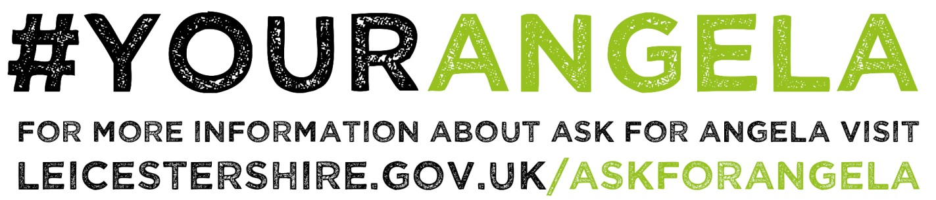

Guidance for Bars and their Staff who are participating within the scheme
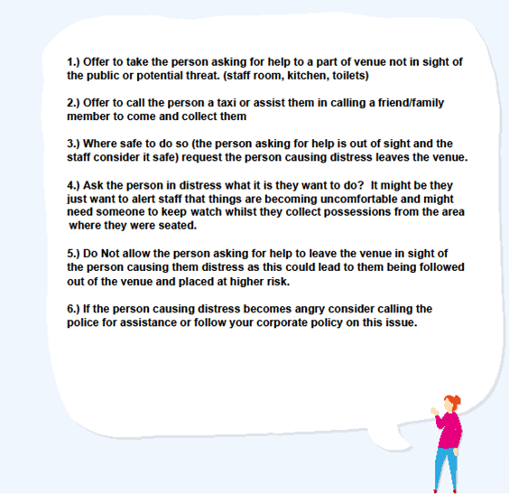

Venue Name:
If someone comes to the bar asking for 'Angela' or asking for help this is the process you are to follow:

- Offer to take the person asking for help to the:
(Staff room, kitchen, staff toilet etc.)

- Offer to call the person a taxi or to give them a safe space to make the call themselves.

- Once the person is safe:
(Consider asking the person who caused distress to leave etc.)

