  Food Hygiene Rating Scheme:  Request for a re-visit | 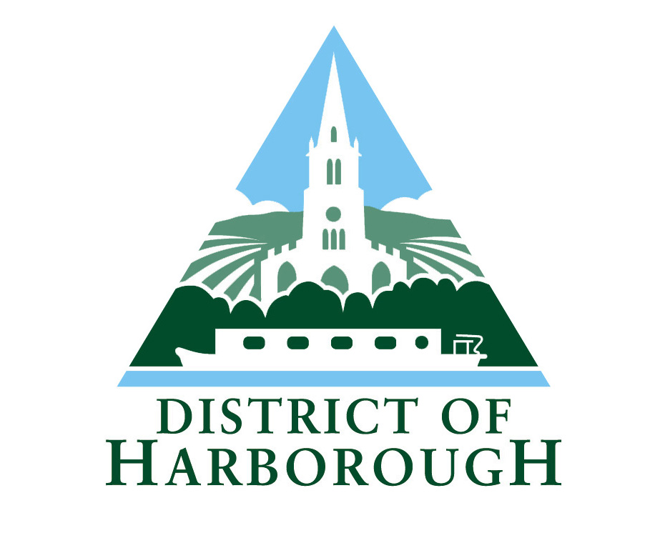 | 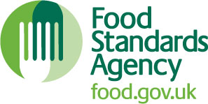

Notes for businesses:

- As the food business operator of the establishment you have a right to request a re-visit for the purposes of re-rating if you have taken action to rectify the non-compliances identified at the time of inspection.
- You can usually make one request for a re-visit per each planned statutory inspection by the local authority and you can make this at any time after the statutory inspection provided that you have made the required improvements.
- You must provide details of the improvements made with your request, including supporting evidence where appropriate.
- There is a fee of £156 for each revisit request and payment is required before the revisit can be undertaken. Either send a cheque payable to Harborough District Council or make a telephone payment using your credit or debit card, telephone 01858 828282.
- If the local authority considers that you have provided sufficient evidence that the required improvements have been made, the local authority will make an unannounced visit. The re-visit will be carried out within 3 months of receipt of your application and payment.
- The local authority officer will give you a ‘new’ food hygiene rating based on the level of compliance that is found at the time of the re-visit - you should be aware that your rating could go up, down or remain the same.
- To make a request for a revisit, please complete the form below and return it to the address at the bottom of the page, with your payment.

Business details
Food business operator/proprietor

Business name

Business addresses

Business tel. number |  | Business email

Inspection details
Date of inspection |  |  |  |  | Food hygiene rating given

Action taken
Please describe the remedial action you have taken with reference to the issues identified in the inspection letter/report provided to you by your local authority with your score:
Compliance with food hygiene and safety procedures

Compliance with structural requirements

Confidence in management/control procedures

Please provide any other supplementary evidence (e.g. photographs, invoices, copies of relevant HACCP documentation etc.).

Signature
Name in capitals

Position |  | Date

Please now return this form to:
Harborough District Council; Regulatory Services, Symington Building, Adam and Eve Street, Market Harborough, LE16 7AG or Email: foodandsafety@harborough.gov.uk

