The Community Grant Fund Small Grant Application Form

Harborough District Council
Apply for a small grant to support community projects and events celebrating the HRH Platinum Jubilee (up to £250 per group)

Constituted Groups only.
We can accept more than one group application from Towns and larger villages

CONTACT DETAILS
Name of Organisation
Main Contact Name
Telephone
Email
Second Contact Name
Telephone
Email
Charity number (if relevant)
Address of the project/event (must be within the district of Harborough).
Are you a constituted group?

Please describe your project or event and how it supports the Queens Platinum Jubilee?
Please include a breakdown of costs
Total you would like to apply for (up to £250) | £

DECLARATION
- I am authorised to make the application on behalf of the above organisation.
- I confirm that our organisation has the necessary governance in place to ensure audited accountability and value for money for the spend of any money allocated through the HDC grant process.
- Our organisation has an up-to-date Safeguarding Policy I can submit upon request.
- I certify that the information in this application is correct.
- All money granted must be used for items listed in application only. If the information in the application changes in any way, I will inform HDC.
- I understand that the information given in this form (except for bank statements) may be made available to members of the public and/or other organisations.
- If successful, I will submit photographic evidence to HDC to enable them to use for publicity regarding the project.
- I agree to participate in monitoring, auditing, and reporting feedback related to HDC grant funding when accepting the grant.
- If successful, I agree to abide by the terms and conditions of the grants awarded above.

*If you are sending this form by email, you do not need to include a signature. We will keep a copy of the email as confirmation of your agreement.

 | Signatory One | Signatory Two
Signed
Name in Block Capitals

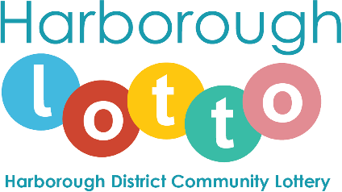

Please complete BACs details below:

Harborough District Council preference is to make payment by BACS as the most efficient way to pay suppliers.
This is a request to authorise Harborough District Council to pay your future invoices by BACS.

Bank account details to be completed in block capitals please.

Name(s) of account holder(s).

Branch sort code |  |  | - |  |  | -

Branch/Building Society
account number

Harborough District Council reference number (OFFICE USE ONLY)

Organisation name and address

Telephone contact details

Email address for emailing the remittance advice:

Signature

Name in block capitals
Position held in company.

Checklist:
- Please ensure you have assessed quote for value for money (this may be questioned if necessary).
- Please include your organisations constitution detailing administration and management.
- BACs details have been completed.

Funding will be allocated on a first come first serve basis (if it meets the criteria). If approved, payments will be made soon after receipt of application.
Please submit your application before 31st March 2022.

*Please note that we are unable to fund anything retrospectively.
Please submit your application form including quotes and supporting information to grants@harborough.gov.uk

