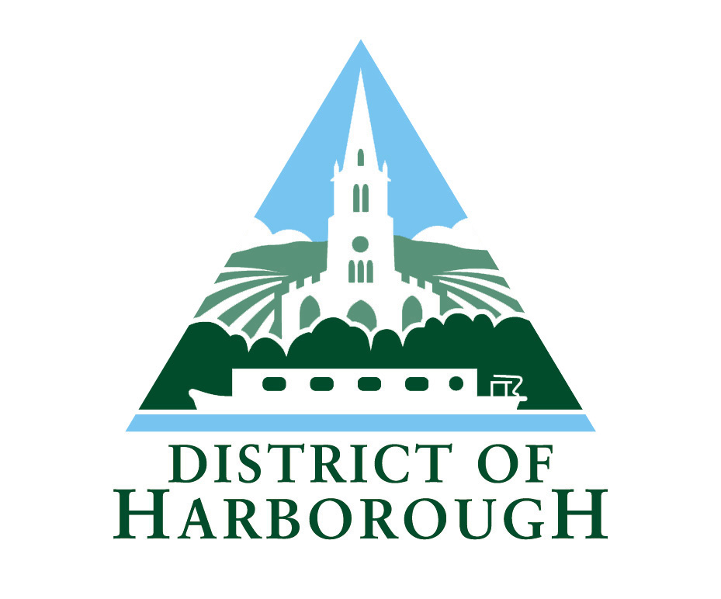

SERVICE PLAN

FOR
HEALTH AND SAFETY ENFORCEMENT 2023-24

1. Introduction

1.1 This Plan outlines how Regulatory Services intends to fulfil its statutory obligations to enforce health and safety legislation.

1.2 The Council’s responsibilities with regard to health and safety legislation are discharged by the Commercial Team within Regulatory Services.

The key points of this service plan are summarised below:

- Interventions have been targeted to high risk premises, or those where complaints have been received, where accidents have occurred, or where there is a history of poor performance.

- Activity has focussed on those topics that are the highest priority in Harborough district

1.3 An Equalities Impact Assessment (EIA) has been completed for the delivery of the health and safety enforcement service. This is available on the Councils website. No negative effects were identified.

2. Service Aims and Objectives

2.1 The Council is responsible for the enforcement of the Health and Safety at Work etc Act 1974 (HASWA) as described by the Health and Safety (Enforcing Authority) Regulations 1998. Section 18 of the Health and Safety at Work etc Act 1974 states that it is the duty of every local authority to perform in accordance with guidance from the Health and Safety Commission.

The Health and Safety Commission Guidance also requires that Local Authorities produce an intervention plan detailing the Local Authorities priorities and its aims and objectives for the enforcement of health and safety.

The overall aim of the service is to protect people’s health and safety by ensuring risks in the changing workplace is managed properly.

Our priority is to manage the risk in high risk, poor performing businesses, and to investigate major injury incidents and fatalities. We will undertake work that has been identified as a national priority, and we will reserve proactive inspections to high risk premises. We will use local intelligence to target poor performers in selected other sectors, using a full range of intervention strategies.

We will work in partnership when possible and support the work of the Leicester Leicestershire and Rutland health and Safety Best Practice Group, and we fully support the Better Business for all partnership.

2.2 Links to corporate aims and objectives

One of the Councils priorities as set out in the Corporate Plan 2022-2031 is to support businesses and residents to deliver a prosperous local economy. The Commercial Team provides advice, support and if necessary, enforcement action to ensure that businesses can thrive and grow whilst ensuring the safety of residents and visitors. All businesses provide employment for residents and there has been an increase in small, rural based businesses in the last two years which continues.

3. Background

  - Profile of Harborough District Council

The district covers approximately 230 square miles and had a population of approximately 97, 500 in 2021. The district is mainly rural with the major populations found in:

- Market Harborough (24, 171), Lutterworth (10,833) and Broughton Astley (9,647) which together make up a total of 47% of the district’s population. (Data from 2021 census)

- the rural centres of Billesdon, Great Glen, Houghton on the Hill, Husbands Bosworth, the Kibworths and Fleckney (22%)

- Leicester’s Principal Urban Area (PUA) encompassing Bushby, Thurnby and Scraptoft (6%).

- The remaining 25% of district residents are dispersed across some c.80 smaller rural villages.

Market Harborough, the largest settlement in the District lies on the southern boundary of the District adjacent to Northamptonshire. It has a key role in providing services, employment, public transport, and shopping and leisure facilities to the surrounding population. Lutterworth and Broughton Astley, are located in the west of the District.

Harborough District covers an area of 238 square miles of rural south and east Leicestershire. It lays within the East Midlands Region, bordering Warwickshire to the west, Northamptonshire to the south and Rutland to the east. Harborough borders 4 other Leicestershire district authorities, Charnwood, Melton, Oadby and Wigston and Blaby, and adjoins the east of Leicester City at Bushby, Scraptoft and Thurnby.

Its central location means that the District has good access to regional and national transport links. The M1 passes through the District in the west whilst the M6/A14 is located to the south. Other main routes in the District include the A6, A47 and A 508 which between them provide links to Leicester, Northampton, Kettering and Corby. Market Harborough is located on the East Midlands Trains route and has frequent links to London, Leicester and stations to the north. Both East Midlands Airport and Birmingham Airport are within 50 miles of Market Harborough.

3.2 Organisational Structure

The enforcement of health and safety is delivered by the Commercial Team within Regulatory Services. Decision making relating to enforcement action is delegated to the Regulatory Services Manager. The Council has 34 elected Councillors. The Council Cabinet is the main decision-making body within the council and is chaired by the leader of the council.

A simple hierarchical chart that details the reporting structure for the Commercial Team which delivers the health and safety service is shown below. Enforcement of food hygiene, infectious disease control and some health protection duties are also functions of that team.

Organisational Chart

Council
Regulatory Services Manager

Cabinet
Corporate Management Team
Scrutiny Panel

Commercial Team Leader (0.8 FTE)

Environmental Health Officers (FT) X2

4. Demands on the health and safety service

The Commercial Section is responsible for health and safety enforcement in Harborough District Council’s area and enforcement officers are authorised with powers under the Health and Safety at Work etc Act 1974.

The routine functions carried out by the service include:

i) Carrying out interventions of our high risk health and safety premises, pursuing the appropriate course of action, e.g. verbal advice, informal letters, improvement and prohibition notices and prosecution.

ii) Carrying out a planned programme of interventions focusing on specific areas of risk determined by the Health and Safety Executive and Local Authorities Enforcement Liaison Committee.

iii) Involvement in specific interventions which support the HSE’s priorities or focus on topics of local importance. See section 5.1.9

iv ) Investigation of workplace accidents and work related diseases in accordance with the councils policy, and the HSE Incident Selection Criteria Guidance.

v) Responding to requests for health and safety advice from businesses and the public

vi) Investigate complaints relating to poor health and safety conditions

There are currently around 1500 premises for which the Council has health and safety enforcement responsibility. The responsibility for the enforcement of the Health and Safety at Work Act etc. 1974 and relevant statutory provisions is governed by the Health and Safety (Enforcing Authority) Regulations 1998 that allocate enforcement to either the Health and Safety Executive or Local Authority according to the main work activity. Since 1974 local authorities have been responsible for enforcement of the health and safety laws in places such as shops, retail and wholesale warehouses, offices, catering, restaurants, bars, hotels, care homes (without nursing care), leisure and cultural services such as golf courses and horse-riding establishments together with consumer services such as undertakers and centres fitting tyres and exhausts.

The Health and Safety Executive is responsible for the remainder of activities e.g. factories, building sites, farms, vehicle repair workshops, railways, power stations, care homes providing nursing care, docks, fairgrounds, schools, colleges and Council run services.

In his report "Reclaiming health & safety for all: An independent review of health and safety legislation ", commissioned by the then Minister for Employment, Professor Ragnar Löfstedt recommended that HSE be given a stronger role in directing Local Authority (LA) health & safety inspection and enforcement activity.

4.1 Enforcement approach

In May 2013 HSE published the National Local Authority Enforcement Code. The Code is designed to ensure that LA health and safety regulators take a more consistent and proportionate approach to their regulatory interventions. It sets out the Government expectations of a risk based approach to targeting.

The current HSE strategy 2022-2032- Protecting people and places was published in May 2022. This sets out strategic objectives for the whole of the GB health and safety system. Local Authority workplace health and safety regulators are a key part of this system and are expected to play their role. The objectives are:

- Reduce work-related ill health, with a specific focus on mental health and stress
- Increase and maintain trust to ensure people feel safe where they live, where they work and in their environment.
- Enable industry to innovate safely to prevent major incidents, supporting the move towards net zero
- Maintain Great Britain’s record as one of the safest countries to work
- Developing services and products that contribute to improved management and control of risks, sharing our knowledge, and
- Continuing the dialogue and conversation with stakeholders to make the system better, always looking to provide simple, pragmatic advice and support.

HELA Circular LAC 67/2 (rev 12) provides a nationally consistent, framework for rating of all premises where local authorities regulate health and safety. The risk categories in the Circular do not determine inspection frequencies but will be used in conjunction with other intelligence such as reported incidents or complaints to decide whether a proactive inspection is justified.

We are committed to improving health and safety outcomes where there is greatest risk and will reserve proactive planned inspections for those premises that present a comparatively high risk. Alternative interventions such as self-assessment questionnaires and the provision of information/mail-shots will be used, as appropriate.

Harborough District Council’s Commercial team presently consists of the following posts:

Team Leader (80% FTE) (20% role involved in health and safety work)

2 x Environmental Health Officers (full time.) These officers spend around 20% of their time involved in health and safety work).

4.2 Access to Health and Safety Services

Staff and facilities are located at the Symington Building in Market Harborough.
All officers have mobile telephones with voicemail facility and personal e-mail addresses.

Inspections are carried out outside office hours as necessary.

The Commercial Team works remotely from the office. All officers are fully equipped to operate at remote locations and have access to all necessary IT programmes. This supports the council’s priority to reduce the amount of office space that it occupies.

The Council’s website has a range of information relating to health and safety matters.

4.3 Enforcement Policy

An Enforcement Policy is in place. This was adopted by the Council in 2016.

4.4 Regulators Code

The Regulators Code came into force in April 2014 and has been adopted by Harborough District Council.

5. Health and Safety Service Delivery 2022/2023

5.1 Programmed Health and Safety Inspections

The Council has always operated the health and safety service in accordance with HSE guidance. HELA Circular 67/2 rev 12 “Setting Local Authority Priorities and Targeting Interventions”, advises on work planning.

In line with advice contained in the National Local Authority Enforcement Code, proactive inspections are restricted to those premises identified as high risk, or where intelligence indicates that intervention maybe necessary. Local intelligence will be used to inform intervention and education campaigns. Intelligence includes reports of incidents and accidents from employees and members of the public, observations of matters of concern by other enforcement officers such as food safety, licensing, planning and building control officers.

5.1.1 Focus of Interventions

As outlined above inspections are focused on those premises that present the highest risk, fit one of the HSE’s current high priority topics or have been identified as poor performers. The Leicester Leicestershire and Rutland Health and Safety Best Practice Group determines a programme of relevant intervention topics that individual local authorities can choose to participate in depending on the relevance to their locality and the resources available.

A project will be undertaken during this period to focus on gas safety in commercial catering premises. This is a national priority topic in LAC 67/2 Revision 12). Officers will raise awareness of the risk of exposure to carbon monoxide in commercial kitchens. This may be done at the same time as a scheduled food hygiene inspection to maximise resources, or separately in some cases. All officers have recently undertaken basic training in this subject area.

5.1.2 Revisits

Revisits will be made to check compliance where there has a been a significant breach of the regulations taking into account the willingness of the employer to comply, the history of compliance and the officer’s confidence in the management of the business.

5.1.3 Accident Investigation

Accident notifications under the Reporting of Incidences, Diseases and Dangerous Occurrences Regulations 1995 (RIDDOR) are investigated as appropriate in accordance with the departmental policy. This is based on the HSE Incident Selection Criteria scheme.

It is expected that around 5 accidents will be fully investigated by the team in any year.

Where an investigation is required, it will commence within 5 working days.

5.1.4 Health and Safety complaints

All complaints of poor health and safety conditions will be investigated and an initial response will be made within 5 working days.

5.1.5 Health and safety advice

Advice is available through signposting from the Councils website. Due to limited resources, the council does not routinely carry out visits purely to give advice on health and safety matters. Advice will continue to be given over the phone, or via email. Customers with general enquiries will be signposted to sources of information, including the HSE.

Better Business for All is a local partnership between business and regulatory services in Leicester and Leicestershire. The aim of the partnership is to create the conditions for an effective and efficient local regulatory system to support business growth through removing real and perceived regulatory barriers. Officers may attend local business events where possible to raise the profile of the service and offer advice and assistance to businesses. Relevant articles are produced for the council’s business newsletter to raise the awareness of health and safety.

5.1.6 Primary Authorities

The service adheres to the Primary Authority Principle. Certain large, multi outlet businesses have established a Primary Authority relationship with a local authority, which tends to be where the head office is located. This scheme aims to give these large businesses one local authority that they can build a close working relationship with, and benefit form their expertise. The Enterprise and Regulatory Reform Act 2013 requires that where a Primary Authority relationship exists, other local authorities must follow published inspection plans, and should not take enforcement action in these premises without first discussing it with the Primary Authority. The intention is to encourage consistency for businesses where they are regulated by several different local authorities.

Harborough District Council does not act as the Primary Authority for any business but should we be approached by a business to do so, due consideration would be given to the proposal.

In the main, Primary Authorities are contacted by the commercial team in relation to complaints investigation. Where an inspection plan has been drawn up between the business and the Primary Authority, Harborough District Council will follow this.

    - Partnerships, Relationships and Liaison

The Council is a member of several groups designed to aid communication and co-operation and the sharing of information between relevant Health and Safety Enforcement agencies. This also ensures a consistent approach between neighbouring local authorities with regard to enforcement action. The key groups are listed below:

- Leicestershire Environmental Health Managers Group

- Leicester Leicestershire and Rutland Health and Safety Best Practice Group

- Better Business For All (a county wide, multi disciplinary forum with the aim of providing businesses better access to all regulatory services)

6. Resources

Staff resources are outlined in section 4.

7. Staff Competencies and development

The Council ensures that it only appoints officers with the necessary competencies and qualifications to carry out Health and Safety enforcement and they are authorized according to their level of competency and experience.

Harborough District Council has in place a training and development plan. Training needs are identified as part of the appraisal process. Staff who are members of Professional Bodies are subject to requirements relating to continuous Professional Development and the authority supports them in achieving the requirements.

8. Quality Assessment

  - Internal Quality Assessment

- Monitoring of a sample of each officers post inspection administration will be carried out by the Team Leader.

- All statutory enforcement notices are approved by the Team Leader or Regulatory Services Manager.

8.2 External Quality Assessments

The Council participates in benchmarking exercises which compares the activities of all local authorities in Leicestershire. A peer review exercise into accident selection took place during 2017/18, along with benchmarking of activities recorded in LAE1 returns.

9. Review against the service plan.

The last approved service plan for health and safety was for the year 2019-20 for which it now seems no longer relevant to examine variations from its targets and ambitions. It is important to reflect on the work carried out by the Commercial Team during the Covid pandemic which was relevant to health and safety matters.

9.1 Covid related activity March 2020- March 2022

The service is proud of its reactions to the challenges and adaptabilities shown by officers throughout the whole pandemic period. Officers adapted to changes in roles without question or complaint, delivering more immediate corporate priority resource to other council services at the start of the pandemic. They provided ongoing advice on covid precautions and enforcement of often complex legislation and application of ambiguous guidance, working unsociable hours and holiday periods.

The team participated in the HSE covid spot check project, which enabled the Council to work with HSE officers to carry out remote and in person verification of covid and health and safety controls. Over 500 businesses were part of the project and received a direct contact through this project.

Letters regarding the risks associated with Legionella in water systems due to closure and reopening of businesses were sent to all hairdressers, leisure facilities and hotels.

In addition, over 700 visits were made to premises over the course of the pandemic to check compliance with legislation and guidance. A number of formal enforcement actions were taken including issuing prohibition and fixed penalty notices.

