Harborough District Council Equality Impact Assessment

An Equality Impact Assessment is an on-going proactive process which requires us to consider the effect our decisions are likely to have on local communities, service users and employees, particularly those most vulnerable and at risk of disadvantage.

This document has been designed to assist in the collation of information and evidence required to support the ‘Due Regard’ process when introducing new policies/procedures/functions and services or reviewing existing ones.

Name of policy/procedure/function/service being assessed: Local Plan
Department and section: Strategic Planning
Name of lead officer: Sarah Driscoll
Other people involved (assisting or reviewing – including any service users or stakeholder groups etc.): Strategic Planning
Date assessment commenced: November 2023
Date assessment submitted for sign off: Mid December 2023

Step 1: Defining the policy/procedure/function/service

After a review of the Harborough Local Plan 2011-2031 (adopted 30 April 2019) in July 2021, the Authority resolved to commence work on the new Local Plan. The aim of the new Local Plan is to identify the scale and location of future growth in the district up to 2041.

Part of this process will involve gathering updated evidence to inform the development of new planning policies to direct future growth and the delivery of associated supporting infrastructure in the district. Preparation of the new Local Plan provides an opportunity for local people and other interested parties to help shape what the district will look like up to 2041. Once adopted the new Local Plan will be used to make development decisions and determine planning applications.

This Issues and Options consultation has been prepared in the context of the current legislation, policy and guidance which provides the legal basis for plan making. In progressing the preparation of the Local Plan, the Council will carefully follow national developments and ensure any new national requirements are incorporated into the Plan making process as appropriate. All the proposed options in this document must therefore be accompanied by a clear caveat that they are proposed in the context of the current situation and may need to be amended as the new Local Plan progresses.

Step 2: Data collection & evidence
Data and information sources:
- An equality impact assessment prepared in 2017 for the adopted Local Plan
- Census data for Harborough District (Appendix 1)
- Joint working with LPA, stakeholders and consultees

Evidence for different topics in the Local Plan will need to be updated to ensure we have the most relevant information to justify the new planning policies. For example the Housing and Economic Needs Assessment (HENA, 2022) provides information about the housing and economic needs of the population in the District.

Planning Acts and Regulations set out the public consultation requirements for Local Planning Authorities that are often referred to as Reg 18 and Reg 19 consultations. As part of the plan making process public consultation events will take place providing the opportunity for members of the public and stakeholder to submit comments.

The first consultation is called the issues and options consultation (Reg 18) and it will take place in January 2024 running for 6 weeks. The second public consultation (Reg 19) will take place after a review of the information from the first consultation and once evidence gathering has been completed. This is likely to take place between January and March 2025.

Step 3: Consultation and involvement

There is ongoing discussion throughout the Local Plan process with a range of stakeholders. The Statement of Community involvement (SCI) (2020) provides details on the consultation process for the Local Plan. The Communications Plan sets out the approach for the Local Plan consultation process in more detail. The HDC website meets the government’s standards for accessibility as does the consultation portal, Opus Consult.

Our preferred method of communication is to invite submission via the online consultation portal; however, paper forms are also available upon request for those unable to access. An appointment can be made, upon request to provide in person assistance with the consultation at the Market Harborough library.

Copies of the consultation documents are made available upon request in alternative formats e.g. large print, audio, or alternative languages. Customers can contact us directly if they have any additional needs or requirements.

The issues and options consultation asks for personal details therefore a separate anonymous equalities monitoring questionnaire will be prepared.

Step 4: Potential impact
Age
The census 2021 has identified an increase in residents aged over 65 (Appendix 1). The census also identifies that there are over a quarter of single person households in the district.

Rural isolation has been identified as an area of concern in the Harborough Rural Strategy 2023-2028. Limitations in transport infrastructure and rural isolation are issues identified in the Health and Wellbeing Strategy 2022-2027, as well as higher housing costs and lower local wage level.

In response to this information differing sizes, type and tenure of housing are considered in the consultation.

Questions have been raised in the consultation about:

- How should the plan deliver affordable homes for rent per annum?
- Should the Council discount the proportion of affordable home ownership?
- Should the mix of sizes apply to all development or only those over a set threshold?
- How should the plan deal with the demand for bungalows?
- Self-build and custom house building

The Housing and Economic Need Assessment (HENA) evidence also considers the following housing needs for an ageing population:
- Housing with support (market and affordable)
- Housing with care (market and affordable)
- Residential care bedspaces
- Nursing care bedspaces

The HENA has identified an expected growth of residents with mobility problems, therefore there is a need to increase the supply of accessible and adaptable dwellings and wheelchair user dwellings.

Questions have been raised in the consultation about:
- Should the plan make specific site allocations for specialist housing or require a proportion on sites over a specific size threshold?
- The M4(2) standard (accessible and adaptable dwellings) and 10-25% of homes meet M4 (3) standard (wheelchair user dwellings) where it is feasible to do so with a higher proportion in the affordable than market sector

The self-build and custom Housebuilding Act 2015 requires Local Planning Authority’s (LPA’s) to keep a register of people seeking to buy land to build homes themselves. Local Councils need to have regard to the register.
A call for sites will run at the same time as the consultation process inviting the submission of new sites for a range of land uses including specialist housing for older people, affordable housing only (e.g. rural exception sites to help address the provision of affordable homes), build to rent, self-build and custom housebuilding, Gypsy and Traveller and travelling showpeople accommodation, leisure, recreation and community facilities.

Disability
The HENA (2022) has identified an expected growth of residents with mobility problems, therefore there is a need to increase the supply of accessible and adaptable dwellings and wheelchair user dwellings. The HENA (2022) identifies that there could be around about 971 wheelchair users up to 2041.

Questions have been raised in the consultation about:
- Should the plan make specific site allocations for specialist housing or require a proportion on sites over a specific size threshold?
- How should the plan deal with the demand for bungalows?
- The M4(2) standard (accessible and adaptable dwellings) and 10-25% of homes meet M4 (3) standard (wheelchair user dwellings) where it is feasible to do so with a higher proportion in the affordable than market sector

Rural isolation has been identified as an area of concern in the Harborough Rural Strategy 2023-2028. Limitations in transport infrastructure and rural isolation are issues identified in the Health and Wellbeing Strategy 2022-2027, as well as higher housing costs and lower local wage level.

A call for sites will run at the same time as the consultation process inviting the submission of new sites for a range of land uses including specialist housing for older people, affordable housing only (e.g. rural exception sites), build to rent, self-build and custom housebuilding, Gypsy and Traveller and travelling showpeople accommodation, leisure, recreation and community facilities.

Gender/Sex
There is no known differential impact for this group. Although Census statistics do show that there are more older women than men living within the district and whilst women statistically live longer they live longer in poorer health so this will need to be considered within the Local Plan.

Religious belief
There is no known differential impact for this group. A call for sites will run at the same time as the consultation process inviting the submission of new sites for leisure, recreation, and community facilities.

Racial Group
The Council will carry out a study to identify the current and future accommodation needs for Gypsies and Travellers. The consultation raises the following questions:
- How can the Council find sites to accommodate the need for Gypsy and Traveller Pitches?
- If we need to allocate sites for new pitches, what size of site should we be seeking to allocate?

A call for sites will run at the same time as the consultation process inviting the submission of new sites for a range of land uses including specialist housing for older people, affordable housing only (e.g. rural exception sites), build to rent, self-build and custom housebuilding, Gypsy and Traveller and travelling showpeople accommodation, leisure, recreation and community facilities.

Sexual Orientation
There is no known differential impact for this group although lack of access to support services is a concern in a rural area and can lead to isolation.

Transgender
There is no known differential impact for this group although lack of access to support services is a concern in a rural area and can lead to isolation.

Other protected groups (pregnancy & maternity, marriage & civil partnership)
There is no known differential impact for this group. A call for sites will run at the same time as the consultation process inviting the submission of new sites for leisure, recreation, and community facilities.

Other socially excluded groups (low literacy, priority neighbourhoods, socio-economic, etc)
There is no known differential impact for this group. A call for sites will run at the same time as the consultation process inviting the submission of new sites for a range of land uses including specialist housing for older people, affordable housing only (e.g. rural exception sites), build to rent, self-build and custom housebuilding, Gypsy and Traveller and travelling showpeople accommodation.

Step 5: Mitigating and assessing the impact
At this stage in the process, we are preparing for consultation to obtain views and gather information to create policies for the Local Plan.
There is no discrimination, but some differential and justified treatment for Gypsy and Travellers as determined by national regulations.

The consultation responses and the equalities monitoring questionnaire will be reviewed and appropriate action will be taken.

Step 6: Making a decision

The EIA has been referenced in the papers at the Communities Overview & Scrutiny Panel on 16th November 2023 . Members approved the issues and options consultation at Council on 18th December 2023. This was a continuation of the adjourned Council meeting held on 11th December 2023.

Step 7: Monitoring, evaluation & review of your policy/procedure/service change
What monitoring systems will you put in place to promote equality of opportunity, monitor impact and effectiveness, and make positive improvements? How frequently will monitoring take place and who will be responsible?
We will review the information from the consultation and equalities monitoring questionnaire then make any appropriate changes for the next public consultation.

An authority monitoring report is conducted annually by officers to monitor the effectiveness of the policies in the Local Plan.

Equality Improvement Plan

Equality Objective :
Action:

Officer Responsible: By when:

Equality Objective :
Action:

Officer Responsible: By when:

Signed off by: T.Nelson
Date: 21.12.2023

Once signed off, please forward a copy for publication to Julie Clarke, Equality and Diversity Officer e-mail: j.clarke@harborough.gov.uk

Appendix 1

Population Growth 2021
In the Harborough district, the population size has increased by 14.3%, from around 85,400 in 2011 to 97,600 in 2021. This is higher than the overall increase for England at 6.6%. The greatest increase is seen in residents aged over 65 as shown in Graph 1 and Table 1. The population pyramid shows further detail, including differences between males and females for Harborough in 2021. There has been a large increase in the group of those aged over 65 since 2011 with the smallest increase in the under 15 age group.

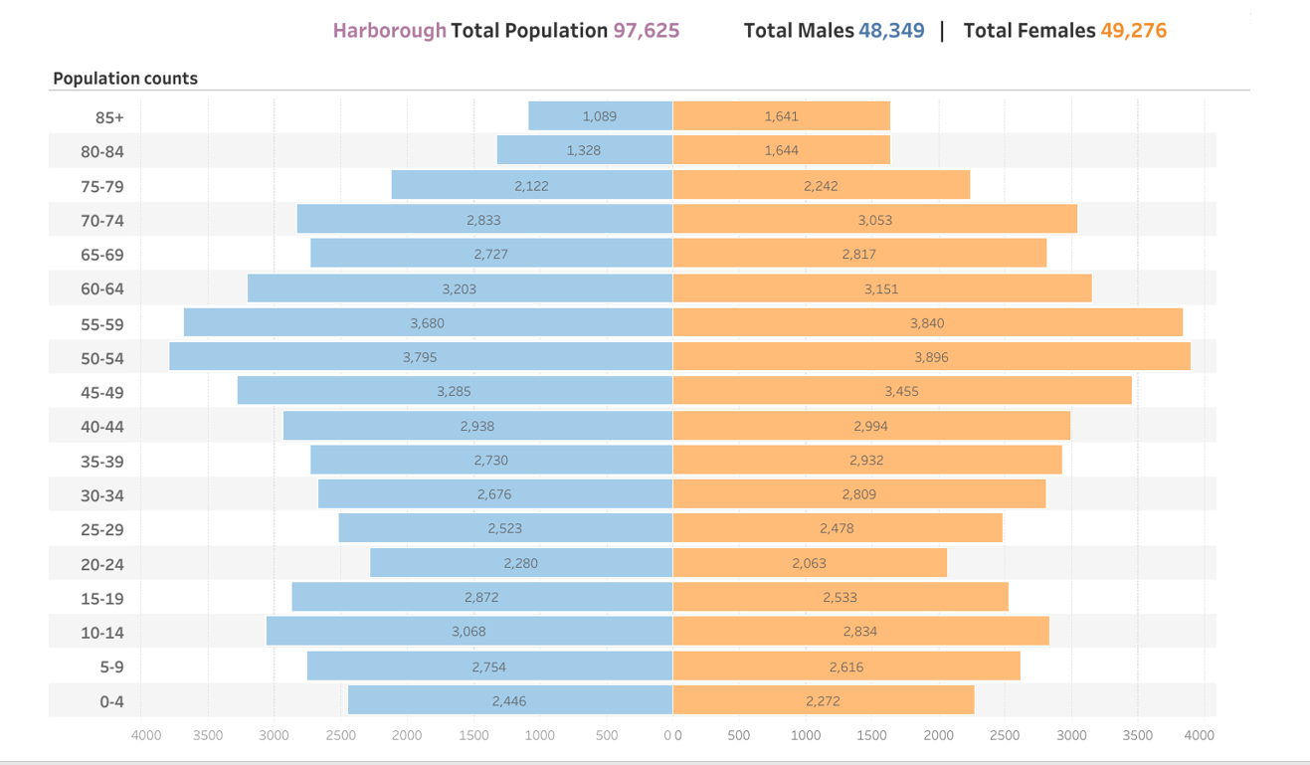

Population pyramid for Harborough 2021
Source: ONS, LSR A population pyramid for Harborough District
Table 1 Age profile of Harborough
 | Population 2011 | Population 2021
Under 15 | 16,348 | 17,196
16-64 | 53,443 | 58,937
over 65 | 15,591 | 21,498
Total population | 85,382 | 97,631

Graph 1: Age profile of Harborough in 2011 and 2021

Household information
Total number of households in the district
The total number of households has increased by 15.8% since 2011, with a total of 40,413 households in 2021. Table 2 shows the total number of households of neighbouring Leicestershire local Authorities.

Table 2 Households in Leicestershire

Authority | Census 2011 | Census 2021 | Change
Blaby | 38,686 | 42,575 | 10.10%
Charnwood | 66,516 | 73,785 | 10.10%
Harborough | 34,898 | 40,413 | 15.80%
Hinckley and Bosworth | 45,377 | 49,446 | 9%
Melton | 21, 490 | 22,599 | 5.10%
North West Leicestershire | 39,128 | 44,973 | 14.90%
Oadby and Wigston | 21,339 | 22,617 | 6%

Household Composition
Aged over 66 years - across Harborough district as already highlighted there was an increase in the number of people living here that were over 66 years. When looking at household data:

-13.2% (5335) of all homes where there is a single person occupancy of someone over the age of 66 years
-12.8% (5153) of all households occupied by a single-family group where everyone is over 66 years
- 2.5% (1009) of all households are multiple family of full-time students and over 66 years
- 28.4%, more than a quarter of all households across the district are occupied by people over 66 years

Lone parents
Across the district 5.1% (2066) households are single parents with dependent children and a further 3.1% (1248) households are single parents with non-dependent children.

Families
69.6% of the households across the district are single family households. The number of households with dependent children are 28.5% (11,455), these are made up in the following way:

- 17% (6956) of households are married/civil partnership couples with dependent children
- 4.3% (1750) single family cohabiting couples with dependent children
- 5.1% (2066) single parent with dependent children
- 1.9% (772) multiple family households with dependent children

A further 10.2% (4,133) are Households with non-dependent children of which 6.5% are married/civil partnership couples, 0.7% cohabiting couples and 3.1% lone parents. 19.5% (7909) of all households are married/civil partnership or cohabiting couples with no children.

14.2% (5725) of households have 4 occupants and a further 5.8% (2,338) households have 5 or more people living in them.

Across the district in addition to those people who live alone over 66 years, a further 19.6% (5179) Households are single persons. This equates to 26%, a quarter of all households across the district being single person households.

Ethnic groups in Harborough
In 2021, 5.4% of Harborough residents identified their ethnic group within the "Asian, Asian British or Asian Welsh" category, up from 3.0% in 2011. The 2.4 percentage-point change was the largest increase among high-level ethnic groups in this area. Across the East Midlands, the percentage of people from the "Asian, Asian British or Asian Welsh" ethnic group increased from 6.5% to 8.0%, while across England the percentage increased from 7.8% to 9.6%.

In 2021, 91.0% of people in Harborough identified their ethnic group within the "White" category (compared with 95.2% in 2011), while 2.1% identified their ethnic group within the "Mixed or Multiple" category (compared with 1.1% the previous decade). The percentage of people who identified their ethnic group within the "Other" category ("Arab" or "Any other ethnic group") increased from 0.2% in 2011 to 0.8% in 2021.

There are many factors that may be contributing to the changing ethnic composition of England and Wales, such as differing patterns of ageing, fertility, mortality, and migration. Changes may also be caused by differences in the way individuals chose to self-identify between censuses.

Religion in Harborough
In 2021, 38.4% of Harborough residents reported having "No religion", up from 24.6% in 2011. The rise of 13.8 percentage points was the largest increase of all broad religious groups in Harborough. Because the census question about religious affiliation is voluntary and has varying response rates, caution is needed when comparing figures between different areas or between censuses. (Graph 2). Across the East Midlands, the percentage of residents who described themselves as having "No religion" increased from 27.5% to 40.0%, while across England the percentage increased from 24.8% to 36.7%.

In 2021, 50.2% of people in Harborough described themselves as Christian (down from 65.5%), while 5.4% did not state their religion (down from 6.9% the decade before).

There are many factors that can cause changes to the religious profile of an area, such as a changing age structure or residents relocating for work or education. Changes may also be caused by differences in the way individuals chose to self-identify between censuses. Religious affiliation is the religion with which someone connects or identifies, rather than their beliefs or religious practice.

Graph 2 showing a comparison of religion in Harborough and England

