Parish of

……………Lutterworth……………….

Casual Vacancy for Parish Councillor

Notice is hereby given that due to the resignation of Councillor Martin Sarfas a vacancy exists in the office of Parish Councillor for the Parish of Lutterworth.

The vacancy will be filled by election if any ten Local Government Electors for the said electoral area submit a written request to that effect in the manner prescribed below and if no such request is made the vacancy will be filled by the Parish Council.

Any request for an election to be held to fill the vacancy must be in writing and must reach the Returning Officer, Harborough District Council, The Symington Building, Adam & Eve Street, Market Harborough LE16 7AG no later than 22nd May 2024.

Dated this 2nd May 2024 ………………………………

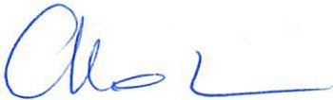


Signed: …………………………………………………….

Parish Clerk

