
Harborough District Council

Community Grant Scheme:
External applicant guidance

Contents

1. Introduction 2
2. Primary Outcomes 2
3. Eligibility Criteria 2
4. Application Process 4
5. Application Form 5
6. Disclaimers 9

Introduction

The Community Grant Fund is a £1 million capital grant scheme for Town and Parish Councils/Meetings and Community Organisations in the Harborough district.

The Community Fund is allocated across all areas in the Harborough district. It will strengthen working relationships between the Council and its parishes, towns and communities, enabling delivery of projects and initiatives at a local level across the district.

Please contact communitygrants@harborough.gov.uk if you have any queries about the Community Fund or the application process. We encourage all potential applicants to contact us before applications are started to discuss your project and ensure it meets the criteria.

Primary Outcomes

All projects must have a clear public benefit, and will need to demonstrate how it meets or aligns to at least one of the Council’s priorities, which are: -

- Community leadership to create a sense of pride in our place
- Promoting health and wellbeing and encouraging healthy life choices
- Creating a sustainable environment to protect future generations
- Supporting businesses and residents to deliver a prosperous local economy

Eligibility Criteria

  - This funding may only be used for new projects. Projects must not start before the grant is approved.

- Applications will only be accepted from Town and Parish councils, constituted Parish Meetings and constituted Community Groups/Organisations. Fees and charges are not covered.

- The funding is intended to support capital projects that create lasting assets, such as improvements to buildings, facilities, or purchasing and installing equipment. Capital funding focuses on enhancing, upgrading, or expanding facilities and activities, rather than covering routine maintenance or general upkeep. For example, replacing structures to modernise a building would be eligible, but repairing something to maintain its current condition would not. In exceptional circumstances, we may consider funding essential repair works where a full replacement would be disproportionate, environmentally unsustainable, or risk harm to a structure of recognised heritage or community value. This may be particularly relevant where repair enables continued use of a key local facility in smaller parishes or rural areas. Such applications must clearly evidence (a) why the repair is the most appropriate and sustainable option; (b) how the asset contributes to community benefit, and (c) why alternative funding is not available.

- Parishes/Towns can work together to submit joint applications but not exceeding the allocation as stated on the website, found here.

- Before applications are submitted, all applicants must seek the views of their Ward Councillor(s) and include these within their application. Contact information for Ward Councillors can be found here - Find my councillor | Harborough District Council.

- In addition, Community Organisations outside Market Harborough who wish to apply will also need to provide a letter of support from their Town/Parish Council or Meeting.

- In Market Harborough only, Community Organisations will first need to obtain a letter of support for their proposal from the Market Harborough Special Expenses Advisory Panel (SEAP), consisting of the ten Ward Councillors, before the organisation applies.

- On those occasions when it will not be possible for Democratic Services to hold an MHSEAP before the closing date for the current round of applications, organisations will be asked to submit their application pending MHSEAP support initially, to avoid any delays. To do this, they will need to attach a holding Word document to be able to proceed through the online application steps. This document should explain the situation e.g. ‘MHSEAP support to be provided after the next Panel meeting’.

- All applicants must hold a bank account in the name of the organisation and be able to provide at least three years of accounts if requested. You must also have Equality and Safeguarding Policies/Statements which they are able to attach to their application. If not, they agree to set these up as part of the application process.

- All completed applications will be presented to the Cabinet Grants Sub-Committee for consideration and decision. Applicants are welcome to attend Cabinet Grants Sub-Committee meetings. For applications over £25,000, this will be a requirement.

- Grant applications can be used to support other grant opportunities such as S106, as a ‘top-up’.

- More than one application can be submitted from each Parish or Town Council, subject to applications not exceeding the total allocated grant amount for that parish or town.

- The contract for delivery will be directly with the group that will be delivering the project, which may be a Parish Council or Meeting or a different group.

- Grants must generally be spent within one year of receipt, unless agreement is given by the Council to extend the spend-period. Any non-spent money must be returned to the Council.

  - The application must be received before the published application deadline.

Application Process

  - A diagram of the applicant’s funding journey

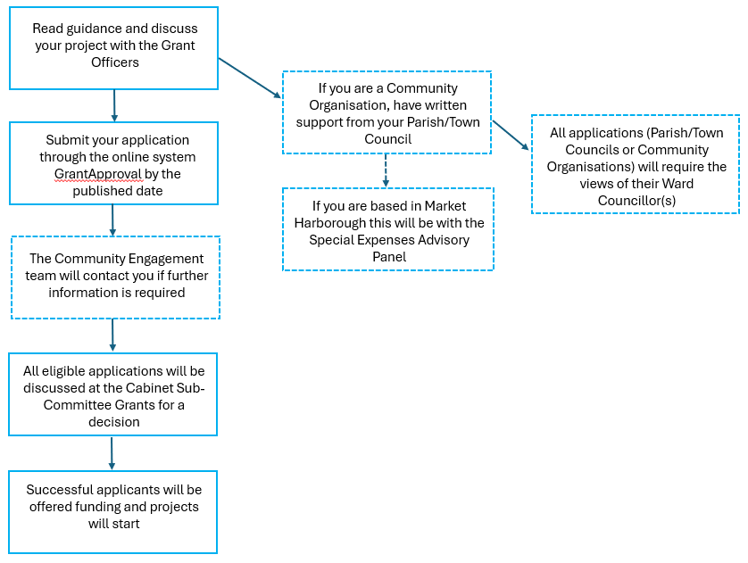
  - Online applications must be made via the www.grantapproval.co.uk website. Please contact communitygrants@harborough.gov.uk if you have any questions.

  - It is advisable that you have prepared your answers offline (for example on a Word document) prior to completing the online application form, as well as having any relevant documents readily available to upload.

  - We strongly advise that all projects are discussed with the Community Engagement team prior to submission. Please email communitygrants@harborough.gov.uk

  - Once an application has been submitted, all further communication on the application should ideally be through the ‘Comments’ function on the online system

Application Form

  - Please make your application via the www.grantapproval.co.uk website. If you have not used this system before, please register for an account. Once you are registered and logged onto the system, please select ‘Harborough’ as the local authority and click ‘find schemes’. The title of the fund in the online system is ‘HDC – £1m Community Grant Scheme’. It is your responsibility to ensure that correct and accurate information is provided first time.

The system has boxes asking for your property reference number, as GrantApproval is also used by businesses. Most community organisations will probably not have a property reference number and it is fine to leave this blank; you will still be able to proceed.

  - Application – Questions

The application form contains the following questions that are split into sections. Each section has a save point at the end of it. Please note that each page will automatically time out after one hour and any unsaved work will be lost.

Section 1 – Project
- Please provide the name of your Parish/Town Council or Parish Meeting. For organisations within Market Harborough only, please state Market Harborough.
- Please provide a brief description of your project. (full details should be included in your project plan)
Note that non-spent money must generally be returned to the Council one year after receipt of the funding. This answer is limited to 1,500 characters

Section 2- Project Finances
- How much funding are you applying for from this grant scheme? Ensure this does not exceed the total amount allocated to your parish. Please provide the information below. (Project total should = Community Grant fund request + other funding pending + secured).

- Is your project part of a larger project? If so, please tell us about the funding you have applied for or secured in no more than 2,000 characters.

- To demonstrate value for money, please list your quotes in the box.
(e.g., Quote A – £3,500, James Dean & Son Ltd; Quote B – £5,000, Bloggs Builders Ltd). Provide one quote for projects under £5,000 and three quotes for projects over £5,000.

- For expenditure of £5,000 and above, please also explain your organisation’s tender process and internal decision-making to demonstrate transparency and/or attach meeting notes or written evidence of this.
The Council reserves the right to determine the acceptability of all quotes. List your preferred supplier(s) and the reasons for your selection. (1500 characters)

- Please indicate if you are able to recover VAT or not. If you can, this element should not form part of your funding request.

- Please confirm the finance email address that should be used for your organisation. This is the address where remittance advice and any future financial correspondence will be sent. Ideally, this should be the address already registered with the Council (for example, the one used for parish precepts or previous payments). If you wish to use a new or different finance email address, please confirm your understanding that this will be the contact used for all future financial correspondence.

Section 3 – Evidence of Need
- How do you know there is a need for this project? Please explain:
The evidence, research, or consultation you have carried out
How you have considered equality, diversity, and inclusion in identifying this need.

- For town and parish councils/meetings only - Why this project is a priority? (1500 characters)

Section 4 – Aims and Impact
- Please explain in no more than 4,000 characters, how your project meets/aligns to at least one of the Council’s priorities: -
Community leadership to create a sense of pride in our place,
Promoting health and wellbeing and encouraging healthy life choices,
Creating a sustainable environment to protect future generations,
Supporting businesses and residents to deliver a prosperous local economy.

Following this question there will be a series of intended outcomes that can be selected as appropriate depending on which council priority applies to your project. These are as follows…

1. Community leadership to create a sense of pride in our place
- Increased access to safe, inclusive and welcoming community facilities
- More varied local events and activities that bring people together
- More residents taking part in decision-making, volunteering, or local leadership
- More people feeling a sense of connection and belonging to the area
2. Promoting health and wellbeing and encouraging healthy life choices
- Increased capacity for community activities that support physical and mental wellbeing
- Expanded opportunities for young people to engage in positive activities and develop skills
- More support for residents who are most in need within the community
- Increase in activities to reduce loneliness and social isolation
3. Creating a sustainable environment to protect future generations
- Increased awareness and adoption of sustainable practices
- Better access to green and outdoor spaces for recreation and wellbeing
- Greater participation in environmentally friendly activities and projects
- More residents involved in taking action to protect the environment
4. Supporting businesses and residents to deliver a prosperous local economy
- Improved facilities that enable groups to raise income and stay affordable
- Increased local footfall and visitor numbers through more accessible and attractive spaces and events
- Expanded access to cultural, educational, and leisure opportunities for residents
- More opportunities for education, volunteering and skills development for adults and young people.

Section 5 – Demographics
There are a series of multiple-choice check boxes to select, to tell us about the current or intended users and beneficiaries of your project. There is also a free text box where you can add user groups that aren’t mentioned.

  - Application - Required Documents

Please upload the following documents to the online application. For each relevant document type, you will need to select a document and click the ‘Upload’ button below it. A list of the uploaded documents will then appear at the top of the page. We would recommend that they check the list of uploaded documents before proceeding with the application.

- The support of the Parish/Town Council (if a Community Organisation)
If you are a Community Organisation, please submit written evidence of support from your Parish/Town Council. This can either be a letter on letter headed paper, or a copy of the Parish/Town Council meeting minutes.

If you are based in Market Harborough, Community Organisations will first need to obtain a letter of support for their proposal from the Market Harborough Special Expenses Advisory Panel (SEAP), consisting of the ten Ward Councillors, before the organisation submits an application. If this applies to you, please contact us as soon as possible at communitygrants@harborough.gov.uk so that we can assist in arranging a date for your proposal to be discussed at a Panel meeting.

On those occasions when it will not be possible for Democratic Services to hold an MHSEAP before the closing date for the current round of applications, you will need to submit your application without MHSEAP support for now, to avoid any delays. To do this, you will need to attach a holding Word document to be able to proceed through the online application steps. This document should explain the situation e.g. ‘MHSEAP support to be provided after the next Panel meeting’.

- The views of the Ward Councillor(s)
Please submit the written views of the Ward Councillor(s) for where the project is based.

- Bank Statement (Mandatory)
Please provide a bank statement to match the bank details provided on the application. This needs to clearly show the bank account name, sort code and account number. Please note this grant can't be paid into an individual account. The bank account name must correspond with the name of the organisation applying for funding.
Note that the applicant must be able to evidence three years of holding a bank account if required.

- Safeguarding Policy and Equality Policy/Statement (Mandatory)
If this is in progress, then please contact the Grant Officers to discuss at communitygrants@harborough.gov.uk.

- Governance Document (Mandatory)
The applicant must be a constituted ‘not for profit’ organisation. Please provide your organisation’s governance information.

- Project Plan (Mandatory)
Please upload your project plan, which should demonstrate the viability and sustainability of the project. Please refer to Section 5.4 for further information.

- Quotations (Mandatory)
Please provide at least one quotation for any assets, products, equipment, or services. Values over £5k require two quotes. These quotations should be from different suppliers.

- Ownership or lease (If Applicable)
If any alterations/works are proposed to a building or land, please provide proof of ownership, or the lease agreement in place. If the property is leased, please also provide a letter of permission from the landlord.

- Permissions (If Applicable)
Please provide evidence of relevant permissions or licences obtained.

  - Project Plan
A project plan template can be downloaded from the ‘Apply for the Community Grant webpage.

Your project plan should include:

- A project name.

- A summary of the project and its objectives.

- An outline of the need for the project and who specifically in the community this will impact. Please include evidence e.g. market research/engagement with the community.
.
- External partners or team members who will deliver the project, along with their roles and responsibilities.

- A detailed project timeline including: the expected start and completion dates, key outcomes, milestones, tasks, and due dates.

- Project finances – Your application project budget should balance; this means that your total cash income must be equal to your total cash expenditure. You should supply a detailed budget breakdown.

- Income – this should include the grant requested from the Community Grant Scheme and any other cash match funding. If you are sourcing additional funding, please list how much and when you expect it to be secured. Any additional funding will need to be secured before any awarded monies are processed.

- Expenditure – a detailed breakdown of the costs required to deliver the project. You should indicate how you have estimated these costs (e.g. quotations).

- Support in-kind - you should provide an estimated value of any non-cash contributions to the project. This may include materials or services that are provided free of charge or at a reduced rate.

- Any risks identified to successful delivery of the project and mitigating steps that you will take.

- The sustainability of the project and plans for ongoing maintenance of any assets that would be purchased with the grant.

- Site plans/photos and any other reference material relevant to the project.

Disclaimers

  - Harborough District Council reserves the right to vary the terms of the Community Grant Scheme as outlined on the Council website and this application guidance. Every effort would be made to inform organisations that have registered their interest with the Council of any such changes.

  - Harborough District Council reserves the right to pause applications to the Community Grant Scheme to evaluate the programme and implement any necessary changes. Every effort would be made to inform organisations that have registered their interest with the Council of any such changes.

  - If you would like a copy of the full terms and conditions for approved funding, then please contact communitygrants@harborough.gov.uk.

  - TAX - Any grant received may be subject to tax and organisations may wish to consult HM Revenue and Customs or a qualified, independent financial advisor.

  - Publicity - Any organisation receiving a grant must agree to publicly acknowledge receipt of the grant, display relevant logos, and agree to participate in any publicity or promotional activities associated with the funding. In addition, they must agree to participate in any monitoring and reporting required by the Council, whether specifically noted in the grant approval notification or not. Such reporting, monitoring and publicity may help inform whether similar funding is offered in future.

  - Information - Personal data supplied on the application form and any supporting documentation will be held on our systems and will be used in accordance with the Data Protection Act 2018 and Freedom of Information Act 2000. The information you provide will be used for statistical analysis, management planning and the provision of services by the Council. You can find further information about our relevant policies on our website here: https://www.harborough.gov.uk/information

  - FRAUD - The online application system will undertake anti-fraud checks and various checks will be made on each application and grant awarded. Any applicant caught falsifying their records to gain grant money will face prosecution and any funding issued will be recovered, as will any grants paid in error.

