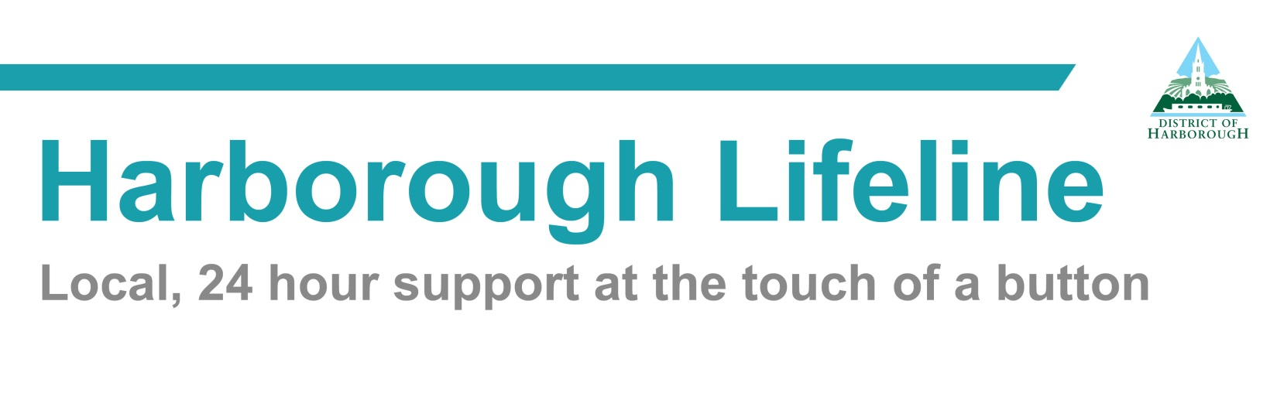
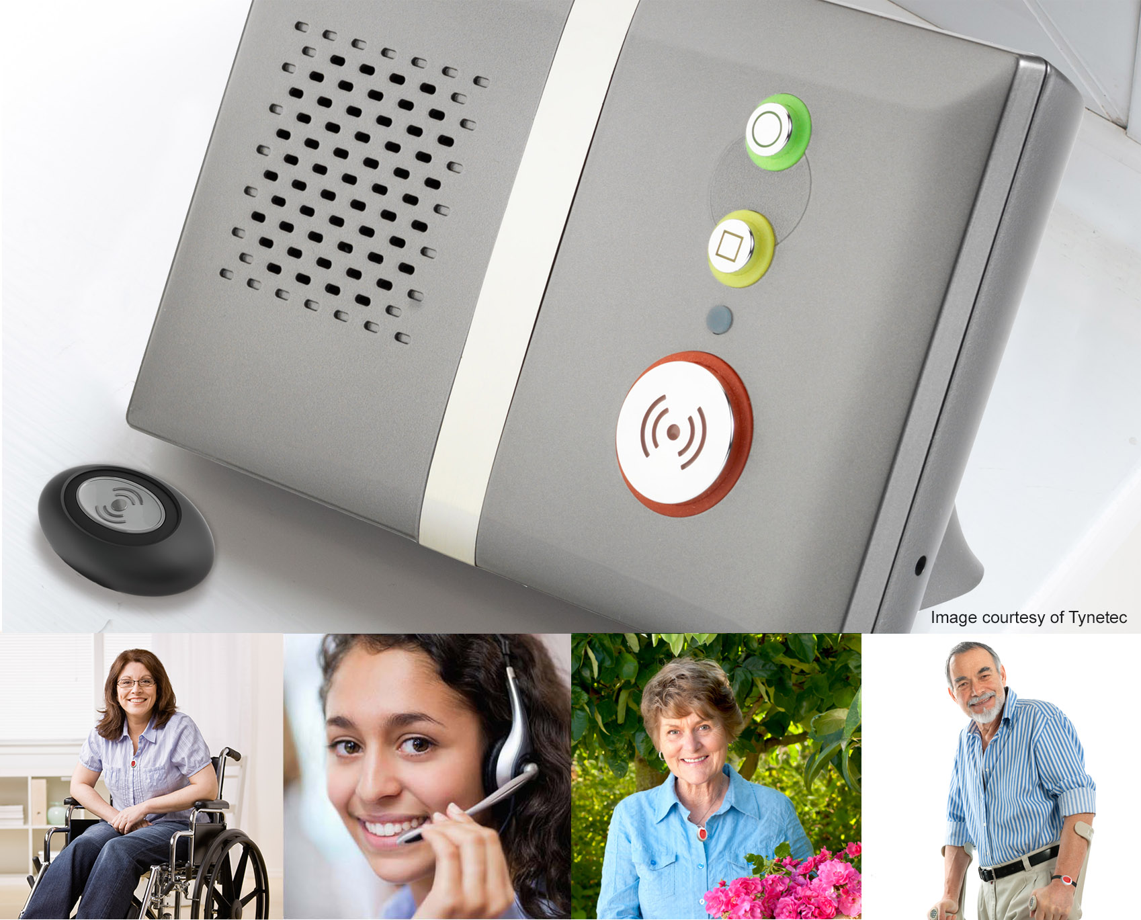
APPLICATION PACK
Harborough Lifeline Costs 2022/23

Set-up Fee / Initial Charge (One off Charge): £85.00 (£102 inc. VAT) standard
£105.00 (£126 inc. VAT) Additional Equipment

Basic Lifeline Package: * Lease of Lifeline unit, pendant & 24/7 monitoring
£4.60 per week (£5.52 inc. VAT)

Many lifeline customers will be exempt from the payment of VAT on Lifeline charges providing they meet the conditions on the ‘VAT Exemption Form’

For an additional cost we can also provide optional sensors which can be programmed to your lifeline unit enabling us to respond quickly to any potential emergency. Additional pendants and fall pendants are available. Please contact us on 01858 464499 to discuss individual requirements and costs.

After sign-up, our Finance team will work out what you owe for the remainder of the financial year, (from the set-up date to 31st March). The amount you owe is then spread across the monthly direct debit payments.

The number of monthly Direct Debits will vary depending upon your specific service / set-up date. Our Finance team will provide you with a minimum of 10 working days’ notice of your first Direct Debit payment. The payment will be taken on around the 25th of the month.

If you choose to spread the set-up fee across the monthly direct debit payments, then the set-up fee and the ongoing Lifeline service costs will be combined and spread out evenly over the year.

If you opt not to spread the set-up fee over your first year, the first direct debit amount will be £85.00 or £105.00 if additional equipment is required, and the total hire of your ongoing Lifeline service will be collected over the remaining Direct Debits.

Note that VAT which is calculated at 20% is not included in the details above.

Clients signing up during February and March may not be invoiced until the new financial year. Therefore, the subsequent year’s invoice may be slightly higher as it will include weekly fees for the previous financial year and set-up fee. This will be spread across the 12 months.

*The weekly charge of £4.60 covers our standard package of a Lifeline unit and pendant. It does not include the cost of any additional telecare products such as fall detectors or smoke alarms etc.

Terminating your service

If you wish to discontinue the service, please let us know promptly. The termination date for the contract and the last date that we charge for will be the date on which we cease monitoring. After the termination date we will be unable to respond to alarms. A Freepost envelope will be sent to your address to enable you to return the equipment quickly and safely.

.

Office only Client ID

Supply First Client Details.

Title |  | Prefers to be addressed as
First Name(s) |  | Surname
Date of Birth

Address
Post Code |  |  | E-Mail
Home Tel Nº |  | Mobile Nº
Digital Tel. Line | Has your Analogue Telephone line been upgraded by your telephone provider to Digital? |  |  |  | Yes / No / Unsure
Broadband | Yes / No | Telephone Service Provider (e.g.: BT, Sky)

An emergency contact should be a friend or relative who lives near you, who has a telephone, and who is willing to be contacted on your behalf in an emergency

Your Responders  Name in Full |  | Responder 1 Address
Your Responders  Name in Full |  |  |  |  |  | Post Code
 |  | Home Tel Nº |  |  | Mobile Nº
 |  | Relationship |  |  | Key Holder | Yes / No

Your Responders  Name in Full |  | Responder 2 Address
Your Responders  Name in Full |  |  |  |  |  | Post Code
 |  | Home Tel Nº |  |  | Mobile Nº
 |  | Relationship |  |  | Key Holder | Yes / No

Your Responders  Name in Full |  | Responder 3 Address
Your Responders  Name in Full |  |  |  |  |  | Post Code
 |  | Home Tel Nº |  |  | Mobile Nº
 |  | Relationship |  |  | Key Holder | Yes / No

Your Responders  Name in Full |  | Responder 4 Address
Your Responders  Name in Full |  |  |  |  |  | Post Code
 |  | Home Tel Nº |  |  | Mobile Nº
 |  | Relationship |  |  | Key Holder | Yes / No

Set-up Requirement |  |  | How do you wish to wear the Pendant (Circle) |  |  | Neck Cord / Wrist Strap / Unsure
 |  |  | Set-up of Equipment. |  |  | Receive via post, pre-programmed unit. Send to: (details)
 |  |  |  |  |  | Lifeline to arrange visit through contact: (details)
Supplementary Information:
Telephone providers are increasingly changing all telephone connections from analogue to digital; it is helpful if we know whether your line has been upgraded, but not essential. Don’t worry if you’re not sure.

With our Permission to Discuss form some customers feel happier knowing that a friend or relative can discuss your Lifeline finances and discuss your Lifeline personal information if there are any changes in your circumstances, such as a change in phone number, key holder, medical condition, etc. This is entirely optional, and we will only contact the nominated person if it’s absolutely necessary.

It is the responsibility of the customer to update Harborough Lifeline if your personal information changes especially medical.
Directions to property if difficult to find
Data Consent: For the purposes of the GDPR + Data Protection Act 2018. At Lifeline we take your privacy seriously and will only use your information to administer your account and to provide help from emergency services + health professionals that you may request.
ype a quote from the document or the summary of an interesting point. You can position the text box anywhere in the document. Use the Drawing Tools tab to change the formatting of the pull quote text box.]
I AGREE
Relationship to applicant if not applicant
Signed |  |  |  |  | Date

Your Health  Information |  | Medical Info
Your Health  Information |  | Doctor |  | Telephone Nº
Your Health  Information |  | Surgery

Your Home Care  Information |  | Name of Organisation
Your Home Care  Information |  | Address
Your Home Care  Information |  |  |  | Post Code
Your Home Care  Information |  | Telephone Nº
Your Home Care  Information |  | How often do they visit?

Your Key Safe  Information |  | Key Safe Code
Your Key Safe  Information |  | Location of Key Safe

Office only Client ID

Supply Second Client Details.

Title |  | Prefers to be addressed as
First Name(s) |  | Surname
Date of Birth

Address
Post Code |  |  | E-Mail
Home Tel Nº |  | Mobile Nº
Digital Tel. Line | Has your Analogue Telephone line been upgraded by your telephone provider to Digital? |  |  |  | Yes / No / Unsure
Broadband | Yes / No | Telephone Service Provider (e.g.: BT, Sky)

An emergency contact should be a friend or relative who lives near you, who has a telephone, and who is willing to be contacted on your behalf in an emergency

Your Responders  Name in Full |  | Responder 1 Address
Your Responders  Name in Full |  |  |  |  |  | Post Code
 |  | Home Tel Nº |  |  | Mobile Nº
 |  | Relationship |  |  | Key Holder | Yes / No

Your Responders  Name in Full |  | Responder 2 Address
Your Responders  Name in Full |  |  |  |  |  | Post Code
 |  | Home Tel Nº |  |  | Mobile Nº
 |  | Relationship |  |  | Key Holder | Yes / No

Your Responders  Name in Full |  | Responder 3 Address
Your Responders  Name in Full |  |  |  |  |  | Post Code
 |  | Home Tel Nº |  |  | Mobile Nº
 |  | Relationship |  |  | Key Holder | Yes / No

Your Responders  Name in Full |  | Responder 4 Address
Your Responders  Name in Full |  |  |  |  |  | Post Code
 |  | Home Tel Nº |  |  | Mobile Nº
 |  | Relationship |  |  | Key Holder | Yes / No

Supplementary Information:
Telephone providers are increasingly changing all telephone connections from analogue to digital; it is helpful if we know whether your line has been upgraded, but not essential. Don’t worry if you’re not sure.

With our Permission to Discuss form some customers feel happier knowing that a friend or relative can discuss your Lifeline finances. Also, if the need arises you can give permission to a friend or relative to discuss your Lifeline personal information, i.e. medical information, who your responders are etc. This is entirely optional, and we will only contact the nominated person if it’s absolutely necessary.

It is the responsibility of the customer to update Harborough Lifeline if your personal information changes especially medical.

Directions to property if difficult to find
Data Consent: For the purposes of the GDPR + Data Protection Act 2018. At Lifeline we take your privacy seriously and will only use your information to administer your account and to provide help from emergency services + health professionals that you may request.
ype a quote from the document or the summary of an interesting point. You can position the text box anywhere in the document. Use the Drawing Tools tab to change the formatting of the pull quote text box.]
I AGREE

Relationship to applicant if not applicant
Signed |  |  | Date

Your Health  Information |  | Medical Info
Your Health  Information |  | Doctor |  | Telephone Nº
Your Health  Information |  | Surgery

Your Home Care  Information |  | Name of Organisation
Your Home Care  Information |  | Address
Your Home Care  Information |  |  |  | Post Code
Your Home Care  Information |  | Telephone Nº
Your Home Care  Information |  | How often do they visit?

Your Key Safe  Information |  | Key Safe Code
Your Key Safe  Information |  | Location of Key Safe
PLEASE BE MINDFUL THAT NOT EVERYONE FEELS COMFORTABLE BEING AROUND DOGS. IF YOU HAVE A DOG/S COULD YOU PLEASE PUT IT/THEM IN A DIFFERENT PART OF THE PROPERTY DURING VISITS BY OUR STAFF – THANK YOU.

Declaration to claim for Exemption from Payment of VAT
Unit Ident:

Ref:

PART A: FOR COMPLETION BY THE CLIENT

H.M. Customs and Excise will allow exemption from payment of VAT on any Lifeline Charges provided the applicant is chronically sick or disabled (See “Relevant Extracts” on the reverse).

Client :
Address :
Postcode : |  | Telephone :

I declare that I am chronically sick or have a disabling condition by reason of:

( please give full and specific description of your condition ) .

and that I am receiving from Harborough District Council, Adam & Eve Street, Market Harborough, LE16 7AG, the services of monitoring a personal alarm call system, and I claim relief from value added tax.

Signature: _____________________________ Date: ______________
Client :

PART B: FOR COMPLETION BY THE SUPPLIER

I, a representative of Harborough District Council, Adam & Eve Street, Market Harborough, confirm that the service of monitoring a personal alarm call service, for the personal use of the disabled person, is supplied to the person named above.

Signature: _____________________________ Date: ______________

Installer :

Please return to:

Harborough Lifeline,
Harborough District Council,
The Symington Building
Adam & Eve Street
Market Harborough
Leics., LE16 7AG (Tel: 01858 828282)

ALL OF THE INFORMATION GIVEN ON
THIS FORM WILL REMAIN PRIVATE AND CONFIDENTIAL AND WILL NOT BE
DISCLOSED TO ANY THIRD PARTIES.

Customs & Excise Notice 701/7 "VAT Reliefs for Disabled People"

H M Customs and Excise state that the provision of the Lifeline Alarm Service, is subject to the standard rate VAT (currently 20%).

However, exemption from VAT can be obtained for persons who are chronically sick or disabled. They consider a chronically sick or disabled person to have:

- A physical or mental impairment which has a long term and substantial adverse effect upon his/her ability to carry out everyday activities.

- A condition which the medical profession treats as a chronic sickness, such as diabetes.

- A terminal illness.

However, it does NOT include a frail elderly person who is otherwise able-bodied, or a person who is temporarily disabled or incapacitated, such as with a broken limb.

To claim exemption from VAT, you should complete the declaration form overleaf.

Important Note:

Please be aware that there are penalties for making a false declaration and for fraudulent evasion of VAT.

Office only Client ID \ FMS

Permission to Discuss:
Financial Details (if No Power of Attorney)
Change of Personal Details

I, ……………………………………………………………… hereby authorise the following person(s) (please list in box below) to act on my behalf with officers who are dealing with my affairs at Harborough District Council. I give permission for the council to discuss my personal / sensitive personal data with these named persons.

The person(s) named below will only be able to act on your behalf if they quote a password that has been agreed between yourselves (please enter in box below).
Financial Details (if No Power of Attorney) – State name of friends and / or relatives & password permission.

Change of Personal Details – State name of friend or relative & password permission.

Signed: (Service User) Daytime Telephone No (Authorised Person) Date

Please return your completed form to the address below:

lifeline@harborough.gov.uk or to Harborough Lifeline, Harborough District Council, The Symington Building, Adam & Eve Street, Market Harborough, Leicestershire, LE16 7AG.

This is in compliance with the General Data Protection Regulations.

Privacy Notice
Under Article 6(1) (a) (consent) (d) vital interest and (e) (public interest) of the general Data Protection Regulations, we are permitted to use data for our tasks; data protection law describes this legal basis for handling your information. It will be used by Harborough District Council and our partners to deliver and improve services and fulfil our statutory delivery. We will not enclose any personal information to any other third parties unless required or allowed to do so by law.

Read more about how we use personal data on our privacy notice page via our:

http://www.harborough.gov.uk/information

Or write to the council at: Information Governance, Harborough District Council, The Symington Building, Adam & Eve St, Market Harborough, LE16 7AG or FOI@harborough.gov.uk

Yours Sincerely

Harborough Lifeline

How did you hear about Harborough Lifeline?

We’re always interested to know where you first heard about our service or who recommended us!

Please tick the relevant box(es) below and add any additional details alongside.

Thank you.

Leaflet / Flyer

Magazine

Council Website

Radio

Promotional Talk

Promotional Event

Recommended by a Friend / Family
Are you aware of how they knew about us?

Recommended by hospital, health, social care

Recommended by another professional

Leicestershire County Council

First Contact

Other (please specify)

